D3.1.x Science&Art@School

Project Reference: | H2020-SEAC-2014-2015/H2020-SEAC-2014-1 , 665917 |  | Author: Angelos Alexopoulos
Code: | D3.1.x |  | Contributors: Michael Hoch, Stephen Preece
Version & Date: | v1.0, 26 May 2016 |  | Approved by:

Table of Contents
1 Introduction / Demonstrator Identity 6
1.1 Subject Domain 6
1.2 Type of Activity 6
1.3 Duration 6
1.4 Setting (formal / informal learning) 6
1.5 Effective Learning Environment 6
2 Rational of the Activity / Educational Approach 7
2.1 Challenge 7
2.2 Added Value 7
3 Learning Objectives 8
3.1 Domain specific objectives 8
3.2 General skills objectives 8
4 Demonstrator characteristics and Needs of Students 9
4.1 Aim of the demonstrator 9
4.2 Student needs addressed 9
5 Learning Activities & Effective Learning Environments 10
6 Additional Information 15
7 Assessment 16
8 Possible Extension 17
9 References 18

Introduction / Demonstrator Identity

Subject Domain
Particle Physics, Physics

Type of Activity
This activity is a combination of:
- In-school
- Out-of-school including research institute/centre, museum, art space

Duration
This is typically a three-day activity

Setting (formal / informal learning)
The setting is both formal (i.e. school) and informal (e.g. research centre) and engages multiple actors such as science and art teachers, scientists and even parents.

Effective Learning Environment
  - Communities of practice
  - Simulations
  - Arts-based
  - Dialogic space / argumentation
  - Experimentation (Science laboratories and eScience applications)
  - Visits to research centres (virtual/physical)
  - Communication of scientific ideas to audience

Rationale of the Activity / Educational Approach

Challenge
Consistent with a Deweyan perspective, the key challenge of Science&Art@School is to offer school students transformative experiences that (1) extend beyond the classroom; (2) transform the learner’s perspective; and (3) lead to deep engagement in science (Pugh et al., 2010; Pugh, 2011; Garner, Pugh & Kaplan, 2016). In other words, and to use Pugh et al’s (2010: 4) example, the challenge is to provide scaffolding for students to “look at the stars differently at night”.

Added Value
Science&Art@School aspires to be a model of teaching for transformative experiences in particle physics, physics and more widely in science by following three learning-by-doing strategies (Dewey, 1958; Pugh & Girod, 2007; Garner, Pugh & Kaplan, 2016):
- Framing scientific content as ideas. This involves, first, the identification of “big ideas” in physics and particle physics and, second, the presentation of those “big ideas” as compelling possibilities for young students.
- Scaffolding re-seeing. This involves the provision of guidance and support to students in order to help them relate their everyday world through the lens of particle physics and the interwoven role that engineering and technology play in advancing not only research and discovery in the field but also in promoting knowledge generation and transfer with a positive social impact.
- Modelling transformative experiences. This involves teachers, science educators and even art pedagogists being able to demonstrate to students how cutting-edge science, technology and innovation may change the way they perceive and experience the world.
Science&Art@School (Hoch & Alexopoulos, 2014) builds on and expands previous educational activities for high-school students, such as ‘hands-on’ particle physics masterclasses (Long, 2011; Ouid-Saada, 2012; Cecire et al., 2014). Through intensive, collaborative learning episodes that make use of creative and artistic interventions, this activity offers students the opportunity to delve into transformative, aesthetic experiences (Pugh & Girod, 2007) that are considered to increase their deep engagement in science (Biscotte, 2015).
Importantly, Science&Art@School workshops produce artworks by the students themselves. These creative objects may be viewed as “artefacts” and, as such, embody motivated use and experiential value (Pugh, 2011). Selected artworks are then incorporated into the art@CMS travelling exhibitions, thereby serving as sources of motivation for and identification with other school communities from around the world (Alexopoulos et al., 2015).

Learning Objectives

Domain specific objectives
Science&Art@School rests on the idea that particle physicists and artists share fertile common ground in their parallel efforts to understand ‘φύση’ (the Greek word for nature). Creating a bridge between these two worlds is worthwhile since it can help students gain a deeper understanding of each subject area. It can also help them think creatively and responsibly about the collaborative scientific effort being done at CMS in CERN, the world’s largest particle physics laboratory.
Science&Art@School thus takes the art@CMS concept a step further by bringing young students from the science curricula but also from the arts, humanities and social science curricula together with CMS researchers, science educators and art teachers during extended learning periods in order to help students:
- Understand how scientific research in particle physics works
- Explore how researchers and artists work and view each other’s world
- Engage in and create artworks inspired by “big ideas” that drive scientific and technological effort at CMS and CERN
- Develop positive and responsible attitudes towards science, technology, collaboration and innovation in large research infrastructures such as the CMS experiment at CERN.

General skills objectives
Science&Art@School is situated within the movement for approaching science education in schools from a science, technology, engineering, arts and mathematics (STEAM) perspective. The so-called STEAM movement, as reflected in various national and international initiatives on both sides of the Atlantic, calls for arts integration into science teaching and learning as a catalyst for developing 21st century skills that are necessary to thrive in the information age.
In line with the P21® Framework for 21st Century Learning, Science&Art@School aims to equip students with the following Learning and Innovation Skills:
- Critical thinking (e.g. use systems thinking)
- Communication (e.g. utilise multiple media and technologies)
- Collaboration (e.g. demonstrate ability to work respectfully with diverse teams)
- Creativity (e.g. use a wide range of idea creation techniques such as brainstorming)
The above skills are described in more detail in the P21® Framework Definitions document.

Demonstrator characteristics and Needs of Students

Aim of the demonstrator
As described in Sections 2 and 3, the principal aim of Science&Art@School is not only to inform, inspire and excite young students about how research in particle physics works but also to engage them effectively through learning-by-doing strategies that employ creative and artistic interventions that take place both in school and out-of-school settings. Ultimately, these interventions focus on providing students with transformative experiences that may also result in the acquisition of 21st century learning skills.
To date, twelve Science&Art@School workshops have taken place in six countries (Austria, France, Rwanda, Switzerland, United Kingdom, United States) with the participation of more than 600 students from both public and private schools. While the majority of students in those workshops were at senior high school level, the demonstrator may also be applicable to students at junior high school level.
The demonstrator requires the active participation of at least three categories of facilitators:
- Science teacher(s)
- Art teacher(s)
- Scientist(s)
The involvement of science education specialists, art curators, and local educational and cultural authorities or agencies, although not necessary, is welcomed.

Student needs addressed
By inviting students to think critically, act creatively and behave responsibly, Science&Art@School workshops speak directly to the three key aspects of the CREATIONS approach, namely the CREATIONS features, the RRI aspects and the IBSE features. However, unless they address specific knowledge-related needs of the students, they run the risk of failing to meet effectively the learning objectives as specified in Section 3. Science&Art@School thus employs a Deign Framework that acts as a flexible tool for both the teacher(s) and the student(s) to develop stronger trust and responsibility throughout all stages of the project. This framework rests on three pillars (i.e. Discover, Define, Engage) which, in turn, are associated with the three learning-by-doing strategies described in Section 2.2. In a nutshell, the Design Framework acts as a non-prescriptive scaffolding which the learner can use to support his or her concept from brainstorming through realization whilst reinforcing good design practice.

Learning Activities & Effective Learning Environments

Science topic: Particle Physics, Physics  Relevance to national curriculum:  No direct relevance to Swiss curriculum but strong connection to the International Baccalaureate® (IB) Programme as well as to other national curricula  Class information  Year Group: Junior high school; Senior high school  Age range: 12-17  Sex: Both  Pupil Ability: Mixed (The scenario allows space for pupils of various abilities to participate) |  |  | Materials and Resources  What do you need? (eg.printed questionnaires, teleconference, etc.)  - Computers, Internet (for the CMS masterclass part)  - Videoconferencing equipment (for the CMS virtual visit part)  - Art materials and props (for the production of artworks part)  Where will the learning take place? On site or off site? In several spaces? (e.g. science laboratory, drama space etc), or one?  - CMS masterclass can take place in school or CMS institute  - CMS virtual visit part can take place in school  - Production of artworks part can take place in school or museum or art centre  - Exhibition can take place in school or museum or art centre  Health and Safety implications? None  Technology? Computers with internet access and videoconferencing equipment for the CMS virtual visit part  Teacher support? Scaffolding
Prior pupil knowledge
While no prior knowledge of particle physics is required, a preparatory session initiated by the science teacher is welcomed. In this session, the science teacher is advised to ignite students’ curiosity by showing relevant audiovisual material or inviting students to do so at home. The ultimate aim is to initiate the inquiry cycle by posing a “big question” in particle physics that will then be followed up by the students.
Individual session project objectives (What do you want pupils to know and understand by the end of the lesson?)
During this scenario, students will:
Day 1
- Be introduced to “big ideas” in particle physics (e.g. The Standard Model)
- Explore fundamental concepts and methods of particle physics research (Particle accelerators and particle detectors)
- Analyse real particle physics data with the use of a virtual lab (CMS mini-masterclass)
- Meet and talk to CMS scientists virtually (CMS virtual visit - optional)
- Be introduced to the interconnections of science and art

Day 2:
- Be introduced to the interconnections of science and art (cont’d)
- Develop concepts and define design framework for artwork production
- Implement and produce artworks using a variety of media

Day 3:
- Communicate the whole process through means of public outreach (e.g. exhibition)

Assessment  - Self-evaluation  - Peer evaluation  - Portfolio assessment  (evaluation template available at Section 7) |  | Differentiation  How can the activities be adapted to the needs of individual pupils?  Science&Art@School is flexible and interdisciplinary by nature and as such speaks well to a diverse group of students. |  | Key Concepts and Terminology  Science terminology: energy, momentum, charge, Standard Model, Bing Bang, hadrons, Higgs boson, dark matter, antimatter, supersymmetry, Planck scale, string theory  Arts terminology: abstract, acrylic, harmony, futurism, minimalism, mixed media, montage, mosaic, neutral, perspective, pop art, style, symbolism, triptych
Session Objectives:
During this scenario, students will:
- engage with big questions about the past, present and future of the Universe (e.g. “where do we come from? What are we made of? Where are we going?”)
- attempt to answer and reflect upon these questions, and communicate their interpretation through tools for authentic scientific inquiry but also through creative experimentation and artistic expression
Learning activities in terms of CREATIONS Approach
IBSE Activity | Interaction with CREATIONS Features |  |  | Students | Teacher | Potential Arts Activity
Phase 1  QUESTION: students investigate a scientifically oriented question | Students pose, select, or are given a scientifically oriented question to investigate. Balance and navigation through dialogue aids teachers and students in creatively navigating educational tensions, including between open and structured approaches to IBSE. Questions may arise through dialogue between students’ scientific knowledge and the scientific knowledge of professional scientists and science educators, or through dialogue with different ways of knowledge inspired by interdisciplinarity and personal, embodied learning. Ethics and trusteeship is an important consideration in experimental design and collaborative work, as well as in the initial choice of question. |  |  | Engage in argumentation/dialogue about a scientific topic that may hold social implications but may also influence their personal life choices/decisions  Generate with the help of teacher investigable questions through means of authentic scientific inquiry  Explore strategies and work structures to answer those questions | Invites students to think of and pose a “big question” in science and particularly in particle physics  Ignites students’ curiosity by prompting a “big question” in science using audiovisual means (e.g. video)  Invites students to think of how scientists and artists approach differently a scientific idea and its social implications. | Brainstorming exercise with science teacher and/or art teacher on how to express a “big question” in particle physics through means of artistic creation
Phase 2  EVIDENCE: students give priority to evidence | Students determine or are guided to evidence/data, which may come from individual, collaborative and communal activity such as practical work, or from sources such as data from professional scientific activity or from other contexts. Risk, immersion and play is crucial in empowering pupils to generate, question and discuss evidence. |  |  | Take part in a seminar with professional scientist(s)  Learn first-hand from scientists the “what”, “how” and “why” of scientific work  Start to build conceptual bridges between scientific data visualisation and its artistic interpretation | Organizes a CMS mini-masterclass in school or research institute  (http://cms.web.cern.ch/content/how-organize-masterclass)  Invites a scientist to run the mini-masterclass  Invites an art educator / artist to help students build interconnections between what they learnt in the CMS masterclass and the world of art | Use of Design Framework for defining core idea, art mediums, materials, process and communication under the guidance of art teacher
Phase 3  ANALYSE: students analyse evidence | Students analyse evidence, using dialogue with each other and the teacher to support their developing understanding. |  |  | Work ‘hands-on’ in groups, analyse and visualise real scientific data from the CMS experiment at CERN  Apply basic principles and laws in physics (e.g. conservation of energy, conservation of momentum)  Embark on artwork production | Science teacher: Facilitates the activity by helping students to connect their analysis techniques with curriculum  Art teacher: Invites students to ignite dialogue on the “beauty of science” (e.g. data visualisation) and its potential connection with artistic projects. | Artworks production phase
Phase 4  EXPLAIN: students formulate an explanation based on evidence | Students use evidence they have generated and analysed to consider possibilities for explanations that are original to them. They use argumentation and dialogue to decide on the relative merits of the explanations they formulate, playing with ideas. |  |  | Discuss the findings of the masterclass with scientist and teacher.  Develop scientific argumentation  Explain their own rationale and design framework to art teacher | Science teacher and art teacher act as facilitators
Phase 5  CONNECT: students connect explanations to scientific knowledge | Students connect their explanations with scientific knowledge, using different ways of thinking and knowing (‘knowing that’, ‘knowing how’, and ‘knowing why’) to relate their ideas to both disciplinary knowledge and to interdisciplinary knowledge to understand the origin of their ideas and reflect on the strength of their evidence and explanations in relation to the original question. |  |  | Make connections between scientific and artistic inquiry  Compare different methodologies and skills they used for physics masterclass and artwork production | Science teacher and art teacher act as facilitators
Phase 6  COMMUNICATE: students communicate and justify explanation | Communication of possibilities, ideas and justifications through dialogue with other students, with science educators, and with professional scientists offer students the chance to test their new thinking and experience and be immersed in a key part of the scientific process. Such communication is crucial to an ethical approach to working scientifically. |  |  | Scientific investigation part (Masterclass): Present the results of their analysis to other students, teacher and scientist as part of the CMS masterclass  Artistic creation part: Present their artworks during the exhibition; they document in a visually appealing manner the development of their artwork from inception to completion. This documentation becomes integral part of the artwork and its communication. | Science teacher and art teacher act as facilitators | Art exhibition
Phase 7  REFLECT: students reflect on the inquiry process and their learning | Individual, collaborative and community-based reflective activity for change both consolidates learning and enables students and teachers to balance educational tensions such as that between open-ended inquiry learning and the curriculum and assessment requirements of education. |  |  | Discuss and reflect upon the evaluation of their work. Explore what worked well and what did not work that well. | Science teacher and art teacher act as facilitators

Additional Information
Additional information on Science&Art@School can be found at:
- http://artcms.web.cern.ch (under projects)
Detailed information on the inaugural Science&Art@School workshop that was implemented in Graz, Austria, in 2013 can be found at:
- http://artcms.web.cern.ch/artcms/project/high-energy-physics-meets-art/
An indicative programme of a three-day Science&Art@School workshop is shown below.
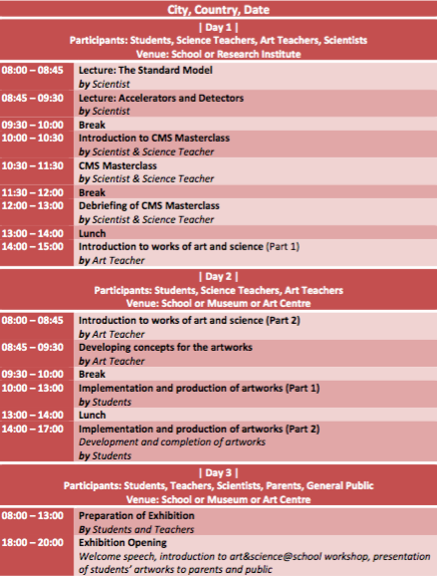

Assessment
21st century skills, such as critical thinking and creativity, may be quantifiable. Due to the nature of creative and critical thinking and their application, any evaluation must be multi-dimensional. While subject knowledge alone will not suffice, it is a necessary foundation in order to ensure the quality of critical and creative thinking.
Science&Art@School workshops incorpodate a formal evaluation framework. This consists of:
- self-evaluation
- peer evaluation
- portfolio assessment
Science&Art@School rests on the premise that creative ideas need to be realised and it is this process of realisation that is supported by the Design Framework. In accordance with the Deign Framework, an assessment template that has been used in previous workshops implemented in Switzerland is presented below.
Evaluation Template for Science&Art@School Workshop
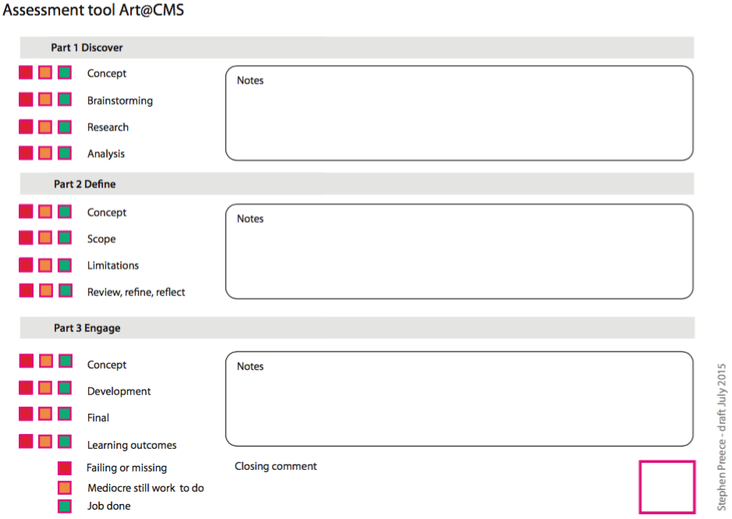

Possible Extension
In the framework of the art@CMS programme, Science&Art@School workshops have been piloted in several schools across six countries in Europe, US and Africa. Speciically, and based on pilot implementation in the International School of Geneva (ECOLINT) over the last three years, Science&Art@School is intended to be built as a unit in programmes such as the Visual Arts International Baccalaureate® (IB) Programme. On February 2016, there were more than 5,000 IB programmes offered worldwide across more than 4,000 schools.

References
Alexopoulos, A., Barney, D., Bilow, U., Adam-Bourdarios, C., Kobel, M., Kourkoumelis, C., Melo., I. & Smith, C.R. (2015). Resources for education and outreach ectivities: Discussion session. The European Physical Society Conference on High Energy Physics, Vienna, 22-29 July.
Biscotte, S. (2015). The necessity of teaching for aesthetic learning experiences in undergraduate general education science. The Journal of General Education, 64, 242-254.
Cecire, K., Bardeen, M., & McCauley, T. (2014). The CMS masterclass and particle physics outreach. EPJ Web of Conferences 71, 27.
Dewey, J. (1958). Art as experience. New York: Perigee Books (original work published 1934).
Garner, J.K., Pugh, K., & Kaplan, A. (2016). Museum visitor identification and engagement with science (VINES): A theory-driven process for designing transformational experiences. Paper presented at the 2016 Annual Meeting of the American Educational Research Association, Washington DC.
Hoch, M. & Alexopoulos, A. (2014). ART@CMS and SCIENCE&ART@SCHOOL: Novel education and communication channels for particle physics. Proceedings of the the 14th ICATPP Conference, Vol. 1, 728-736.
Long, L. (2011). More ‘hands-on’ particle physics: Learning with ATLAS at CERN. Physics Education, 46, 270-280.
Ouid-Saada, F. (2012). International particle physics masterclasses – Bringing LHC data into the classroom. The 36th International Conference on High Energy Physics, Melbourne, 4-11 July.
Pugh, K. (2011). Transformative experience: An integrative construct in the spirit of Deweyan pragmatism. Educational Psychologist, 46, 107-121.
Pugh, K., & Girod, M. (2007). Science, art and experience: Constructing a science pedagogy from Dewey’s aesthetics. Journal of Science Teacher Education, 18, 9-27.
Pugh, K.J., Linnenbrink-Garcia, L., Koskey, K.L., Stewart, V.C., & Manzey, C. (2010). Motivation, learning and transformative experience: A study of deep engagement in science. Science Education, 94, 1-28.

http://www.p21.org/about-us/p21-framework
http://www.p21.org/storage/documents/docs/P21_Framework_Definitions_New_Logo_2015.pdf
http://www.allminds.ch & http://www.designcouncil.org.uk
http://www.ibo.org

