D3.1.13 May Month of Mathematics (M³)

Project Reference: | H2020-SEAC-2014-2015/H2020-SEAC-2014-1 , 665917 |  | Authors: | Dobrivoje Lale Eric and Djurdja Timotijevic (CPN)
Code: | D 3.1.13 |  | Contributors:
Version & Date: | v1.0, 27th May 2016 |  | Approved by:

Table of Contents
1 Introduction / Demonstrator Identity 3
1.1 Subject Domain 3
1.2 Type of Activity 3
1.3 Duration 3
1.4 Setting (formal / informal learning) 3
1.5 Effective Learning Environment 3
2 Rational of the Activity / Educational Approach 4
2.1 Challenge 4
2.2 Added Value 4
3 Learning Objectives 6
3.1 Domain specific objectives 6
3.2 General skills objectives 6
4 Demonstrator characteristics and Needs of Students 7
4.1 Aim of the demonstrator 7
4.2 Student needs addressed 8
5 Learning Activities & Effective Learning Environments 9
6 Additional Information 14
7 Assessment 16
8 Possible Extension 17
9 References 18

Introduction / Demonstrator Identity

Subject Domain
Mathematics

Type of Activity
Science Center based – Large scale National Activity

Duration
- two months (maximum time with preparations for organization of whole one-month event)
- two hours (a minimum time for individual or group visit for pupils / children)

Setting (formal / informal learning)
Informal, but the meetings during the preparation phase could be as well in schools, teachers’ associations, science centers / museums...

Effective Learning Environment
- Communities of practice
- Arts-based
- Dialogic space / Argumentation
- Communication of scientific ideas to audience

Rational of the Activity / Educational Approach

Challenge
Mathematics in Serbia, but probably all over Europe, is perceived by general public as inadequately taught to the pupils in 21st century and, subsequently, distant, hard to understand and reserved for small group of gifted ones. According to the research results from 2012 in Serbia (CPN 2012, conducted MASMI Public Opinion Research Agency), among all STEM subjects, mathematics controversially stands out as the most loved and the most hated one. More than 50% of respondents stated that math is/was the subject they hated the most, nevertheless, for 25% of respondents math is/was the most favourite one. Those results were not a surprise for researchers. The traditional methods used for teaching mathematics in schools really do present mathematics as an abstract, distant, complicated discipline, with no relation to everyday life and personal experience of students. Ii t is also presented as a discipline that is not for everyone, but for those most intelligent and talented ones. In line with that, special attention is put on additional math education for gifted students (Mathematical gymnasium, Science Center Petnica, Mathematical Institute of Serbian Academy of Sciences and Arts, etc.) while formal mathematics teaching in everyday classroom in primary and secondary school stays outdated, unimaginative, curricula demanding and too formal.

Added Value
For applying contemporary practices and recent interactive math programs in Serbia, Center for the Promotion of Science, together with Mathematical Institute of Serbian Academy of Sciences and Arts and many other local, national and international partners, established in 2012 May Month of Mathematics (M³) programme as a mean to present mathematics from different perspective and with different values – creativity, applicability and connection to everyday life.
The main idea of the program is that math is beautiful, creative and fun, and the goal is to show that side of math to the audience, who is usually stuck in their stereotypes of mathematics as a scary school subject. The main idea behind all the planning and the execution of the M³ program is to make it obvious to as broad general public as possible just how fascinating math is, how imaginative and inspiring for artists as well as scientists it can be, if it is presented in a different manner than usually is. The team behind the organization of M³ program uses all means available to uncover that side of mathematics, to people of all ages and interests. For example:
– we use mathematical cartoons to attract even very young children,
– building simple geometrical objects out of everyday items is a great tool of sparking the curiosity of the youngest children,
- short documentary movies on fascinating math phenomena are constantly being screened, to quickly and effectively attract casual visitors who are not necessarily motivated to learn about math,
– interactive exhibits are made in a way that gets the audience quickly involved, inviting them to solve a puzzle or presenting them with something unexpected, getting them motivated to find out the mathematical explanation behind it,
– for school kids workshops are organized, where the topics they’re learning about in their schools are presented in a completely new, interactive and inclusive way,
– the advanced audience gets a chance to meet world famous mathematicians and to listen to their lectures while debated with them in an open atmosphere.

We believe that M³ concept is a good example of RRI practices for several reasons:

- M³ is tackling science education in a specific way, targeting not just pupils in the classroom, but young people out of the school, their parents and teachers, and everyone interested, as an fantastic example of public engagement,

- Since it is making math more available, more understandable, more applicable and more fun, it consequently attracts more students to science what should eventually result in:

- increased science literacy among general public, making them able to be involved in a dialogue with science and research community,
- more students interested in a science career.

Learning Objectives

Domain specific objectives
- promotion of mathematics as fundamental science, used in all other sciences, humanities and creative disciplines
- promotion of programs of math faculties and Mathematical Institute
- stimulation of mathematical activities as part of informal learning – math societies and clubs
- presentation of similar programs and achievements from different European countries (Germany, France, Italy, Austria, Holland…)
- Serbian edition of famous math books by contemporary authors, such are Gunter Ziegler, Cedric Villani and Keith Devlin
- promotion of the mathematical projects and programs funded by the European Commision

General skills objectives

- active participation in the negotiation of scientific concepts
- development of creative and critical skills
- understanding of mathematical concepts and phenomena, and their presence in everyday life
- interconnection of math with various aspects of arts
- development of cooperation and teamwork
- students will learn to realize common impulses between discipline knowledge in
- both science and arts
- pupils will learn to make their own decisions during inquiry processes and
- reflect on outcomes

Demonstrator characteristics and Needs of Students

Aim of the demonstrator
General concept and the ideas of May Month of Mathematics are recognized and supported by different educational instances throughout Serbia. Direct cooperation is established with Ministry of Education, Science and Technological Development, Serbian Academy of Sciences and Arts, regional and local educational authorities, scientific institutes, universities and faculties, primary and secondary schools, and informal learning professionals. Such a large programme needs a support on every possible level, and for its success it is crucial to be exceptionally well connected and open for different options and adjustments.
As so far five completely different programs were organized (2012–2016), each of them have had a unique visual identity and a topic that is serving as an umbrella for diverse content. Those uniting topics are always inserted very general, but also inspiring and attractive like “Math and Nature”, “Math and Arts”, “The Rhythm of Mathematics” etc. Belonging elements of each program are describing symbolic and practical meaning of the overarching theme. However, in addition to its content, visual identity is constructing a strong appearance which is influencing audience in a way that they should connect and analyze different activities under the same M³ program.
Primary target group is always high school children as they’re approaching the phase when they have to decide what kind of faculties, and subsequently, what kind of careers they will choose. Next target group is primary school children with goal to engage them more with science introducing the concept of scientific culture and interdisciplinary approach. Finally, M³ programs are always influencing general audience, both those directly involved and those that are maybe just passing by our venues. In that sense, it is necessary to provide those venues where people are usually coming or at least passing by – not only those which are recognized as parts of formal or informal learning setting. Furthermore, M³ is always asking for and using the support of the university students that are standing as volunteers or educators in the process. However, they’re acting the important role as mediators between pupils and scientific content.
May Month of Mathematics therefore needs active participation of at least several professional groups:
- Math and science teachers, pedagogues,
- Scientists (mathematicians, but also others from represented disciplines as well),
- Informal educators and trainers,
- Students of math faculties (also from other scientific faculties, represented disciplines and faculties for professional education and arts).

Student needs addressed
Children, teachers and general audience are placed in M³ setting which is encouraging and supporting their active participation, personal and group investigation, and critical thinking and questioning. However, as the final outcome, several M³ activities are asking for creative solutions and outcomes (workshops, makers’ areas, math board games). In that way, May Month of Mathematics is serving as the classical IBSE model, but also representing the excellent example for RRI practice in the domain of science education. Finally, both elements are incorporated into CREATIONS approach which is determined by this project.

Learning Activities & Effective Learning Environments

Science topic: Mathematics and related disciplines  Relevance to national curriculum: Not directly connected but always serving as a support to regular teachers’ activities.  Class information  Year Group: Primary and secondary schools  Age range: 7-18  Sex: both  Pupil Ability: All pupils could participate |  |  | Materials and Resources  What do you need? (egg.printed questionnaires, teleconference, etc.)  - exhibitions of interactive exhibits and visual representations  - movies, documentaries, cartoons with mathematical topics  - technical equipment : computers, projectors, smart boards, printers, audio-visual systems, internet  - workshop materials and consumables  - printed materials for interactive work  Where will the learning take place? On site or off site? In several spaces? (e.g. science laboratory, drama space etc), or one?  - central exhibition space, egg. science center, science museum or science club  - parallel settings in different venues  - scientific and educational institutions (research centers, institutes, faculties)  - schools  Health and Safety implications? None  Technology? Computers, audio-video reproduction systems and internet.  Teacher support?
Prior pupil knowledge
As schools are reserving their visit slot in advance, while declaring class and age information, all programs are customized for the each group. In that way, the content they choose is correlated with their actual knowledge and abilities. However, their respective teachers are preparing pupils for their visits giving them basic information about the specific programs and activities. Sometimes, if requested, the complete scheduled could be arranged with a teacher.
Individual session project objectives (What do you want pupils to know and understand by the end of the lesson?)
During this program, pupils will:
- gain the basic knowledge about the chosen topic(s),
- understand relations between mathematical theories and practices,
- analyze the presence of mathematics in everyday life, including various artistic disciplines,
- investigate and research on their own, separately or/and in group,
- be inspired to ask questions and to critically discuss the content,
- produce creative outcomes as a result of workshop (activity),
- share their experiences with other pupils, friends, parents, relatives…
Assessment  - activity questionnaires  - general questionnaires  (as described in Section 7) |  | Differentiation  How can the activities be adapted to the needs of individual pupils?  All activities are adapted to the needs and knowledge of each group, in communication with school principal, representatives or respective teacher(s). |  | Key Concepts and Terminology  Science terminology: math, (math) applications, geometry, biology, physics, psychology, polyhedra, Pythagoras, Leonardo and other famous historic figures, contemporary famous mathematicians, equations, optimization  Arts terminology: arts, architecture, visual mathematics, creativity, colors, shapes and forms, tiling, music, sound, rhytm
Session Objectives:
During this scenario, students will

Learning activities in terms of CREATIONS Approach
IBSE Activity | Interaction with CREATIONs Features |  |  |  | Student | Teacher | Potential arts activity
Phase 1:  QUESTION: students investigate a scientifically oriented question | Students pose, select, or are given a scientifically oriented question to investigate. Balance and navigation through dialogue aids teachers and students in creatively navigating educational tensions, including between open and structured approaches to IBSE. Questions may arise through dialogue between students’ scientific knowledge and the scientific knowledge of professional scientists and science educators, or through dialogue with different ways of knowledge inspired by interdisciplinarity and personal, embodied learning. Ethics and trusteeship is an important consideration in experimental design and collaborative work, as well as in the initial choice of question. |  |  |  | Engage with educator’s questions. Watching different (interactive) materials and using web to explore specific topic or subject. | Strong support and guidance in order to attract the students’ interest to specific math subject. | Drawing or making a model, use of arts as supporting system.
Phase 2:  EVIDENCE: students give priority to evidence | Students determine or are guided to evidence/data, which may come from individual, collaborative and communal activity such as practical work, or from sources such as data from professional scientific activity or from other contexts. Risk, immersion and play is crucial in empowering pupils to generate, question and discuss evidence. |  |  |  | In this phase, pupils / students are taking over the leading role from the educator(s) until the end of the activity. Children’s attitude should be playful and creative, not strict and rigid. They’re just starting their quest for the answers and evidences… | In this phase, educator and teacher has the crucial role to directly inspire and guide children bringing them to the correct (necessary) starting point. | Arts models from the previous phase could be useful in the creative exploration process.
Phase 3:  ANALYSE: students analyse evidence | Students analyse evidence, using dialogue with each other and the teacher to support their developing understanding. |  |  |  | Internal communication, critical thinking, open discussion. | Mediator if / when necessary, with participation of faculty students as engaded educators. | Limitless creativity as a way of research and investigation.
Phase 4:  EXPLAIN: students formulate an explanation based on evidence | Students use evidence they have generated and analysed to consider possibilities for explanations that are original to them. They use argumentation and dialogue to decide on the relative merits of the explanations they formulate, playing with ideas. |  |  |  | Use of previous knowledge, not only from mathematics but also from other disciplines and activities. Development of interdisciplinary way of thinking. | Support and/or indirect assistance if children can’t formulate reliable explanation. | Explanation might be presented through short video (made by phone camera), song or a poem, or any other basic artistic form.
Phase 5:  CONNECT: students connect explanations to scientific knowledge | Students connect their explanations with scientific knowledge, using different ways of thinking and knowing (‘knowing that’, ‘knowing how’, and ‘knowing this’) to relate their ideas to both disciplinary knowledge and to interdisciplinary knowledge to understand the origin of their ideas and reflect on the strength of their evidence and explanations in relation to the original question. |  |  |  | Stimulation for the use of knowledge from other disciplines and from everyday life. | Teacher could remind students to the classes they’ve previously passed through.
Phase 6:  COMMUNICATE: students communicate and justify explanation | Communication of possibilities, ideas and justifications through dialogue with other students, with science educators, and with professional scientists offer students the chance to test their new thinking and experience and be immersed in a key part of the scientific process. Such communication is crucial to an ethical approach to working scientifically. |  |  |  | Team work in the preparation of final presentation, open dialogue at the end, mutual and individual remarks and conclusions. | Just supporting, without formal role. | Potential use of artistic mediums in the final presentation (with educator’s guidance).
Phase 7:  REFLECT: students reflect on the inquiry process and their learning | Individual, collaborative and community-based reflective activity for change both consolidates learning and enables students and teachers to balance educational tensions such as that between open-ended inquiry learning and the curriculum and assessment requirements of education. |  |  |  | Personal or group reflections, comments and proposals for better understanding of IBSE process from pupils’ or students’ point of view. | Inspiration and support for personal or group reflections, comments and proposals. | Asking children to propose additional artistic content that could be useful in future IBSE activities.

Additional Information
Each edition of M³ program has its unique visual identity and separate online presentation. However, all of them could be found (as archive) at http://www.cpn.rs/m3/.
For each year, informative materials are prepared and printed, in forms of posters, flyers, catalogues and brochures.
Each year, a famous international mathematician is a guest of honour of M3 program, with the translation of its popular science book into Serbian.

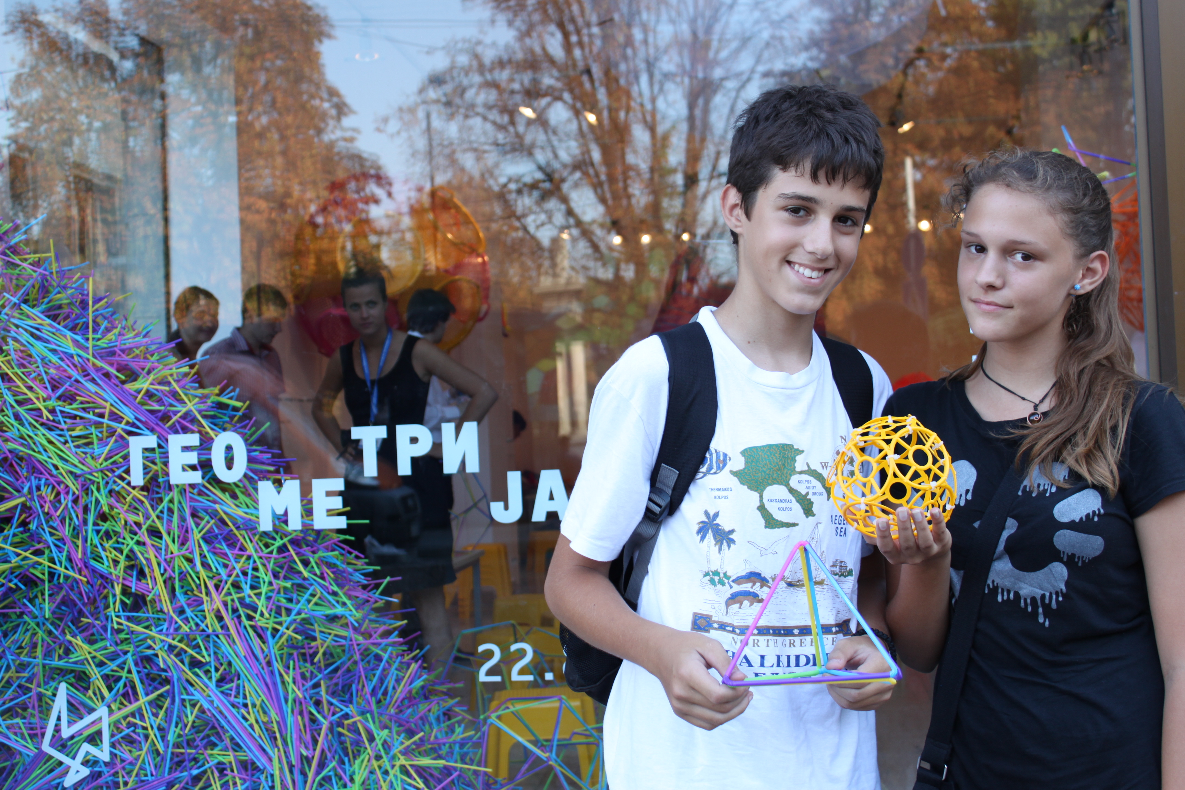
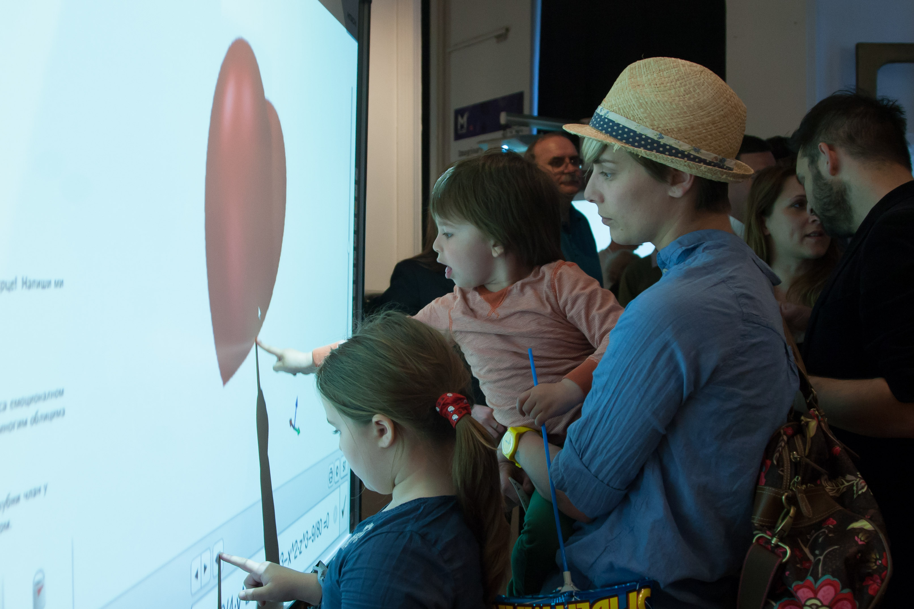
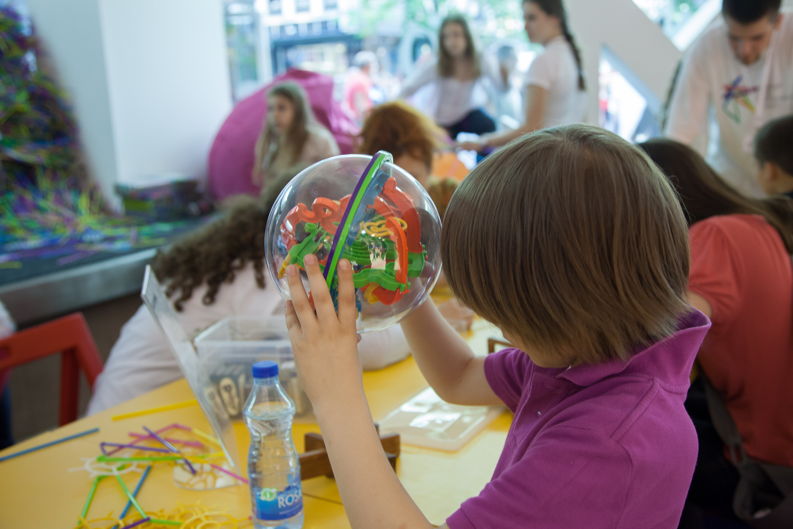

Assessment

Two kinds of evaluation being conducted during the previous M³ programs. First of all, all of the organized activities with an audience (such as workshops and lectures) are being evaluated right after the activity, using specific questionnaires. Further more, the overall impressions are evaluated by a questionnaire any participant can fill any time during their visit to any segment of M³ program. Also, the overall number of the participants is estimated.
What would be very useful, but so far out of our scope, is a research of the general population before and after the M3, to see if the general opinions of the mathematics as well as the number of students choosing mathematics as a career has changed. The positive fact confirming this is that the number of applications for the faculties of mathematics in Serbia is strongly rising for the last 3-4 years.

Possible Extension
Some segments prepared and produced under the auspices of M³ program were already presented at regional level, particularly in several neighboring countries like Croatia, Bosnia and Herzegovina, Macedonia and Montenegro. There was a wide interest for the use or visit of some elements by partners in Romania, Hungary and even Georgia. We strongly believe that basic ideas, concept and content in general or divided to segments have strong potential on international level.
In few occasions, ideas and content of M³ program were integrated into preparations of applications for different EU programs. Some of them, however, are still under consideration.

References

