D3.1.3 Inquiring the Ghost particles

Project Reference: | H2020-SEAC-2014-2015/H2020-SEAC-2014-1 , 665917 |  | Author: | Zacharoula Smyrnaiou, Menelaos Sotiriou, Evagelia Petropoulou, Zois Assimakopoulos, Vasiliki Grigoriou (NKUA)
Code: | D 3.1.3 |  | Contributors:
Version & Date: | V1, 25/5/2016 |  | Approved by:

Table of Contents
1 Introduction / Demonstrator Identity 6
1.1 Subject Domain 6
1.2 Type of Activity 6
1.3 Duration 6
1.4 Setting (formal / informal learning) 6
1.5 Effective Learning Environment 6
2 Rational of the Activity / Educational Approach 7
2.1 Challenge 7
2.2 Added Value 7
3 Learning Objectives 8
3.1 Domain specific objectives 8
3.2 General skills objectives 8
4 Demonstrator characteristics and Needs of Students 9
4.1 Aim of the demonstrator 9
4.2 Student needs addressed 9
5 Learning Activities & Effective Learning Environments 10
6 Additional Information 15
7 Assessment 16
8 Possible Extension 17
9 References 18

Introduction / Instructions
This part should be excluded from your FINAL Demonstrator
- Summary of the CREATIONS approach
As a result the CREATIONS approach is informed and grounded on three closely interrelated aspects: a) the CREATIONS features, b) the RRI principles and c) the IBSE principles.
CREATIONS Pedagogical Framework |  | IBSE
CREATIONS  features | RRI aspects | Essential features of IBSE | Effective learning environments
- Dialogue  - Interdisciplinarity  - Individual, collaborative and communal activities for change  - Balance and navigation  - Empowerment and agency  - Risk, immersion and play  - Possibilities  - Ethics and trusteeship | - Governance  - Public  - Science education engagement  - Gender equality  - Open access/open science  - Ethics  - Sustainability  - Social justice/inclusion | - QUESTION  - EVIDENCE  - ANALYSE  - EXPLAIN  - CONNECT  - COMMUNICATE  - REFLECT | - Communities of practice  - Simulations  - Arts-based  - Dialogic Space / argumentation  - Experimentation (Science laboratories and eScience applications)  - Visits to research centres (virtual/physical)  - Communication of scientific ideas to audience

Although the key aspects of the CREATIONS approach are presented in a tabular format, the process is in practice highly organic, enabling the dialogue among students, teachers, researchers, ICT media and creative representation, drawing on a range of personal and disciplinary knowledge to thread across and between these features

- The Demonstrators’ Generic Framework
The design of Demonstrators’ Generic Framework is mainly based on IBSE Best Practice of Pathway (Summer school, 2013), Scenario of Metafora EU project (e.g. 3d juggler (Smyrnaiou et al., 2012a; 2012b)) and Implementation Scenario of CREAT-IT EU project (such as Science Theatre Implementation Scenario, M. Sotiriou, 2015).
There are different ways to approach inquiry. Reflective inquiry seeks to draw attention on the coupling of metacognition and inquiry in the context of solving open-ended, ill-structured investigations in science (Kyza & Edelson, 2003). The Shimoda et al (2002)’s generic inquiry cycle is made explicit to students and is presented as a sequence of goals to be pursued. The Bruce & Bishop (2002) circle aims for students to learn how to learn and metacognitive skills, and stresses the need to engage children as active learners to collaborate and to understand the perspectives of others. Schwartz et al (1999) circle is implemented as a technology template to guide learners through case-, problem-, project-based learning. Although many versions of the inquiry cycle have been presented by various authors (de jong et al., 2002; Pedaste et al., 2015), the IBSE Best Practice of Pathway cycle was chosen as the most suitable for Creations. Besides this core cycle, there is a place for Question, Evidence, Analyse, Explain, Connect, Communicate and Reflect (figure 1). This circle stresses the need to engage children as little scientists, creative learners and science communicators.
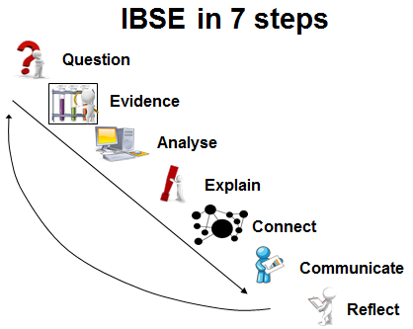
Figure 1: IBSE Best Practice of Pathway, Summer School, (Rosi, 2013)

The Demonstrators’ Generic Framework structures the description of the pedagogical intervention around what we called “Introduction” or “Demonstrator Identity” which includes information about the : author, subject domain, type of activity, duration, setting and effective learning environment. The second element of the structure is the “Rationale of the Activity/ Educational Approach” which focuses on: the teaching and learning problem (challenge) addressed by this demonstrator and the added value of using the Creation Project for implementing this demonstrator. Challenge-based learning builds on the successes of problem-based learning models where students engage in self-directed work scenarios (or “problems”) based in real life (Johnson, Laurence et al., 2009). By giving students the opportunity to focus on a challenge of global significance, challenge-based learning creates a space where students can direct their own research into real-world matters and think critically about how to apply what they learn (Smyrnaiou, et al., 2015; Johnson, Laurence et al., 2009). An example could be an art & science event (performance, paintings, etc.).
The third element of the structure involves the learning objectives which are divided to two categories which involve domain specific learning and general learning skills which is supported by the Creation Framework. The fourth element of the Demonstrators’ Generic Framework involves the “Demonstrator characteristics and Needs of Students” and aims at collecting information about the issues explored and the real needs of students. It is very important because the literature of Science Education offers important data concerning the students’ attitudes towards science and underlines the continuing decline of interest the young people show in pursuing scientific careers (S&M) in a way that threatens the future of Europe (ROSE, Osborne et al., 2003; Osborne & Dillon, 2008).
The fifth element provides information about the Sequence and description of the activities focusing on a detailed description of each activity and the effective learning environment (s) involved and the sixth additional information. Finally, some assessment suggestions are requested along with possible extensions and list of suggested sources/references. For example, inter-workgroup assessment: after performing a theatrical stage on / represents a scientific concept or cultural elements, the workgroups may exchange their ideas / performances/ representations and ask their peers to evaluate them. The criteria for the evaluation may be set collaboratively by the workgroups as they discuss in class /stage, etc.. Concerning the possible extensions, after having performed a theatrical stage on scientific concept or cultural elements putting into effect their own ideas, the students share their performance and ask the students of another team to perform on the same scientific concepts (or cultural elements). At this phase of the performance, the workgroups decide on the representation of scientific concept (or cultural elements) through embodiment (gestures, facial expressions, full body movements, sentiments), music, choreography, narration, or using digital tools or other objects.

Introduction / Demonstrator Identity

Subject Domain
Physics, Arts

Type of Activity
The specific activity is a combination of:
(a) School based and
(b) School – research centre collaboration

As it is developed the activity can be characterised as a Small scale Activity at a Local level

Duration
1 month

Setting (formal / informal learning)
Both formal and informal. The demonstrator involves classroom inquiry activities and virtual visits to CMS.
Formal and Informal learning settings
- Classroom
- Research center, art center (physical visit or virtual)
- The ‘Neutrino Microworld’ (logo-based)
- HYPATIA event analysis tool written by IASA
- Open Discovery Space portal (http://www.opendiscoveryspace.eu/community/greek-student-parliament-science-834221 - as a collaboration area) if several schools, national or international are involved.

Effective Learning Environment
- Simulations (digital/physical)
- Arts-based
- Visits to research centres (virtual/physical)
- Communication of scientific ideas to audience

Rational of the Activity / Educational Approach

Challenge
Student’s basic knowledge, concerning the way that the world is structured, begins, in a micro level, with basic concepts of molecules and atoms. Taking this as the starting point for our journey in the world of the subatomic particles, we aspire to introduce students to the most recent discoveries in the particle physics research – “The Ghost Particles, neutrinos”. The selection of this challenging topic is not guided only by the recent ‘2015 Nobel prize award in physics for the discovery of neutrinos’ oscillations’ but also for the still unsolved mysteries of their identity and all the potential scientific breakthroughs that their exploration, by next generation scientists, may induce.
The main goal of the specific demonstrator is to incorporate a series of activities which will allow us to create an engaging learning environment in classroom. Students will be given the opportunity to inquire and learn the history of particle physics from ancient history until present and acquire basic concepts and principles guiding the field of particle physics, beyond the school curriculum.
The demonstrator involves a set of interactive activities guided by the principles of IBSE approach that aspires to engage students in an authentic scientific discovery process. Students will be involved in the construction of a timeline regarding the history of particle physics, exploring and reflecting on the cultural aspects that prevailed in each era as well as the adopted way of scientific inquiry for each time period. Students will also be challenged to project the acquired knowledge and scientific concepts through dramatization activities by applying experiential modelisation techniques that enhance deep understanding of learning ‘objects’ (Smyrnaiou, et al., 2016; Smyrnaiou & Kynigos, 2012).
Students will have the opportunity to become part of the greatest scientific adventure in CERN and communicate with scientists through the ATLAS virtual visits. This way, they receive a tour of the control room, get answers to their questions but they also examine how professional researchers work in the field of particle physics. In addition, students will also be engaged in hands-on experimentation through interactive simulations and collaboratively perform realistic high energy physics data analysis, using the HYPATIA event display tool (Kourkoumelis & Vourakis, 2014) which uses data collected from the LHC running.
Finally, students’ understanding of the scientific concepts/theories under negotiation is projected through their engagement in creative artistic mediation such as role playing/dramatization, drawings of subatomic particles featuring their principles, posters, digital storytelling, short theatrical plays, etc.
Through these interactive activities we anticipate that students will be involved in an engaging learning environment in which complex scientific concepts will emerge in a way that additional pedagogical value will arise during the educational process.

Added Value
The Greek School curriculum in Physics addresses very basic concepts regarding particle physics, limited to the identification of the three subatomic particles; neutrons, protons, electrons. Students’ limited engagement in the field of particle physics not only deprives them of the most magical and challenging aspects of physics and current scientific research but it results in students having misconceptions about the fundamental aspects of the world and what it is made of. Students’ illiteracy in terms of basic aspects of the subatomic world also hinders their personal engagement in tracking and following scientific endeavors and breakthrough discoveries that are currently taking place in scientific centers such as CERN; a key element that would enhance their linking with science and society in a personal context.
The ‘Inquiring the Ghost Particle’ demonstrator applies the Inquiry Based Science Learning (IBSE) approach as an effective educational framework that aspires to engage students in an authentic scientific discovery process. Students’ engagement with scientific concepts/theories of the particle physics is grounded on the process of scientific reasoning and construction of scientific knowledge based on the ground premises of mental exploration, testing hypotheses, data collection and consequent discursive exploration and analysis. This way, students will manage to face their misconceptions and learning derives as the product of the cognitive interaction and conflict between intuitive learning and new cognitive schemas and ideas that are structured by challenging our intuitions while engaged in scientific inquiry situations (Smyrnaiou, & Evripidou, 2012). In their effort students will be supported by computer based models and simulations that contribute to the explanation and assimilation of demanding scientific concepts (Smyrnaiou, et al., 2012). Students’ engagement with the HYPATIA event display tool, negotiating realistic high energy physics data collected directly from the LHC running as well as students’ design of their own simulations projecting neutrino decays, facilitates and enhances students’ immersion in the scientific inquiry approach (Zacharia, 2003). According to Lemke (2009) ‘…to learn science is to learn how to have some degree of participation in this process of invention and discovery’.
A key element of this demonstrator is students’ creative manipulation of the acquired knowledge. Students’ engagement in role playing/dramatization is grounded on physical representation of transfer approach (Hung, et al., 2015) which directly connects physical movements and gestures with students’ perception and deep understanding of scientific concepts (Kynigos, Smyrnaiou & Roussou, 2010). In addition, students’ hands-on engagement with drawings and development of digital storytelling, addressing the underlying principles that guide the subatomic world, projects their perception and understanding of the newly acquired scientific concepts. The creative manipulation of scientific concepts enhances students’ deep reflection of the underlying principles/theories and sets a prolific ground for alternative thinking and connectivism with other domains. This way students are engaged in processes that bring into the foreground their own conceptualizations and ideas regarding scientific ideas.
In addition, the demonstrator has been realised through the implementation of the ‘Content and Language Integrated Learning’ (CLIL) approach with a main aim to highlight the communicative approach (dialogic approach, argumentation) adopted in foreign language teaching to enhance students’ inquiring and reflective process while collaboratively negotiating scientific concepts (Coyle, 2006; Lemke, 2009; Marsh, 2012). Furthermore, students had the opportunity to realise their inquiry by using and exploring first source material and acquire the scientific vocabulary that is currently used by the scientific community.

Learning Objectives

Domain specific objectives
The main aim of the ‘Inquiring the Ghost Particle’ demonstrator is to improve pupils’ enjoyment of and attainment in science via inquiry-based investigations. The demonstrator’s objective is to introduce students to the most recent discoveries in the field of particle physics research and enhance their development of inquiry skills by engaging them in reflective processes on the way of scientific inquiry throughout the history of particle physics. This is achieved by providing opportunities for students to engage in hands-on inquiry activities and communicate and discuss key scientific concepts and processes with experts in the field.

The ‘Inquiring the Ghost Particle’ demonstrator’s domain specific objectives are to engage/enhance students’:

- Inquiry process of scientific concepts
- Developing competences of critical / analytical thinking
- Experiencing scientific concepts and phenomena that are not visible on a macro level
- Access to most recent researchers’ work in particle physics
- Involvement in scientific data analysis
- Development of collaborative skills
- Understanding and involvement in the interaction of Science and Art

Towards attaining these objectives, peripheral aims are formed addressing students’ needs to:
- develop abilities necessary to do scientific inquiry
- develop understandings about scientific inquiry
- identify questions and concepts that guide scientific investigations
- use technology to improve investigations and understanding of scientific concepts
- recognize, analyze and imagine alternative explanations and models
- develop lifelong learning skills
- develop attitudes befitting a scientific ethos
- link with science and society in a personal context

General skills objectives
In the context of the ‘Inquiring the Ghost Particle’ demonstrator, the general skills objectives addressed are:
- Active participation in the negotiation of scientific concepts
- Develop creative and critical skills
- Understanding of scientific concepts and phenomena
- Scientific interconnection of science with aspects of art (students will design decay simulations in software, create drawings of elementary particles/neutrinos, perform short theatrical plays) which engages students in experiential modelisation and facilitates deep understanding of complex concepts/theories.
- Develop spirit of cooperation and teamwork
- Connect the science classroom with state-of the-art research and scientific community

More Specifically:
- Students will have the opportunity to approach basic principles and concepts of the subatomic world “The Standard Model Of Particle Physics”.
- Students will have the opportunity to explore the world of particle physics during their collaborative involvement with interactive computer based simulations and models.
- Students will examine how professional researchers work in the field of particle physics (virtual visits / video demonstrators).
- Students will attempt to approach science from a different perspective, through the combination of science and multiple aspects of art.

Demonstrator characteristics and Needs of Students

Aim of the demonstrator
The demonstrator’s main aim is to give the opportunity to high school students to learn about established principles regarding Particles Physics and learn about recent advances in physics research. The complex concepts that feature particle decays and subatomic structure will be presented to students through challenging and inquiry–based learning activities, such as interactive simulations and creative experimentations, artifacts and drawings, aiming to raise students’ interest in the process of physics-based discovery and strengthen their inquiry skills in pursuing knowledge in an autonomous way beyond the school curriculum.
The ‘Inquiring the Ghost Particle’ demonstrator has been applied to 1 public school, addressing junior high school students between 12 and 14 years old. Three teachers of different disciplines were involved in the realization of the demonstrator: (1) a physics teacher, responsible for guiding students, regarding scientific concepts and supervising the learning material, (2) a teacher of English for the realization of the CLIL approach, who guided students in their inquiry through first source material and (3) a teacher of Arts who provided students with drawing techniques to facilitate their effective attributing of their conceptual scientific ideas. The demonstrator was realized within four weeks -a two hour extra-curriculum lesson each week- and resulted with students’ presentations on the thematic area of the history of particle physics, the principles of neutrinos and the way current detectors work. In addition, students realized an artistic exhibition with their work of arts that projected their conceptions of the sub-atomic particles and their corresponding principles.
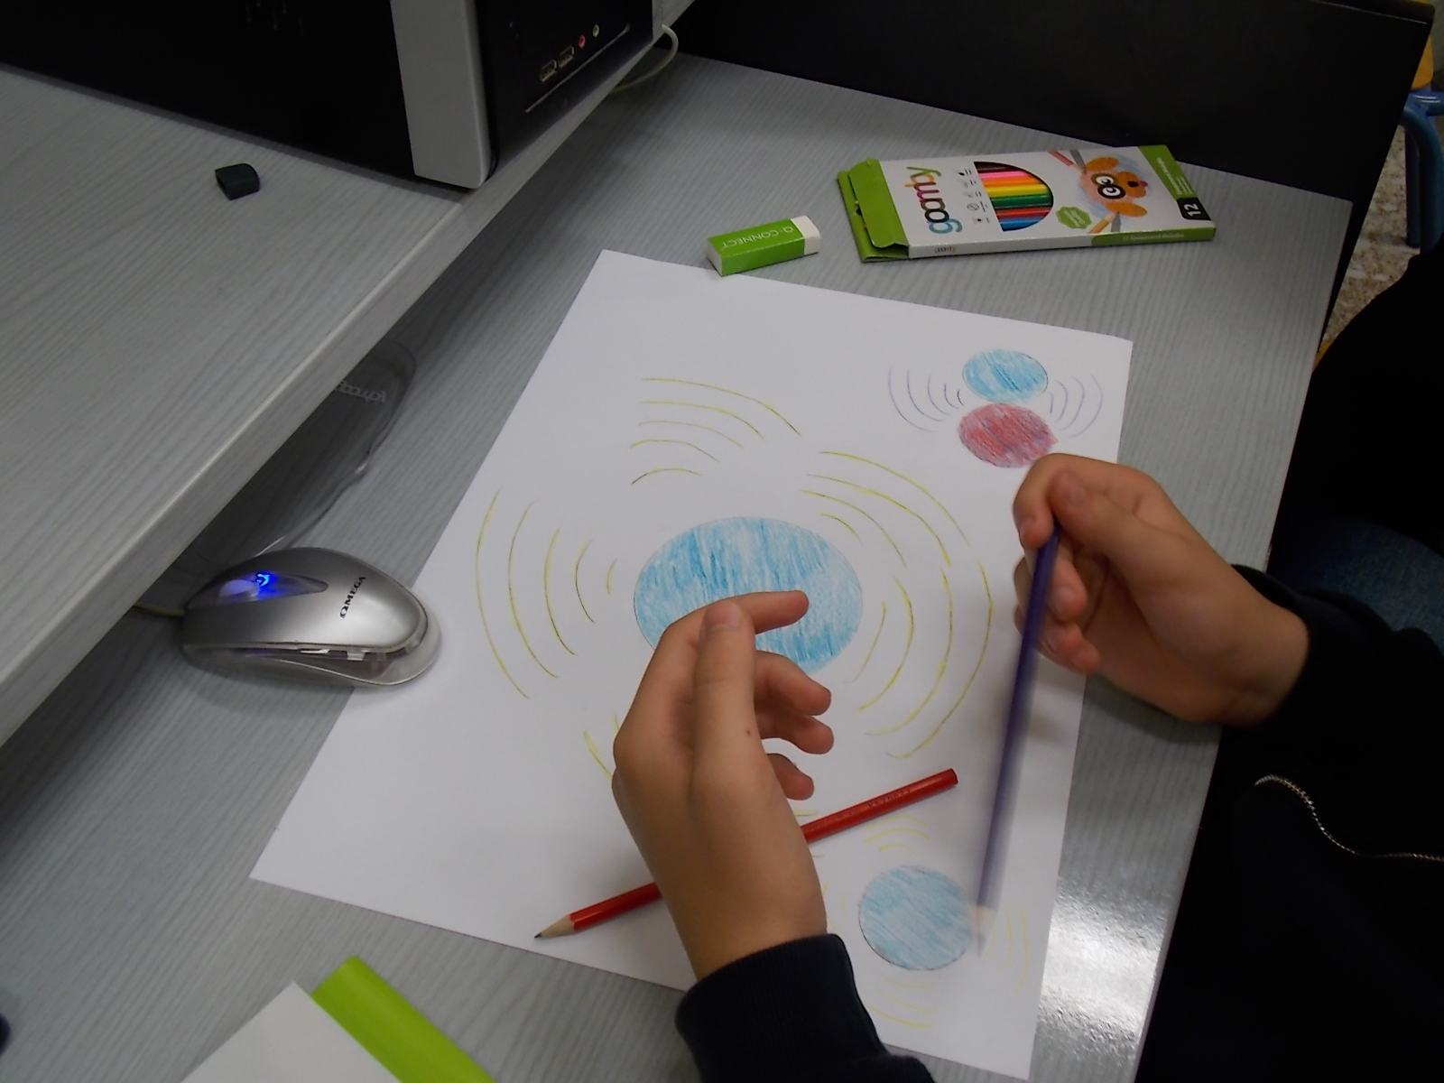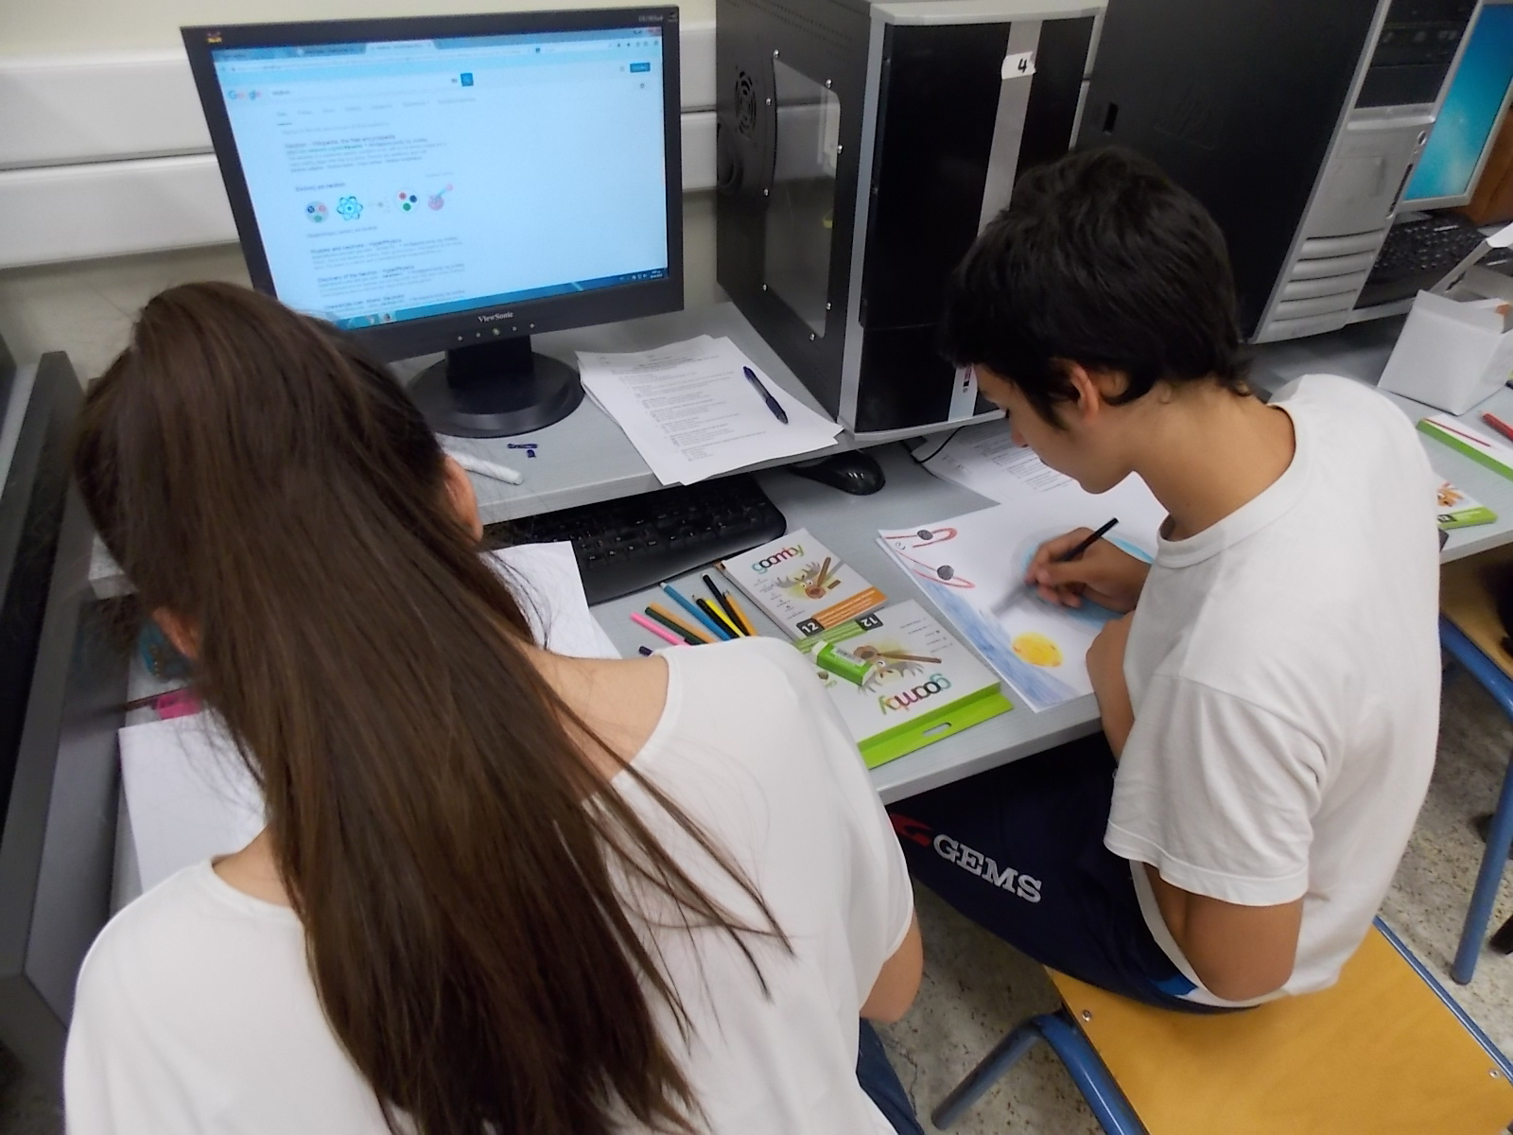
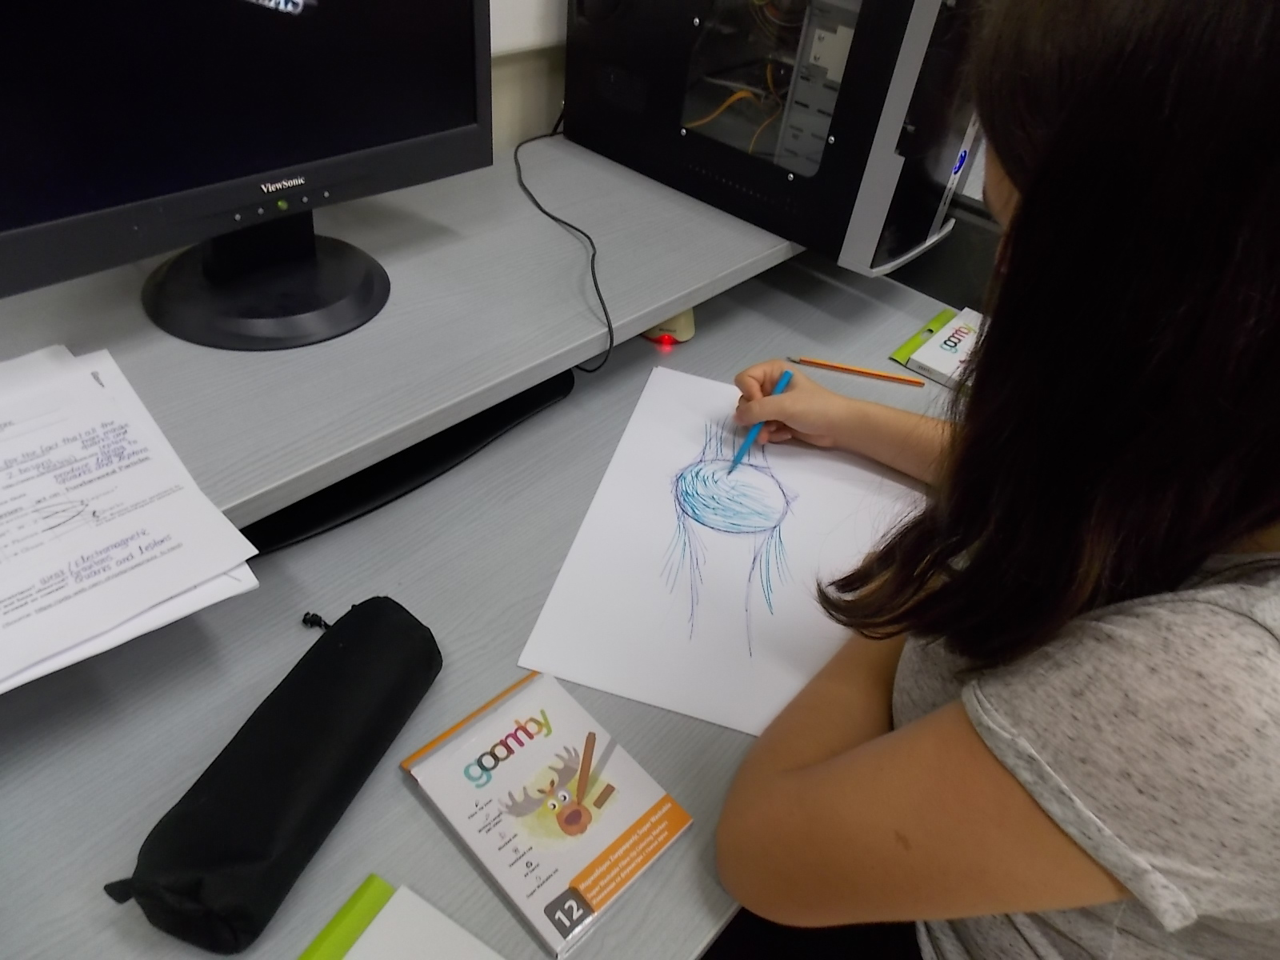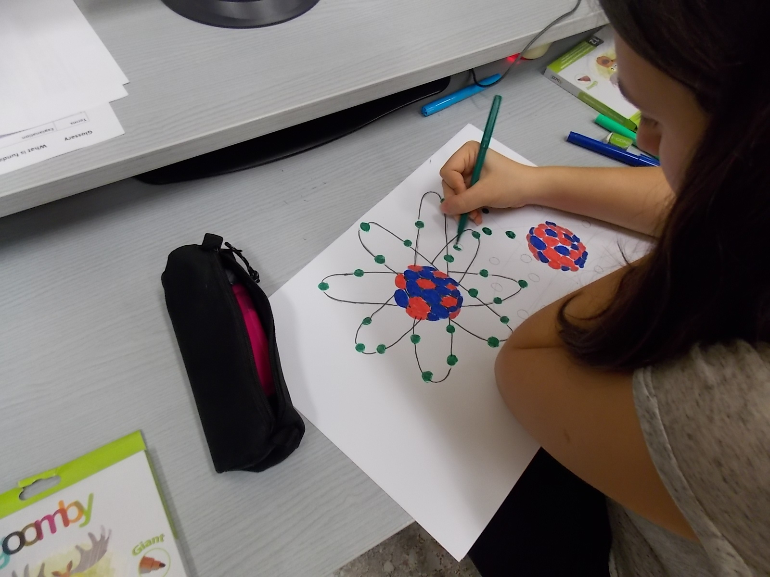

Student needs addressed
In the ‘Inquiring the Ghost Particle’ demonstrator the topic for negotiation was selected due to its challenging factor and its centrality to contemporary scientific issues and problems that need solving. It is applied as an extension to the curriculum of physics and provides students the opportunity to approach basic principles and concepts of the subatomic world. By immersing learners in active investigations of contemporary issues, and engaging them in collaborative discourse, they manage to constructively build on each other’s ideas and enhance their learning of scientific concepts. Having students motivated by and engaged in authentic problems that require solving and stimulate their creativity and critical thinking they become key players of the learning process.
Students act as scientists and naturally apply inquiry–based approaches to address the problem under negotiation. They develop research questions, identify, investigate and experiment on various solutions with the help of primary source materials. In addition, the demonstrator highlights the significance of interconnecting science, culture and creativity and enhances students’ reflection process on the scientific inquiry applied throughout the history of particles physics. A key element in the demonstrator is students’ linking of science and society in a personal context and their engagement in the creative manipulation of the acquired scientific knowledge.

Learning Activities & Effective Learning Environments

Science topic: Particle Physics- Art  (Relevance to national curriculum)  Extension to Greek Junior High School physics curriculum  Class information  Year Group: 1st – 3rd grade of Junior high school  Age range: 12-14  Sex: Mixed  Pupil Ability: Mixed eg (The scenario allows space for pupils of various abilities to participate) |  |  | Materials and Resources  What do you need? (eg.printed questionnaires, teleconference, etc.) PC labs  Where will the learning take place? On site or off site? In several spaces? (e.g. science laboratory, drama space etc), or one? The activities will take place in the classroom and there will be a communication with scientists through the ATLAS virtual visits.  Health and Safety implications? None  Technology? Computer and internet access  Teacher support? Scaffolding
Prior pupil knowledge
Basic concepts regarding particle physics; identification of the three subatomic particles: neutrons, protons, electrons

Individual session project objectives (What do you want pupils to know and understand by the end of the lesson?)
During this scenario, students will
Week 1: Brainstorming and Inquiry phase: Discuss and document their initial ideas about how the world around us (blocks of matter) is constructed. This brainstorming activity is followed by a short inquiry phase concerning subatomic particles. The initial activities are followed by a presentation of the standard model from Cern’s researchers, bridging the gap between high-school curriculum and modern physics research.
Week 2: Hands-on experimentation phase: At the end of this phase students have the opportunity to experiment with an interactive simulation relevant with the topics discussed earlier (elementary particles) which gives them the opportunity to compare, combine and make assessments related to the knowledge and the concepts they acquired through the process. The use of computer based simulations and half-baked microworlds will give the students the opportunity to examine scientific data and historical facts related to the discovery of neutrinos and particles decay process. The simulations are logo based or based on Flash or Unity to facilitate both students’ and teachers’ access to operational and programming functions and interventions that will be guided by the scientific issues under negotiation.
Week 3: Students’ simulation-based design phase & Virtual visits phase: Following this activity the students are encouraged (under the guidance of their tutor) to create their own simulation by using simple premade “blocks” of logo code. The students will also have the opportunity to take a remote tour at relevant main experiments at LHC (CMS and ATLAS) through Virtual Visits to their Control Centers and even to the underground cavities. Additional to the above they can watch a video related to WIPAC ‘S “Ice cube” infrastructures.
Week 4: Students’ artistic implementation of scientific concepts: Through the activities described above students will be encouraged to engage in multiple assignments that combine art and science (drawings, posters, comics and short theatrical plays, etc.). Their final works of arts are exhibited in their school’s main hall.
Assessment  Students’ deliverables |  | Differentiation  The ‘Inquiring the Ghost Particle’ approach is grounded on the respect for students’ needs and interests as a cornerstone for its successful realization. The selection of the topic and the exploration of relevant issues depend on students. During the inquiry phase all students will participate and contribute with relevant to their interest data. |  |  | Key Concepts and Terminology  Science terminology: subatomic particles, neutrinos, standard model  Arts terminology: drawing, dimension, shade, scale, video, digital storytelling, dramatization (role playing)
Session Objectives:
During this scenario, students will deepen their understanding on scientific concepts and phenomena regarding particle physics and the way of scientific inquiry and face their misconceptions

Learning activities in terms of CREATIONS Approach
IBSE Activity | Interaction with CREATIONs Features |  |  | Student |  | Teacher | Potential arts activity
Phase 1:  QUESTION: students investigate a scientifically oriented question | Students pose, select, or are given a scientifically oriented question to investigate. Balance and navigation through dialogue aids teachers and students in creatively navigating educational tensions, including between open and structured approaches to IBSE. Questions may arise through dialogue between students’ scientific knowledge and the scientific knowledge of professional scientists and science educators, or through dialogue with different ways of knowledge inspired by interdisciplinarity and personal, embodied learning. Ethics and trusteeship is an important consideration in experimental design and collaborative work, as well as in the initial choice of question. |  |  | - Build interest in the scientific issue  - engage with inquiry related to current scientific reserach  - use the web to explore and examine their initial ideas  - Understand science as a process not as stable facts |  | The teacher tries to attract students’ attention by eliciting students’ relevant questions or pinpoint unexplored areas to the topic under negotiation.  What is the universe made of?  Which are the fundamental particles?  How long have people been thinking about the fundamental particles? Which great discoveries/findings have led us to current knowledge? Which was the scientific method that characterized each era (in the history of particle physics)?  How many different types of matter particles exist?  What are the ‘anti-particles’? | What do we want to find out/now about these issues?  What do you know about these?
Phase 2:  EVIDENCE: students give priority to evidence | Students determine or are guided to evidence/data, which may come from individual, collaborative and communal activity such as practical work, or from sources such as data from professional scientific activity or from other contexts. Risk, immersion and play is crucial in empowering pupils to generate, question and discuss evidence. |  |  | - Plan and conduct simple investigation  - Collaborate to make a particle physics timeline  - Search evidence to define the scientific method of each era |  | The teacher identifies possible misconceptions. | Create drawings to illustrate the history of particle physics and identify milestones
Phase 3:  ANALYSE: students analyse evidence | Students analyse evidence, using dialogue with each other and the teacher to support their developing understanding. |  |  | Students engage in analysing data (organizing data, finding patterns, assessing data quality), interpreting data, making inferences, modeling, etc.). |  | Acts as a facilitator of the process | Introduce the debate topic, regarding the scientific way and what is currently accepted.  Can philosophical ideas be characterized as scientific method?
Phase 4:  EXPLAIN: students formulate an explanation based on evidence | Students use evidence they have generated and analysed to consider possibilities for explanations that are original to them. They use argumentation and dialogue to decide on the relative merits of the explanations they formulate, playing with ideas. |  |  | Each group of students evaluates its explanations in light of alternative explanations, particularly those reflecting scientific understanding. |  | Teacher divides students in groups. Each group of students formulates and evaluates explanations from evidence to address scientifically oriented questions. | Provide creative examples/models/drawings to strengthen their explanations.
Phase 5:  CONNECT: students connect explanations to scientific knowledge | Students connect their explanations with scientific knowledge, using different ways of thinking and knowing (‘knowing that’, ‘knowing how’, and ‘knowing this’) to relate their ideas to both disciplinary knowledge and to interdisciplinary knowledge to understand the origin of their ideas and reflect on the strength of their evidence and explanations in relation to the original question. |  |  | Students engage in hands-on experimentation with interactive simulations  They design their own decays and thest their hypotheses and previous explanations  Exploration of new areas according to students’ interests |  | Allows room and enhances connectivism with other disciplines | Creativity in identifying connectivism and providing possible solutions.
Phase 6:  COMMUNICATE: students communicate and justify explanation | Communication of possibilities, ideas and justifications through dialogue with other students, with science educators, and with professional scientists offer students the chance to test their new thinking and experience and be immersed in a key part of the scientific process. Such communication is crucial to an ethical approach to working scientifically. |  |  | Realize virtual visit with ATLAS and communicate with scientists. They ask questions and present their own understanding.  They engage in creating artistic drawings that project their conceptual understanding of the scientific concepts. |  | Acts as a facilitator of the process.  Assess pupil’s acquired knowledge. | Artistic projection of scientific concepts through role-playing, digital storytelling and drawings.
Phase 7:  REFLECT: students reflect on the inquiry process and their learning | Individual, collaborative and community-based reflective activity for change both consolidates learning and enables students and teachers to balance educational tensions such as that between open-ended inquiry learning and the curriculum and assessment requirements of education. |  |  | They reflect on their initial misconceptions and the way they were faced.  Discuss on current research findings and their impact on our lives.  Elaborate on other scientific issues of current interest that they would like to explore. |  | Highlights on the importance of an adopted way of scientific way.  Challenges students with questions on theoretical physicists and experimental physicists. | Why is the current way of scientific inquiry sustainable?  Students are invited to imagine the consequences in the case of unavailability of a common ground for scientific inquiry among the scientific community.

Additional Information
In the context of the ‘Inquiring the ghost Particle’ demonstrator, students are engaged in hand-on experimentation with computer-based simulations. The ‘Neutrino Microworld’ (logo-based) applied in this demonstrator is an interactive simulation, projecting ‘positron emission’ and a b-decay (See figure below). In this simulation students are provided with background information on the standard model and the subatomic particles and they are engaged in making hypothesis, observations in particles’ activity during particles decay process. Through this interactive simulation, learners have the opportunity to compare, combine and make assessments related to the knowledge and the concepts they acquired through the process. The representational aspect of the simulation contributes to the explanation and assimilation of demanding scientific concepts.

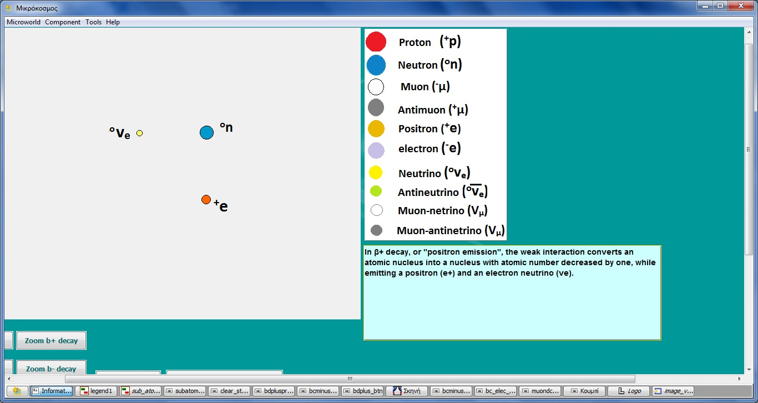

Besides the classroom activities, students will participate in the ATLAS virtual visits during which they will have the opportunity to communicate with scientists and examine how professional researchers work in the field of particle physics.
In addition, students may collaborate and communicate further their ideas with schools form other areas of the country or even aboard, through the Open Discovery Space Platform (ODS - http://www.opendiscoveryspace.eu/el/community/learning-science-through-theater-2-834218) which is an online platform where teachers and students have the opportunity to share their opinions and their educational resources.
Some suggested teaching/learning resources:
- https://www.youtube.com/watch?v=V0KjXsGRvoA Video CERN: ‘The Standard Model of Particle Physics’
- http://pdg.web.cern.ch/pdg/cpep/startstandard.html ‘The Adventure of particles’: Interactive Simulation
- https://www.youtube.com/watch?v=nlv06lSAC7c quarks
- https://www.youtube.com/watch?v=E99HuhaXO08 leptons
- https://www.youtube.com/watch?v=WzHSI-NlYUI -Announcement of the Nobel Prize in Physics 2015
- https://www.youtube.com/watch?v=nkydJXigkRE -Why neutrinos matter
- https://www.youtube.com/watch?v=m7QAaH0oFNg How you represent a neutrino
- https://www.youtube.com/watch?v=qgg4YUnLL3Y The Sun's Neutrino Heartbeat

Demonstrator’s resources
http://atlas-live-virtual-visit.web.cern.ch/atlas-live-virtual-visit/
https://wipac.wisc.edu/ghostparticle
http://etl.ppp.uoa.gr/_content/download/index_download_en.htmhttp://hypatia.phys.uoa.gr/
http://popplet.com/app/#/3092760
https://www.glogster.com/
https://animoto.com/

Assessment

Both quantitative and qualitative data are required to assess students’ and teachers’ cognitive and creative development through the implementation of the Demonstrator. For quantitative assessment we recommend the use of the ‘Science Motivation Questionnaire II (SMQ-II)’ (Glynn, et al., 2011; Maximiliane, Schumm, Bogner, 2016) that is addressed to students and the ‘VALNET’ questionnaire addressed to teachers.
In the context of the ‘Inquiring the Ghost Particle’ demonstrator, the students’ qualitative assessment process was evaluated through worksheets, collaborative design of artifacts and artistic drawings and final presentations of the scientific ideas under negotiations. In addition, to assess the effectiveness of the demonstrator with the implemented CLIL approach, there were used two questionnaires: (1) a pre-evaluation questionnaire and (2) a post evaluation questionnaire.

- Pre –evaluation questionnaire

Fundamentally Speaking
"What is the world made of?
What holds it together?"


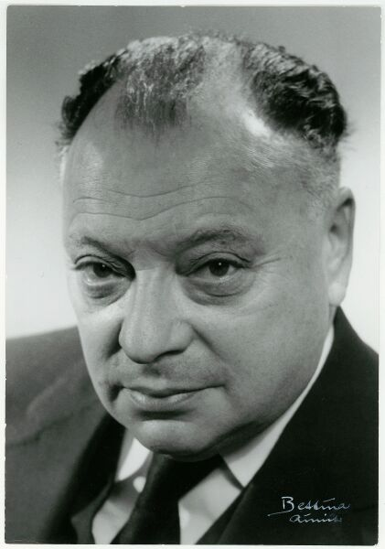

Democritus (460-370 B.C.) Wolfgang Ernst Pauli (1900 –1958)

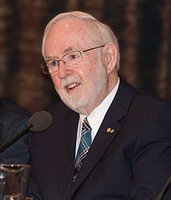
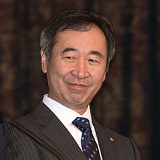

Takaaki Kajita (b.1959) Arthur Bruce McDonald (b.1943)

People have asked these questions for thousands of years. But only recently has a clear picture of the "building blocks" of our universe been developed. The scientists who have developed this picture work in an exciting and challenging field called high-energy particle physics. Their discoveries are summarized in the chart, Standard Model of Fundamental Particles and Interactions.
How much do you know about the latest theories and research on these ancient questions? You can find out by reading each of the statements below and placing a check mark in the proper box on the next page to indicate whether you agree or disagree.

- Knowledge testing

Challenges  Put a tick in the box of your choice and make sure you provide explanations. | Agree | Disagree
- There are subatomic particles that have no mass and no electric charge.
Explanation:

- Antimatter is science fiction and not science fact.
Explanation:
- The smallest components of the nucleus of an atom are protons and electrons.
Explanation:

- Gravity is the strongest of the fundamental forces of nature.
Explanation:

- Scientists never state a theory before it is proven.
Explanation:

- Gravitational forces are one of the accepted four fundamental forces of the universe.
Explanation:

- Another name for neutron is neutrino.
Explanation:

- Personal beliefs in scientific methodology

In the following table state the degree of agreement/disagreement with the following statements by placing a check mark in the proper box.

Statements | Totally agree  1 | Agree  2 | Disagree  3 | Totally disagree  4
- Inquiry is important in learning science
- Creativity is important in learning science
- Science can be combined with Arts
- Science can be combined with Philosophy
- Science can be combined only with the so called STEM subjects (science, technology, engineering, mathematics).
- Science must only be based on scientific evidence
- Scientists should not question previous scientific findings

- According to your opinion, which are the stages in scientific inquiry that a scientist should follow to reach scientific conclusions?
________________________________________________________________________________________________________________________________________________________________________________________________________________________________________________________________________________________________________________________________________________________________________

- Do you think there are any benefits by attending a science course in English? Explain your answer.
________________________________________________________________________________________________________________________________________________________________________________________________________________________________________________________________________________________________

- Post-Evaluation Questionnaire
Please state your personal beliefs, by putting a tick in the appropriate box. You may tick only one box for each statement.

a/a | Statement  Generally, I believe that the creative approach is  (1) a very efficient practice  (2) an efficient practice  (3) a little efficient practice  (4) no efficient practice  (5) I don’t know  Regarding: | 1 | 2 | 3 | 4 | 5
 | Learning Physics
1. | Inquiry of scientific concepts
2. | Communication of scientific concepts
3. | Making arguments based on evidence
 | The teaching process
4. | Lesson planning
5. | Activities
6. | Use of ICT
7. | Collaboration
8. | Creativity
 | Learning English as a foreign language
9. | Reading
10. | Listening
11. | Speaking
12 | Writing

13. | Please, state any other comments/recommendations you may have regarding the implemented activities.

Possible Extension
The key idea that is highlighted in the ‘Inquiring the Ghost Particle’ demonstrator is its main aim to facilitate and enhance students’ inquiry skills. It aims to challenge and capacitate students to explore in an autonomous way current scientific issues and scientific research, beyond the school curriculum; according to their interests. This way, students will gain an intrinsic interest in physics and be enabled to face possible misconceptions they may have. Therefore, the topic for negotiation may differ and change according to current scientific breakthroughs and students’ personal interests and queries.
Furthermore, the demonstrator has been realized as a small scale local activity. By encouraging teachers and students from other regions of the country or even from different countries to participate and collaborate in the inquiry of the same scientific issues, it could become a large scale international activity, where students from different countries communicate, exchange information, share their creative ideas and their own scientific understandings. In this case, it is highly recommended the use of the ‘Open Discovery Space portal’ (http://www.opendiscoveryspace.eu/community/greek-student-parliament-science-834221 as a collaboration area.

References

Hung, I-Chun , Hsu, Hsiu-Hao, Chen, Nian-Shing, Kinshuk. (2015). Communicating through body: a situated embodiment-based strategy with flag semaphore for procedural knowledge construction. Educational Technology Research and Development, 63, (5), pp 749-769.

Kourkoumelis, C. and Vourakis, S. (2014). HYPATIA-An online tool for ATLAS event visualization. Physics Education, 49,(1), pp 21-32 [Retrieved May 2016, available online at http://iopscience.iop.org/0031-9120/49/1/21/]

Kynigos, C., Smyrnaiou, Z., & Roussou, M. (2010, June). Exploring rules and underlying concepts while engaged with collaborative full-body games. In Proceedings of the 9th International Conference on Interaction Design and Children (pp. 222-225). ACM.

Lemke, J.L. (2009). Teaching All the Languages of Science: Words, Symbols, Images, and Actions. [Retrieved May 2016, available online at http://academic.brooklyn.cuny.edu/education/jlemke/papers/barcelon.htm]

Maximiliane F. Schumm & Franz X. Bogner (2016) Measuring adolescent
science motivation, International Journal of Science Education, 38:3, 434-449, DOI:
10.1080/09500693.2016.1147659

Smyrnaiou, Z., Kynigos, C. (2012). Interactive Movement and Talk in Generating Meanings from Science, IEEE Technical Committee on Learning Technology, Special Theme "Technology-Augmented Physical Educational Spaces" Hernández Leo, D. (Ed). Bulletin of the Technical Committee on Learning Technology, 14, (4), 17-20. [Retrieved May 2016, available online at http://www.ieeetclt.org/ content/bulletin-14-4].

Smyrnaiou, Z. & Evripidou, R. (2012). Learning to Learn Science Together with the Metafora tools. In Roser Pintó, Víctor López, Cristina Simarro, Proceedings of 10th International Conference on Computer Based Learning in Science in Science (CBLIS), Learning science in the society of computers, 26th to 29th June 2012, Barcelona, Catalonia/Spain, 132-139, 2012.

Smyrnaiou, Z., Moustaki, F., Yiannoutsou, N., & Kynigos, C. (2012). Interweaving meaning generation in science with learning to learn together processes using Web 2.0 tools. Themes in Science & Technology Education, 5(1/2), 27-42 [Retrieved May 2016, available online at http://earthlab.uoi.gr/theste/index.php/theste/article/view/105].

Smyrnaiou, Z., Sotiriou, M., Georgakopoulou E., Papadopoulou, E. (2016). Connecting Embodied Learning in educational practice to the realisation of science educational scenarios through performing arts, International Conference « Inspiring Science Education », Athens, 22-24 April 2016.

Zacharia, Z. (2003) Beliefs, attitudes and intentions of science teachers regarding the educational use of computer simulations and inquiry-based experiments in physics. Journal of Research in Science Teaching, 40 (8), 792-823.

2011 Shawn M. Glynn, University of Georgia, USA http://www.coe.uga.edu/smq/

