D3.1.x GSOrt (Global Science Opera in real time)

Project Reference: | H2020-SEAC-2014-  2015/H2020-SEAC-2014-1 ,  665917 |  | Author: | Petros Stergiopoulos
Code: | D 3.1.x |  | Contributors:
Version & Date: | V1.0, 27/05/2016 |  | Approved by:

Table of Contents
1 Introduction / Demonstrator Identity 6
1.1 Subject Domain 6
1.2 Type of Activity 6
1.3 Duration 6
1.4 Setting (formal / informal learning) 6
1.5 Effective Learning Environment 6
2 Rational of the Activity / Educational Approach 7
2.1 Challenge 7
2.2 Added Value 7
3 Learning Objectives 8
3.1 Domain specific objectives 8
3.2 General skills objectives 8
4 Demonstrator characteristics and Needs of Students 9
4.1 Aim of the demonstrator 9
4.2 Student needs addressed 9
5 Learning Activities & Effective Learning Environments 10
6 Additional Information 15
7 Assessment 16
8 Possible Extension 17
9 References 18

Introduction / Instructions
This part should be excluded from your FINAL Demonstrator
- Summary of the CREATIONS approach
As a result the CREATIONS approach is informed and grounded on three closely interrelated aspects: a) the CREATIONS features, b) the RRI principles and c) the IBSE principles.
CREATIONS Pedagogical Framework |  | IBSE
CREATIONS  features | RRI aspects | Essential features of IBSE | Effective learning environments
- Dialogue  - Interdisciplinarity  - Individual, collaborative and communal activities for change  - Balance and navigation  - Empowerment and agency  - Risk, immersion and play  - Possibilities  - Ethics and trusteeship | - Governance  - Public  - Science education engagement  - Gender equality  - Open access/open science  - Ethics  - Sustainability  - Social justice/inclusion | - QUESTION  - EVIDENCE  - ANALYSE  - EXPLAIN  - CONNECT  - COMMUNICATE  - REFLECT | - Teachers as tutors  - Individual journeys  - Use of modern tools in classroom  - Open Repositories of Resources  - Open access to eScience tools and infrastructure  - Curriculum and evaluation adequacy  - Communities and network

Although the key aspects of the CREATIONS approach are presented in a tabular format, the process is in practice highly organic, enabling the dialogue among students, teachers, researchers, ICT media and creative representation, drawing on a range of personal and disciplinary knowledge to thread across and between these features

- The Demonstrators’ Generic Framework
The design of Demonstrators’ Generic Framework is mainly based on IBSE Best Practice of Pathway (Summer school, 2013), Scenario of Metafora EU project (e.g. 3d juggler (Smyrnaiou et al., 2012a; 2012b)) and Implementation Scenario of CREAT-IT EU project (such as Science Theatre Implementation Scenario, M. Sotiriou, 2015).
There are different ways to approach inquiry. Reflective inquiry seeks to draw attention on the coupling of metacognition and inquiry in the context of solving open-ended, ill-structured investigations in science (Kyza & Edelson, 2003). The Shimoda et al (2002)’s generic inquiry cycle is made explicit to students and is presented as a sequence of goals to be pursued. The Bruce & Bishop (2002) circle aims for students to learn how to learn and metacognitive skills, and stresses the need to engage children as active learners to collaborate and to understand the perspectives of others. Schwartz et al (1999) circle is implemented as a technology template to guide learners through case-, problem-, project-based learning. Although many versions of the inquiry cycle have been presented by various authors (de jong et al., 2002; Pedaste et al., 2015), the IBSE Best Practice of Pathway cycle was chosen as the most suitable for Creations. Besides this core cycle, there is a place for Question, Evidence, Analyse, Explain, Connect, Communicate and Reflect (figure 1). This circle stresses the need to engage children as little scientists, creative learners and science communicators.
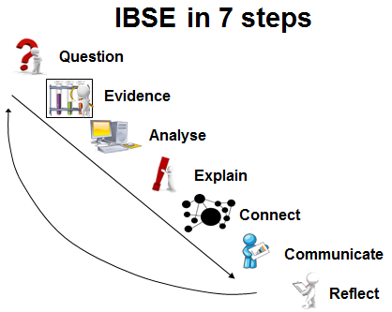
Figure 1: IBSE Best Practice of Pathway, Summer School, (Rosi, 2013)

The Demonstrators’ Generic Framework structures the description of the pedagogical intervention around what we called “Introduction” or “Demonstrator Identity” which includes information about the : author, subject domain, type of activity, duration, setting and effective learning environment. The second element of the structure is the “Rationale of the Activity/ Educational Approach” which focuses on: the teaching and learning problem (challenge) addressed by this demonstrator and the added value of using the Creation Project for implementing this demonstrator. Challenge-based learning builds on the successes of problem-based learning models where students engage in self-directed work scenarios (or “problems”) based in real life (Johnson, Laurence et al., 2009). By giving students the opportunity to focus on a challenge of global significance, challenge-based learning creates a space where students can direct their own research into real-world matters and think critically about how to apply what they learn (Smyrnaiou, et al., 2015; Johnson, Laurence et al., 2009). An example could be an art & science event (performance, paintings, etc.).
The third element of the structure involves the learning objectives which are divided to two categories which involve domain specific learning and general learning skills which is supported by the Creation Framework. The fourth element of the Demonstrators’ Generic Framework involves the “Demonstrator characteristics and Needs of Students” and aims at collecting information about the issues explored and the real needs of students. It is very important because the literature of Science Education offers important data concerning the students’ attitudes towards science and underlines the continuing decline of interest the young people show in pursuing scientific careers (S&M) in a way that threatens the future of Europe (ROSE, Osborne et al., 2003; Osborne & Dillon, 2008).
The fifth element provides information about the Sequence and description of the activities focusing on a detailed description of each activity and the effective learning environment (s) involved and the sixth additional information. Finally, some assessment suggestions are requested along with possible extensions and list of suggested sources/references. For example, inter-workgroup assessment: after performing a theatrical stage on / represents a scientific concept or cultural elements, the workgroups may exchange their ideas / performances/ representations and ask their peers to evaluate them. The criteria for the evaluation may be set collaboratively by the workgroups as they discuss in class /stage, etc.. Concerning the possible extensions, after having performed a theatrical stage on scientific concept or cultural elements putting into effect their own ideas, the students share their performance and ask the students of another team to perform on the same scientific concepts (or cultural elements). At this phase of the performance, the workgroups decide on the representation of scientific concept (or cultural elements) through embodiment (gestures, facial expressions, full body movements, sentiments), music, choreography, narration, or using digital tools or other objects.

Introduction / Demonstrator Identity

Subject Domain
Physics, Mathematics

Type of Activity
Performance

Duration
3-6 months

Setting (formal / informal learning)
➢ School Based with ICT & teleconference support
➢ School- Art@CMS / CERN collaboration

Effective Learning Environment
Communities of practice (both web-based & physical)
Arts-based
Communication of scientific ideas to audience
Dialogic space/argumentation (school based)

Rational of the Activity / Educational Approach

Challenge
To approach scientific concepts through performance arts and body-motivating activities.
The objective is to produce an online live (or recorded) interactive, audiovisual, artistic event with multiple distant schools linked together via videoconference. A GSOrt event is the result of collaborative preparation, co-creation and realization of a live-performance sympraxis, with an emphasis in Music.

The GSOrt demonstrator will also have the task of initializing educational communities into the idea of “sonification” for educational purposes that is the challenge of explaining a scientific concept through sound.
The approach that the demonstrator adapts towards this task is threefold.
- Symbolic (the connection between sounds/music in comparison with the scientific concept is purely artistic)
- Mathematic (the connection between science and the Arts is directly reflected in pure mathematics)
- Adaptive (which is a combination of the above)
The symbolic way of sonification in an educational setting we can say that fully rely on the creativity of teachers who encourage students to approach imaginative ways to convert ideas into sounds. Using basic concepts of the musical phenomenon as pitch (or even noise),notes (tone frequencies), note durations, Time signature (or other rhythmic or measure attributes), teachers guide the students to create sound designs, or musical pieces, expressing the required concepts.
The mathematical approach is associated with the direct sonification of data. Here the teacher explains the correlations between arithmetic or mathematical figures and the behavior of data flow (the parameters) of a scientific concept. Usually this method employs mathematical applications that can be associated with live coding, giving data conversions to audio directly via a computer application.

The adaptive approach is the combination of the two above methods. In the adaptive approach the teacher has the opportunity to choose how sonification can assist him/her depending both on the teaching needs and the learning environment. In this way purely mathematical approaches can be combined with creative solutions coming directly from a performance arts setting.

Added Value
Developing a network of teachers online channels sharing multicast-activities inspired by science on national or international level through the “Let Us Share The Music” practice.
“Let Us Share The Music” is a multiple-site-link scenario in which all participants (remote sites) collaborate with each other in order to create and perform a music web event. “Let Us Share The Music” was the title of the demonstration-scenario that was carried out successfully during the 5th Educational Conference “School of Tomorrow (http://www.ea.gr/ep/schooloftomorrow/main.html).The scenario of this action is selected and registered as "good-practice" by the Greek Pedagogical Institute as part of the Major Teacher's Traning Programm.
Working in parallel to this approach, the demonstrator aims to enhance special music tuition from a distance to places where music education is scarce or impossible. Workshop is addressed to teachers with prior experience in multiple-site videoconferences who are interested in hosting cultural events prepared by remote educational communities.

Learning Objectives

Domain specific objectives
GSOrt demonstrator aims to produce an advanced interactive scene of the Global Science Opera. The main objective is to motivate rural and remote schools to collaborate in all aspects of the development according to the GSO guidelines (developing sound contributions, stage performances, sets, music sound/music recordings, dialogues etc). Remote schools collaborate through online videoconference. Teachers develop materials that are part of the sequence of screens whch form the final scene.
Teachers produce an outline of the characteristics of the web event including the introduction of the participants, the goals, the nature of the event and the main aspects of interaction are compiled by the organizer. All participant-sites, or their main representatives (Alpha contacts), are invited to agree or adapt this outline according to their fundamental educational needs. Actual broadcasting venues or rooms involved in the multicast are defined and examined. A time schedule is arranged with milestones and objectives for all the rest of the phases according to WASO or ST case studies.

General skills objectives
-To understand scientific concepts through body-motivating activities.
-To understand scientific concepts through the sonification of the details needed to describe them

Demonstrator characteristics and Needs of Students

Aim of the demonstrator

The aim of the demonstrator is to motivate remote schools to collaborate through video-conference in order to produce audiovisual and performance-practice content for the development of a Global Science Opera Scene. The main aim is to engage rural schools in this process in national or international level.

Student needs addressed
Students collaborate in teams in order to produce audiovisual content that is directly related to the Global Science Opera libretto. The audiovisual content is put together in order to form the corresponding scene of the Opera.

Learning Activities & Effective Learning Environments

Science topic: Particle Physics  (Relevance to national curriculum) Primary and Secondary Education  Class information  Year Group: 4-6 grade Primary, 1st – 3rd grade of Junior high school and 1st-2nd grade of Senior High School  Age range: 10-16  Sex: both  Pupil Ability: mixed (The scenario allows space for pupils of various abilities to participate). Pupils with music background in secondary levels are encouraged to produce material or participate in activities that motivate their fellow students. |  |  | Materials and Resources  Optional material: musical instruments, percussion, drawing material.  Where will the learning take place? On site or off site? In several spaces? (e.g. science laboratory, drama space etc), or one? Activities are open to take place any where that the teacher wants. School theatres are preferred. Video or sound recordings can be done inside or outside the classroom. The final performance (either for filming or live purposes) can take place in the school theatre.  Health and Safety implications? none  Technology? Computer with external webcamera. External microphone. Internet Connection. Handycam.  Teacher support? scaffolding
Prior pupil knowledge
Though not necessary: pupils with music background in secondary levels are encouraged to produce material or participate in activities that motivate their fellow students.
Individual session project objectives (What do you want pupils to know and understand by the end of the lesson?)
During this scenario, students will:
(Numbers of sessions correspond to videoconference meetings with teachers or students or both).

(1-5 sessions)
Be introduced in the idea of sharing an interactive sequence of events with remote participants. Scientific awareness is not only a matter of discussion within a classroom but also an engaging activity that can be shared between multiple student-communities.

(1-3 sessions)
Be introduced into the planning of a distributed event the same way scientists exchange knowledge without boundaries. Part of one’s team preparation or solving a quest bringing a scientific element to light, is cruscial not only for the people who produce it but also for any another team far away. Sharing knowledge through a collaborative activity could be a result of collaboration between scientifically aware members of a community the very same way as performers share stage or music.

(1-7 sessions)
Be introduced into the idea of using a performance experiment as an inspiring activity for gaining scientific knowledge. The steps for making a performance “sympraxis” are similar to the steps that guide scientists toward knowledge

(1-2 sessions)

Understand that scientific concepts are proved as evidence of human knowledge available to the human kind. This kind of unique sharing is needed and awarded by the society much like people cherish the arts as part of being human. The reflection of a scientific achievement upon all people is open and free to be criticized. Scientists build and evolve ideas and concepts in similar way artists depend upon the previous knowledge and cultural heritage in order to go further.

Assessment  Students enhance their creativity by putting scientific knowledge within the concept of Music and Visual performance. |  | Differentiation  How can the activities be adapted to the needs of individual pupils?  GSOrt demonstrator is developed upon the idea of bottom-up initiative where rural and remote schools play the cruscial role in sharing student-centered activities outside region-boundaries. The needs of remote school are put in front. |  | Key Concepts and Terminology  Science terminology: Mathematics, Particle physics, Particle detectors.  Arts terminology: Music, Stage performance, Sonification, Interactive performance, Paintings, Libretto, Operatic scenes, Operatic Recitativo.
Session Objectives:
During this scenario, students will

Learning activities in terms of CREATIONS Approach
IBSE Activity | Interaction with CREATIONs Features |  |  |  | Student | Teacher | Potential arts activity
Phase 1:  QUESTION: students investigate a scientifically oriented question | Students pose, select, or are given a scientifically oriented question to investigate. Balance and navigation through dialogue aids teachers and students in creatively navigating educational tensions, including between open and structured approaches to IBSE. Questions may arise through dialogue between students’ scientific knowledge and the scientific knowledge of professional scientists and science educators, or through dialogue with different ways of knowledge inspired by interdisciplinarity and personal, embodied learning. Ethics and trusteeship is an important consideration in experimental design and collaborative work, as well as in the initial choice of question. |  |  |  | Students are introduced to the idea of participating in an online interactive event with distant communities. The theme of the scene along with the roles of each site, combined with the corresponding educational needs and target group, are taken in account in order for the teachers to introduce IBSE | Teachers prepare a draft of the interactive scene by mutually agree on their roles of performance and contribution. This includes a summary of the scene, the characters, and the distribution of action among the participants according to the needs. Preparation of material (such as sets, costumes, scene-pictures, videos, sounds, music, etc) is defined during this phase and arranged according to time-schedule. | Drafting upon the main characteristics of the event such as stage sets, costumes, movements, voices, musical motivos,
Phase 2:  EVIDENCE: students give priority to evidence | Students determine or are guided to evidence/data, which may come from individual, collaborative and communal activity such as practical work, or from sources such as data from professional scientific activity or from other contexts. Risk, immersion and play is crucial in empowering pupils to generate, question and discuss evidence. |  |  |  | Active Investigation. (Script/directing group: Investigate characters and generate ideas for dialogues/actions, |  | Actor group: Investigate characters and work on performance in collaboration with script/directing group, Music group: Generate musical ideas which correspond to the script, Dance group: After consulting with script/directing, actor and music groups, generate choreography ideas to incorporate in the play, Set/costumes group: Generate ideas after consulting script group and collect materials, Video group: Generate ideas after consulting script group and collect or create video clips.)  This phase may also allow the use of the teleconference "virtual stage" as shared environment between sites if necessary.
Phase 3:  ANALYSE: students analyse evidence | Students analyse evidence, using dialogue with each other and the teacher to support their developing understanding. |  |  |  | Students are assigned the preparation of the scene-content and the local rehearsals, according to the above phase. They create an environment of inquiry based learning through the analysis of the scientific ant artistic elements given. Each role or dramatized collaboration represents the common place of understanding between themselves, the scientific concept and the teachers.  The virtual stage environment is available for online rehearsals if necessary. | Teachers guide the students in gathering the necessary evidence and write about their characteristics. | Students experiment with sounds that can be used and recorded. The use of objects to produce sound is cruscial.
Phase 4:  EXPLAIN: students formulate an explanation based on evidence | Students use evidence they have generated and analysed to consider possibilities for explanations that are original to them. They use argumentation and dialogue to decide on the relative merits of the explanations they formulate, playing with ideas. |  |  |  | Remote students are introduced online and perform their roles at the scene according to the Link Scenario.  Students rehearse their activities after discussing about the content with their teachers. Direction and movement are settled. | Teacher reads the explanations of students (or teams) in the classroom improving the concept according to science-teaching goals | Remote teams are explaining particle motion through body and sound engagement. Recitativos, arias or plain crosstalk are the basic tools.
Phase 5:  CONNECT: students connect explanations to scientific knowledge | Students connect their explanations with scientific knowledge, using different ways of thinking and knowing (‘knowing that’, ‘knowing how’, and ‘knowing this’) to relate their ideas to both disciplinary knowledge and to interdisciplinary knowledge to understand the origin of their ideas and reflect on the strength of their evidence and explanations in relation to the original question. |  |  |  | Students repeat their rehearsals. | Teacher help to find drama elements that support scientific knowledge. For this task they exploit movement, audio triggered activity or visual response.
Phase 6:  COMMUNICATE: students communicate and justify explanation | Communication of possibilities, ideas and justifications through dialogue with other students, with science educators, and with professional scientists offer students the chance to test their new thinking and experience and be immersed in a key part of the scientific process. Such communication is crucial to an ethical approach to working scientifically. |  |  |  | Students discuss with their teacher elements of the other team's actions according to the scenario, and they ideas for improving their own roles/actions (or others') to support the scene. | Teacher conducts the exploitation of possibilities either using discussion within the classroom or outdoor activities and stimuli such as virtual visits at CERN or dialogues with scientists. | The event is video recorded.
Phase 7:  REFLECT: students reflect on the inquiry process and their learning | Individual, collaborative and community-based reflective activity for change both consolidates learning and enables students and teachers to balance educational tensions such as that between open-ended inquiry learning and the curriculum and assessment requirements of education. |  |  |  | Students write down a sequence of activities needed to produce the scene. | Teachers discuss with their students offline in seperate session. A collaboration-blog with the online material is built with potential open-discussion forum for further projects in the future.

Additional Information
Each member of the GSOrt community is encouraged to use teleconference GUI environment as a tool for online audiovisual performance practice. Video, pictures and audio material can be part of a sequence of screens that support the libretto. Virtual presentations support the flow of the scene based upon the mutually agreed sequence of events. Teachers are introduced in all possible kinds of interaction between the remote educational communities that contribute to the effort and the teleconference platform. GSOrt demonstrator uses an Adobe Connect Pro meeting room used as virtual stage. (“Dolphin” is the name used currently and "Skystage" is the name used by GSO). It is the virtual meeting point that serves as a "stage" in which both the virtual rehearsals and the final events take place. It is different from Skype and Google Hangouts in terms of screen manipulation and content management which is a feature that can be useful in this effort.

“Alpha contacts”-Hosts in GSOrt
A “host” of a videoconference meeting is considered an “Alpha contact” in the GSO community. GSOrt demonstrator aims to qualify Alpha contacts in running their own independent multicast channels that support interaction between multiple remote participants. Using Skystage as an Alpha contact can include more features than just activating Camera & Voice but this kind of usage will be determined for each one of the participants according to their technical capacities, availability and will.
All contributing communities have at least one teacher that represent them (similar to the Alpha contacts in GSO). Members are free to use Skystage in rehearsal mode whenever they want. Skystage can serve as a meeting point where you can exchange ideas, share word documents in double-zip (zip file containing another zip file with the document), share your screen, share jpeg, ppt, pdf, flv and mp3 with other Alphas in real time (the same way you do it in other teleconference platforms). Files can remain on Skystage for other Alphas to see and you can remove files you consider unnecessary. Skystage can be used freely anytime but, as the activity goes by, a timetable for scheduled rehearsals must be announced.

“Skysets”?
The virtual scenery of sets for Skystage are windows ("pods" is the right term but), let's call them "skysets". Apart from other virtual stage aspects, skysets can be classified in terms of bandwidth consumption from "light" to "heavy" as follows:
Chat (skyboard), Image, Voice, Powerpoint, Camera & Voice

(For “image” and “powerpoint” classification depends on the file size of course. Don’t forget that Skystage is a live broadcasting environment and files shared in the "share skyset" are distributed to all participants in real time. The lower file size the better).
As an Alpha contact you are able to use Skystage for performance from the moment you enter. You have the right - “by default”- of magnifying and restoring the size of skysets at will. This means that apart from being able to activate either your Camera & Voice, or just the voice from the Talk button below the screen, you are also able to use the maximize button of any skyset. If you click at the maximize button, skyset maximizes. If you click it again skyset restores itself to its prefixed size. This feature can personalize the participation of each Alpha on stage, especially when used on a powerpoint slide or an image. In this way interaction is not limited to the low resolution of the webcamera.
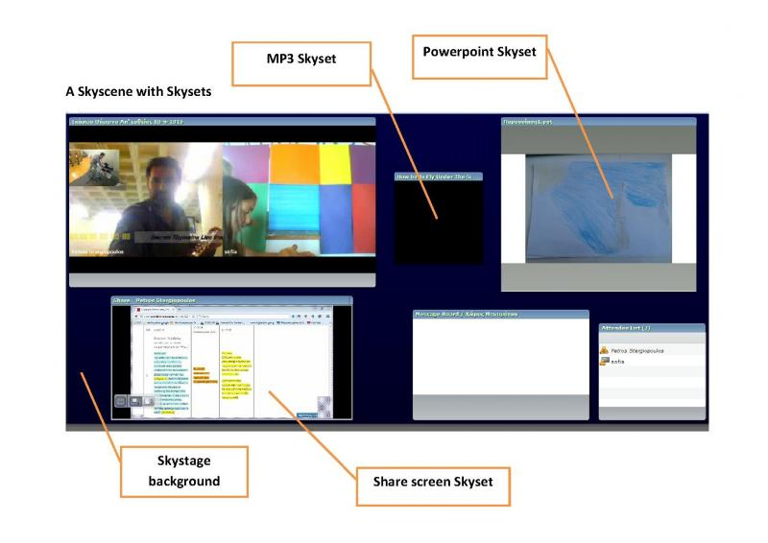

Skyset manipulation affects Skystage and all participants directly in real time. This means that what you see in your screen is what everybody sees in theirs. A skyset is responsive to all of us in real time so two Alphas must agree on its use just as if they were “touching” the same real object in the same real stage. So if you have one or more skysets (pods) in a layout (skyscene) then every Alpha contact can maximize or restore them at will by default. That means that skyset manipulation is common to everybody by default. This feature, which affects skystage as a whole, is activated by default but can be deactivated from the skyset's settings.

Powerpoints as “skysets”
Each Alpha contact can upload a 1- 5 slide powerpoint with images (or words or links or all of them) to support or accompany the performance directly on Skystage. As a suggestion the powerpoint can show: images from the preparation of the event, an experiment related to the event, a link to a page, an image used as scenery, an image used as a reference to what we see and hear. The powerpoint skyset is used to support the scene prepared.

Videos as “skysets”
Skystage can support the live synchronized video performance, providing that all participants are linked with sufficient bandwidth. Final video skysets are submitted and uploaded on Skystage prior to a rehearsal. A combination of skysets is actual a screen-layout, let's call it: a "Skyscene"

Skystage is a multiple-screen-layout environment. Different compilations of skysets will be arranged in different layouts (screens as scenes), called “Skyscenes”. This works just like preparing “scenes” on a play. A skyscene is a saved compilation of skysets including the “Camera and Voice”, the “skyboard” and the “Powerpoint” skysets. Skyset-sizes are prefixed by host but they can change during the rehearsals.

Skystage will include two kinds of Skyscenes: draft and final
A draft skyscene is prepared for rehearsals. Except from the above skysets, a draft skyscene contains also an attendee list pod (so that everybody sees who is present) and a file share pod (for uploading and downloading material). Skystage is now on rehearsal mode so the skyscene which is now active is a draft skyscene. Skyset sizes can change upon request to the host and a draft skyscene is subject to change any time.
A final skyscene contains the fixed locked size of “Camera and Voice”, the “skyboard”, the “Powerpoint” skyset with its final .ppt content and any other skyset requested during rehearsals. Each country will have its own Final skyscene on Skystage.
The sequence of the final skyscenes is managed by the host according to a Link Scenario which is the sequence of skyscenes derived from the WASO libretto and the scenes of the Opera. It is useful for the hosts but it will also be useful for everyone who wants to understand the "skystage" activity or "technical" profile of the libretto.

Levels of interactivity
Depending on circumstances and capabillities the levels of interactivity describe three possible situations of interaction with skystage: High, Medium and Low. High and Medium levels are synchronous.

(1) High (synchronous)
Advanced interactivity includes a powerpoint or video presentation which will be broadcasted live assisting a live audiovisual event. The final version of the powerpoint presentation will be based upon the Skylight powerpoint protype and it will be uploaded to Skystage prior to the rehearsals. The ppt will be consisting of 5 or even more slides. These slides will serve as background or side-images of the main skyscene. A change of the dimensions or number of skysets on a skyscene can also be requested to the host by the Alpha contact.
A second Alpha contact could be engaged to react on the scene, upon a certain scenario. This means that a skyscene can interact with another skyscene from another Alpha contact. An action, a movement, a sound, literally any event can trigger response upon another skyscene can be adapted as audiovisual communication or response between two or more Alpha contacts (e.g. a divided melody between two Alphas, an experiment taking place in two or more different locations, etc.).
Two or more Alpha contacts can also prepare and rehearse a common skyscene or multiple skyscenes according to the scenario. Audiovisual response between them can be the basic means of interaction but, literally, pure imagination is the limit.

(2) Medium (synchronous)
Medium interactivity may include one powerpoint presentation up to five slides and an audio or audiovisual event. These slides will serve as background or side images of the main skyscene as described above.

(3) Low (asynchronous)
Low interactivity includes a video/audio or powerpoint skyset uploaded to skystage and the possibility of participating with chat. No live online event will be prepared.
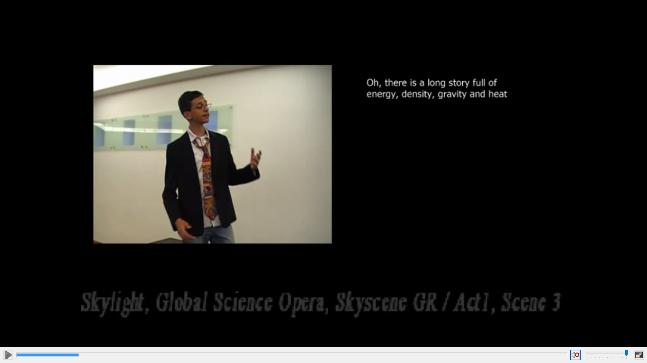

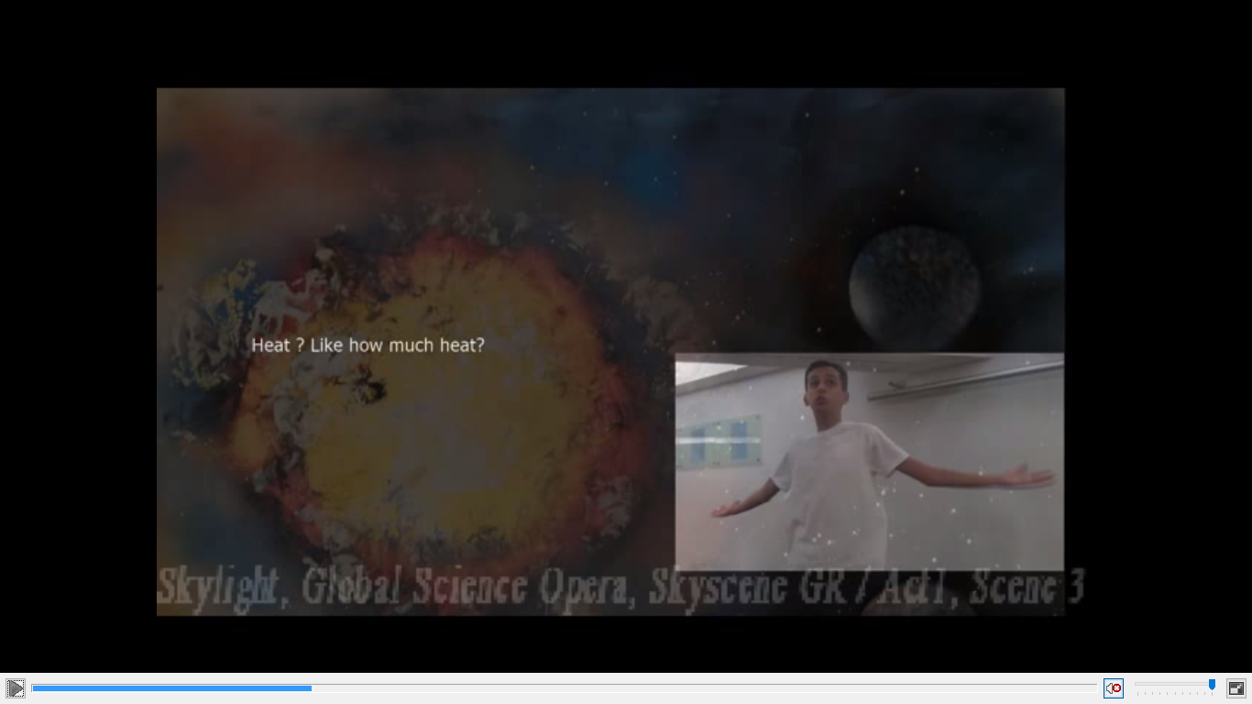

Assessment

GSOrt activities are evaluated through constant communication between the members of the community. Additional evaluation through online questionnaires is provided by the CREATIONS consortium.

Possible Extension
GSOrt demonstrator aims to develop and promote advanced and innovative videoconference capabilities used as tools for blending Science-through-the-Arts activities with traditional science teaching. This action encourages the development of a live & interactive network of remote web-channels that can link together remote communities in areas were access to music-education practice is scarce or impossible. If Music is an act of performance in which many musicians collaborate together in order to create it ("sympraxis"), then internet can be conceived as a live virtual stage in which many remote participants produce a live concert using multiple-site videoconference as a tool. It is a music (cultural) event created by students assisted by their teachers. All places collaborate together from a distance so as to produce a web-concert as a final event ("dromenon").
Science-teaching practices such as “Learning Science Through Theatre”, Junior Science Café that have been thoroughly described through the CREAT-IT project can fully support the development of an associated Teachers Academy endorsing the GSOrt learning activities.
Teacher Academy of reference:
http://www.opendiscoveryspace.eu/topic-courses/live-music-education-academy

References
CREAT-IT project: "Implementing Creative strategies into Science Teaching"
Anna Craft, Oded Ben Horin, Menelaos Sotiriou, Petros Stergiopoulos, Sofoklis Sotiriou, Kerry Chappell, Sarah Hennessy, Dobrivoje Lale Eric, Cinzia Belmonte.
Conference Book URL: http://ndste2014.weebly.com/uploads/2/3/5/5/23551418/book_of_abstracts.pdf , p.37
Paper URL: http://connect.ea.gr/ndste2014paper/

