D3.1.x CMS Virtual Visits

Project Reference: | H2020-SEAC-2014-2015/H2020-SEAC-2014-1 , 665917 |  | Author: Angelos Alexopoulos
Code: | D3.1.x |  | Contributors: Michael Hoch
Version & Date: | v1.0, 27 May 2016 |  | Approved by:

Table of Contents
1 Introduction / Demonstrator Identity 3
1.1 Subject Domain 3
1.2 Type of Activity 3
1.3 Duration 3
1.4 Setting (formal / informal learning) 3
1.5 Effective Learning Environment 3
2 Rational of the Activity / Educational Approach 4
2.1 Challenge 4
2.2 Added Value 4
3 Learning Objectives 5
3.1 Domain specific objectives 5
3.2 General skills objectives 5
4 Demonstrator characteristics and Needs of Students 6
4.1 Aim of the demonstrator 6
4.2 Student needs addressed 6
5 Learning Activities & Effective Learning Environments 7
6 Additional Information 15
7 Assessment 16
8 Possible Extension 17
9 References 18

Introduction / Demonstrator Identity

Subject Domain
Particle Physics, Physics

Type of Activity
This activity is a combination of:
- In-school
- Out-of-school including research institute, science cafè, science fair

Duration
This is typically a 60’ to 90’ activity

Setting (formal / informal learning)
The setting is mainly formal (i.e. school) but can also be informal (e.g. science cafè, science fair) and engages multiple actors including students, teachers, scientists, parents and general public

Effective Learning Environment
  - Communities of practice
  - Dialogic space / argumentation
  - Experimentation (Science laboratories and eScience applications)
  - Visits to research centres (virtual/physical)
  - Communication of scientific ideas to audience

Rationale of the Activity / Educational Approach

Challenge
Science centres can provide students with authentic experiences in science and STEM by several means, one of which is school visits to their facilities. Accordingly, CERN and the LHC experiments have developed over the last years on-site visits programmes that cumulatively attract more than 100,000 people annually. Specifically, the CMS experiment at CERN welcomes on average more than 20,000 school students per year.
Yet not all schools can afford visiting CERN mainly due to geographical and financial barriers. To overcome these barriers, the CMS experiment has launched a Virtual Visits programme that allows even more students from around the world to enter the world of science, physics and particle physics.

Added Value
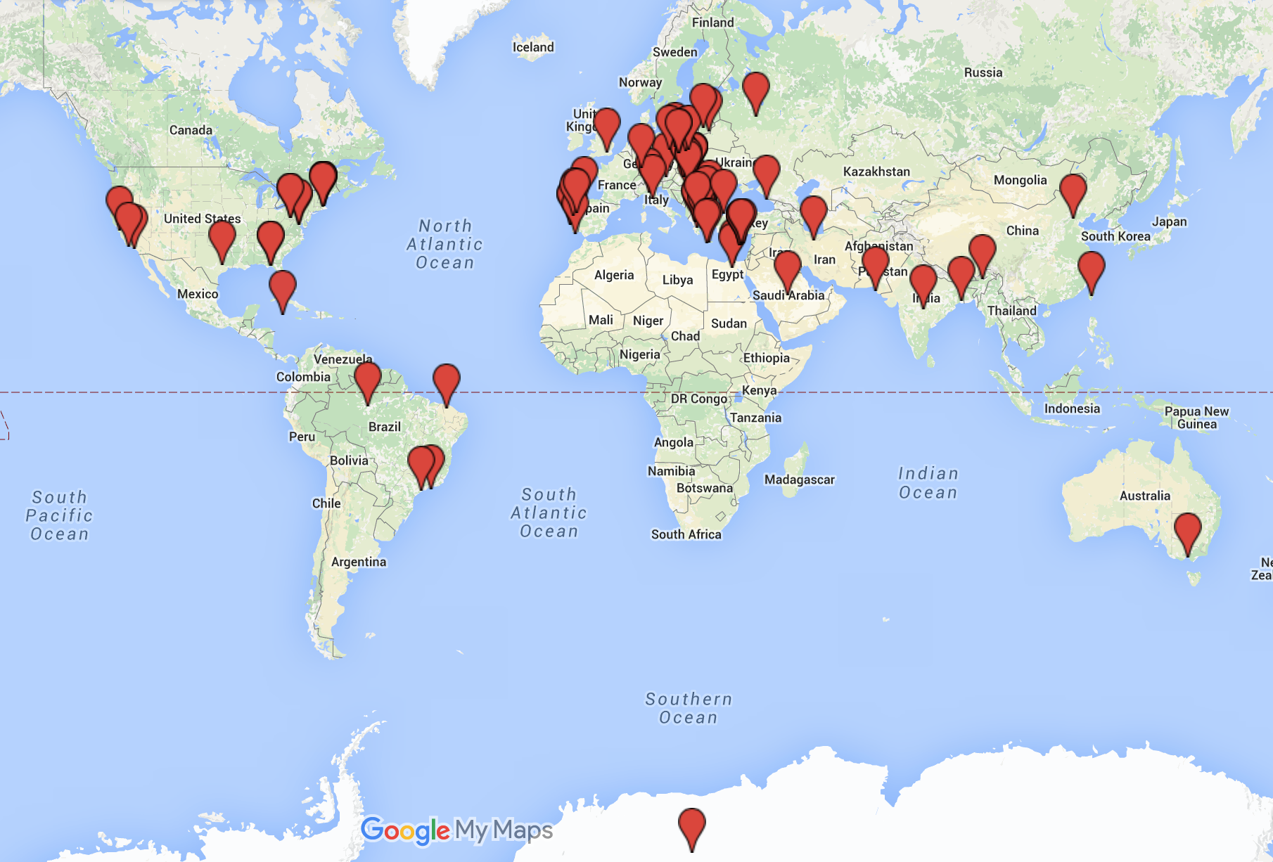
The CMS Collaboration comprises more than 4,000 members from over 190 universities and institutes in more than 40 countries. As a result, communication among research teams takes very often place remotely with the use of videoconferecing tools. By taking advantage of the exact same ICT tools used by the scientists at CMS and more widely at CERN, the CMS Virtual Visits programme can connect even the most remote student communities with CMS scientists located on-site. A second advantage consists of the adaptation of the virtual visit experience to the language requirements of participating schools. A third advantage is that virtual visits can be valuable add-ons to other educational activities for students such as Particle Physics Masterclasses, Science&Art@School workshops and other CREATIONS activities such as the Global Science Opera and Learning Science through Theatre.
World map showing CMS Virtual Visits locations. Since September 2014, about 16,000 students have connected virtually with the CMS experiment at CERN and interacted live with physicists and engineers in their native language.

Learning Objectives

Domain specific objectives
CMS Virtual Visits act as open dialogic spaces that tap into the advantages offered by synchronous communication technology with the aim to inspire and engage the public and especially school students with the world of science, physics and particle physics.
The domain specific objectives of CMS Virtual Visits are:
- Offer students and teachers the opportunity to interact in real time with particle physicists, engineers and other researchers working at the CMS experiment at CERN
- Offer students and teachers the opportunity to visit virtually experimental facilities (e.g. particle detector, control room etc.) and appreciate the magnitude and complexity of engineering and technology involved in big science experiments in particle physics
- Offer students and teachers the opportunity to learn about the human and organizational aspects of big science
- Complement other educational activities for students such as Particle Physics Masterclasses, Science&Art@School workshops and special events (e.g. science fairs)

General skills objectives
The general skills objectives of CMS Virtual Visits are:
- Students may develop scientific inquiry skills by preparing in advance questions that they will then pose to the scientists during the virtual visit
- Students may develop communication and social skills by learning to interact and dialogue with scientists but also with other students from other locations who take part in the virtual visit
- Students may develop an appreciation of the importance of scientific research in particle physics not only in terms of scientific knowledge gains but also in terms of technology transfer and applications with a positive socioeconomic impact
- Students may break stereotypical views of scientists and also develop identification with the global, collaborative scientific effort being made at the world’s largest particle physics laboratory

Demonstrator characteristics and Needs of Students

Aim of the demonstrator
The aim of CMS Virtual Visits is to act as interactive, open educational and outreach platform for inspiring and engaging young students and teachers with the science, engineering and technology of big science research infrastructures and specifically the CMS experiment at CERN’s Large Hadron Collider.
CMS Virtual Visits achieve this aim through:
- Connecting remotely school communities with scientists and engineers working on site at the CMS experiment
- Complementing other educational activities for students such as Particle Physics Masterclasses and Science&Art@School workshops

Student needs addressed
Based on quantitative and qualitative feedback from teachers and students, CMS Virtual Visits address satisfactorily the following students’ needs:
- Interest in STEM subjects
- Curiosity about big science questions in the field of particle physics
- Sense of belonging to the scientific enterprise
- Identification with scientists, engineers and technologists as professional role models
In addition, CMS Virtual Visits are offered in the native language of the participants and, as such, ease the communication process between scientists and students.

Learning Activities & Effective Learning Environments

Science topic: Particle Physics, Physics, Engineering, Technology  Relevance to national curriculum:  While there is no immediate connection to national curricula, CMS Virtual Visits can act as valuable scaffolds for standard in-class activities related to the teaching of Physics at senior primary, junior and senior high school levels.  Class information  Year Group: Senior primary school; Junior high school; Senior high school  Age range: 10-18  Sex: Both  Pupil Ability: Mixed (The scenario allows space for pupils of various abilities to participate) |  |  | Materials and Resources  What do you need? (eg.printed questionnaires, teleconference, etc.)  - Computer with access to the internet, projector and basic videoconferencing equipment  Where will the learning take place? On site or off site? In several spaces? (e.g. science laboratory, drama space etc), or one?  - School classroom or science lab  - School theatre  - Science cafè  - Science fair or festival  Health and Safety implications? None  Technology? Computers with internet access and videoconferencing equipment  Teacher support? Preparation and Scaffolding
Prior pupil knowledge
While no prior knowledge of particle physics is required, a preparatory session initiated by the science teacher is welcomed. In this session, the science teacher is advised to ignite students’ curiosity by showing relevant audiovisual material or inviting students to do so at home. The material is in electronic format and is provided to the teacher in advance. The ultimate aim is to initiate the inquiry cycle by posing a “big question” in particle physics that will then be followed up by the students during the virtual visit.
Individual session project objectives (What do you want pupils to know and understand by the end of the lesson?)
During this scenario, students will:

Assessment  - Evaluation (quantitative & qualitative) by the teachers in the form of online questionnaire and reports |  | Differentiation  How can the activities be adapted to the needs of individual pupils?  CMS Virtual Visits are customized to the students’ learning needs according their age as well as their native language. |  | Key Concepts and Terminology  Science terminology: experiment, accelerator, detector, particle collisions, calorimeter, GeV, hadrons, leptons, Computing Grid, radiation, discovery, Higgs boson, Bing Bang, histogram, physics events, medical physics  Arts terminology: N/A
Session Objectives:

During this scenario, students will:

- engage with big questions driving scientific research in particle physics.
- learn about the science, engineering and technology involved in particle physics experiments
- embark on dialogue and discussion with scientists in real time

Learning activities in terms of CREATIONS Approach
NOTE: CMS Virtual Visits speak only to Phase 1 and 2 of the Inquiry Cycle
IBSE Activity | Interaction with CREATIONS Features |  |  | Students | Teacher | Potential Arts Activity
Phase 1  QUESTION: students investigate a scientifically oriented question | Students pose, select, or are given a scientifically oriented question to investigate. Balance and navigation through dialogue aids teachers and students in creatively navigating educational tensions, including between open and structured approaches to IBSE. Questions may arise through dialogue between students’ scientific knowledge and the scientific knowledge of professional scientists and science educators, or through dialogue with different ways of knowledge inspired by interdisciplinarity and personal, embodied learning. Ethics and trusteeship is an important consideration in experimental design and collaborative work, as well as in the initial choice of question. |  |  | Engage in argumentation/dialogue about a scientific topic that may hold social implications but may also influence their personal life choices/decisions  Generate with the help of teacher investigable questions that may want to clarify with a scientist and explore further in the context of e.g. particle physics masterclass | Invites students to think of and pose a “big question” in science and particularly in particle physics to a scientist  Ignites students’ curiosity by prompting a “big question” in science using audiovisual material provided during the preparation for the virtual visit  Invites students to think of how physicists, engineers and technologists may approach differently a scientific idea and its social implications. | Preparatory exercise with science teacher aimed at classifying questions into categories such as:  - science  - engineering and technology  - career and life
Phase 2  EVIDENCE: students give priority to evidence | Students determine or are guided to evidence/data, which may come from individual, collaborative and communal activity such as practical work, or from sources such as data from professional scientific activity or from other contexts. Risk, immersion and play is crucial in empowering pupils to generate, question and discuss evidence. |  |  | Take part in a virtual visit with professional scientist(s)  Learn first-hand from scientists the “what”, “how” and “why” of scientific work  Start to understand the career path of a professional scientist and the different professions involved in big science | Organizes a CMS Virtual Visit  (http://cms.web.cern.ch/content/virtual-visits )
Phase 3  ANALYSE: students analyse evidence | Students analyse evidence, using dialogue with each other and the teacher to support their developing understanding.
Phase 4  EXPLAIN: students formulate an explanation based on evidence | Students use evidence they have generated and analysed to consider possibilities for explanations that are original to them. They use argumentation and dialogue to decide on the relative merits of the explanations they formulate, playing with ideas.
Phase 5  CONNECT: students connect explanations to scientific knowledge | Students connect their explanations with scientific knowledge, using different ways of thinking and knowing (‘knowing that’, ‘knowing how’, and ‘knowing why’) to relate their ideas to both disciplinary knowledge and to interdisciplinary knowledge to understand the origin of their ideas and reflect on the strength of their evidence and explanations in relation to the original question.
Phase 6  COMMUNICATE: students communicate and justify explanation | Communication of possibilities, ideas and justifications through dialogue with other students, with science educators, and with professional scientists offer students the chance to test their new thinking and experience and be immersed in a key part of the scientific process. Such communication is crucial to an ethical approach to working scientifically.
Phase 7  REFLECT: students reflect on the inquiry process and their learning | Individual, collaborative and community-based reflective activity for change both consolidates learning and enables students and teachers to balance educational tensions such as that between open-ended inquiry learning and the curriculum and assessment requirements of education.

Additional Information
CMS Virtual Visits webpage (including information on technical requirements and “how to book” a virtual visit for your school)
- http://cms.web.cern.ch/content/virtual-visits
A paper on CMS and ATLAS Virtual Visits presented at the 2015 EPS-HEP Conference
- http://cds.cern.ch/record/2132292/files/ATL-OREACH-PROC-2016-003.pdf
An article on the CERN website on a CMS Virtual Visit
- http://home.cern/students-educators/updates/2014/02/students-visit-heart-cms-detector
Repository of CMS Virtual Visits (including preparatory materials, reports and feedback from participants and recorded videos of virtual visits)
- http://indico.cern.ch/category/5975/

Assessment
CMS Virtual Visits are systematically asssessed by teachers who are invited to fill out an online questionnaire after the completion of the event. In this questionnaire, they are invited to:
- express their level of satisfaction with the technical and organizional aspects of the event
- indicate whether and the ways in which they prepared their students for the event
- rate the quality of the information material that was provided to help prepare the students
- indicate the extent to which the event:
  - met their own expectations
  - was appreciated by the students
  - may have a positive effect on the students’ interest in STEM
- indicate the scientists in terms of their communication skills
- indicate their overall satiscation with the event
- indicate (in open ended manner) any follow-up plans

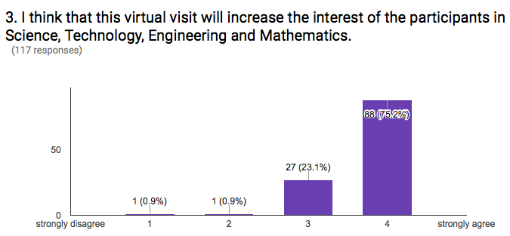
Overall, teachers’ feedback has so far been positive across the above areas. For example, as shown in the graph below, the majority of teachers (75%) agree strongly that this activity is likely to increase their students’ interest in STEM.

Possible Extension
As mentioned in Section 2.2, CMS Virtual Visits represent a valuable add-on activity that can be embedded into and enhance other CREATIONS demonstrators including:
- Science&Art@School workshops
- Particle Physics Masterclasses
- Learning Science through Theatre
- Student Parliament
- Global Science Opera and GSOrt
- Summer Schools
- Etc.
In sum, CMS Virtual Visits can complement CREATIONS educational activities at local, national and international level.

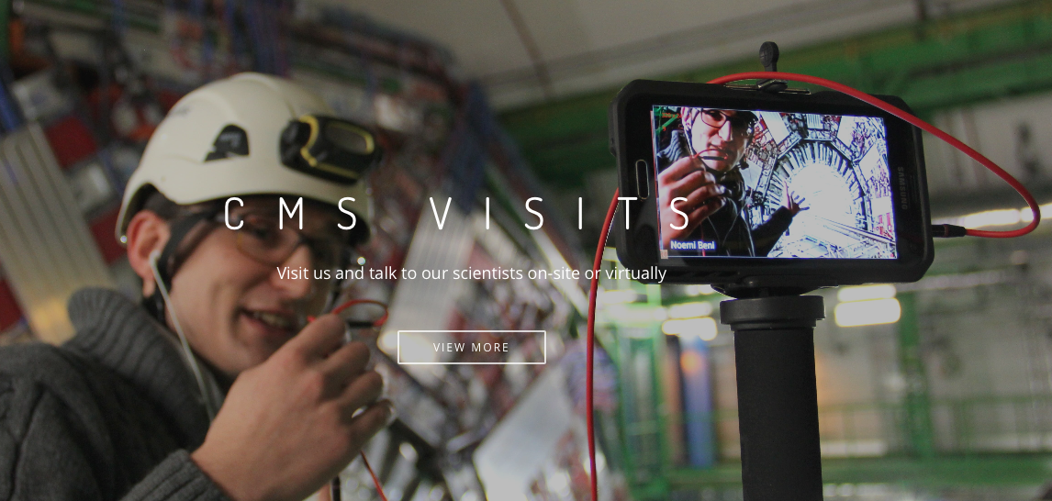

References
Hoch, M. & Alexopoulos, A. (2014). ART@CMS and SCIENCE&ART@SCHOOL: Novel education and communication channels for particle physics. Proceedings of the the 14th ICATPP Conference, Vol. 1, 728-736.
Lapka, M., Goldfarb, S., Aguirre, L., Hill., Adam-Bourdarios, C., Alexopoulos, A., Beni, N., Hoch, M., Petrilli, A. & Zsillasi, Z. (2015). ATLAS and CMS virtual visits: Bringing cutting edge science into the classoom and beyond. The European Physical Society Conference on High Energy Physics, Vienna, 22-29 July.

http://cms.web.cern.ch/content/virtual-visits

