D3.1.UBT Bionics – out-of-school learning in the zoo

Project Reference: | 665917 |  | Author: | Michaela Marth (UBT)
Code: | D 3.1.x |  | Contributors: | Dr. Cathérine Conradty (UBT)
Version & Date: | V2 |  | Approved by:

Table of Contents
1 Introduction / Demonstrator Identity 6
1.1 Subject Domain 6
1.2 Type of Activity 6
1.3 Duration 6
1.4 Setting (formal / informal learning) 6
1.5 Effective Learning Environment 6
2 Rational of the Activity / Educational Approach 7
2.1 Challenge 7
2.2 Added Value 7
3 Learning Objectives 8
3.1 Domain specific objectives 8
3.2 General skills objectives 8
4 Demonstrator characteristics and Needs of Students 9
4.1 Aim of the demonstrator 9
4.2 Student needs addressed 9
5 Learning Activities & Effective Learning Environments 10
6 Additional Information 15
7 Assessment 16
8 Possible Extension 17
9 References 18

Introduction / Instructions
This part should be excluded from your FINAL Demonstrator
- Summary of the CREATIONS approach
As a result the CREATIONS approach is informed and grounded on three closely interrelated aspects: a) the CREATIONS features, b) the RRI principles and c) the IBSE principles.
CREATIONS Pedagogical Framework |  | IBSE
CREATIONS  features | RRI aspects | Essential features of IBSE | Effective learning environments
- Dialogue  - Interdisciplinarity  - Individual, collaborative and communal activities for change  - Balance and navigation  - Empowerment and agency  - Risk, immersion and play  - Possibilities  - Ethics and trusteeship | - Governance  - Public  - Science education engagement  - Gender equality  - Open access/open science  - Ethics  - Sustainability  - Social justice/inclusion | - QUESTION  - EVIDENCE  - ANALYSE  - EXPLAIN  - CONNECT  - COMMUNICATE  - REFLECT | - Teachers as tutors  - Individual journeys  - Use of modern tools in classroom  - Open Repositories of Resources  - Open access to eScience tools and infrastructure  - Curriculum and evaluation adequacy  - Communities and network

Although the key aspects of the CREATIONS approach are presented in a tabular format, the process is in practice highly organic, enabling the dialogue among students, teachers, researchers, ICT media and creative representation, drawing on a range of personal and disciplinary knowledge to thread across and between these features

- The Demonstrators’ Generic Framework
The design of Demonstrators’ Generic Framework is mainly based on IBSE Best Practice of Pathway (Summer school, 2013), Scenario of Metafora EU project (e.g. 3d juggler (Smyrnaiou et al., 2012a; 2012b)) and Implementation Scenario of CREAT-IT EU project (such as Science Theatre Implementation Scenario, M. Sotiriou, 2015).
There are different ways to approach inquiry. Reflective inquiry seeks to draw attention on the coupling of metacognition and inquiry in the context of solving open-ended, ill-structured investigations in science (Kyza & Edelson, 2003). The Shimoda et al (2002)’s generic inquiry cycle is made explicit to students and is presented as a sequence of goals to be pursued. The Bruce & Bishop (2002) circle aims for students to learn how to learn and metacognitive skills, and stresses the need to engage children as active learners to collaborate and to understand the perspectives of others. Schwartz et al (1999) circle is implemented as a technology template to guide learners through case-, problem-, project-based learning. Although many versions of the inquiry cycle have been presented by various authors (de jong et al., 2002; Pedaste et al., 2015), the IBSE Best Practice of Pathway cycle was chosen as the most suitable for Creations. Besides this core cycle, there is a place for Question, Evidence, Analyse, Explain, Connect, Communicate and Reflect (figure 1). This circle stresses the need to engage children as little scientists, creative learners and science communicators.
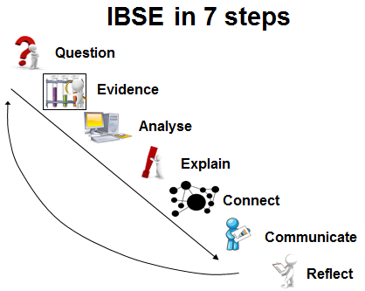
Figure 1: IBSE Best Practice of Pathway, Summer School, (Rosi, 2013)

The Demonstrators’ Generic Framework structures the description of the pedagogical intervention around what we called “Introduction” or “Demonstrator Identity” which includes information about the : author, subject domain, type of activity, duration, setting and effective learning environment. The second element of the structure is the “Rationale of the Activity/ Educational Approach” which focuses on: the teaching and learning problem (challenge) addressed by this demonstrator and the added value of using the Creation Project for implementing this demonstrator. Challenge-based learning builds on the successes of problem-based learning models where students engage in self-directed work scenarios (or “problems”) based in real life (Johnson, Laurence et al., 2009). By giving students the opportunity to focus on a challenge of global significance, challenge-based learning creates a space where students can direct their own research into real-world matters and think critically about how to apply what they learn (Smyrnaiou, et al., 2015; Johnson, Laurence et al., 2009). An example could be an art & science event (performance, paintings, etc.).
The third element of the structure involves the learning objectives which are divided to two categories which involve domain specific learning and general learning skills which is supported by the Creation Framework. The fourth element of the Demonstrators’ Generic Framework involves the “Demonstrator characteristics and Needs of Students” and aims at collecting information about the issues explored and the real needs of students. It is very important because the literature of Science Education offers important data concerning the students’ attitudes towards science and underlines the continuing decline of interest the young people show in pursuing scientific careers (S&M) in a way that threatens the future of Europe (ROSE, Osborne et al., 2003; Osborne & Dillon, 2008).
The fifth element provides information about the Sequence and description of the activities focusing on a detailed description of each activity and the effective learning environment (s) involved and the sixth additional information. Finally, some assessment suggestions are requested along with possible extensions and list of suggested sources/references. For example, inter-workgroup assessment: after performing a theatrical stage on / represents a scientific concept or cultural elements, the workgroups may exchange their ideas / performances/ representations and ask their peers to evaluate them. The criteria for the evaluation may be set collaboratively by the workgroups as they discuss in class /stage, etc.. Concerning the possible extensions, after having performed a theatrical stage on scientific concept or cultural elements putting into effect their own ideas, the students share their performance and ask the students of another team to perform on the same scientific concepts (or cultural elements). At this phase of the performance, the workgroups decide on the representation of scientific concept (or cultural elements) through embodiment (gestures, facial expressions, full body movements, sentiments), music, choreography, narration, or using digital tools or other objects.

Introduction / Demonstrator Identity

Subject Domain
Bionics – out-of-school learning in the zoo:
The intervention provides selected bases around the theme of bionics and their diversity.

Type of Activity
A day in the zoo shows different aspects of bionic. These aspects are presented in a big learning circle included some handicraft work, hands- on stations and guided learning.

Duration
One day per class. All in all 16 classes included.

Setting (formal / informal learning)
Formal learning is located in different scenarios in the zoo. These activities are guided by trained employees in the zoo.

Effective Learning Environment
The learning scenarios are located in the zoo in Nuremberg. In the zoo there are different stations where the students could learn about bionic and train individual skills.
- Simulations of the streamline shaped animals are shown in the learning scenarios, which should be visualizing the theoretical model of the moving problem in the water. Inquiry based experiments should be brought in classroom or even in the zoo.
- Art based learning scenarios are located in the zoo with the handicraft work for the Fin Ray-Effect ® and some more practical experiments in the exhibition next to the zoo.
- Dialogic space is given in the zoo special argumentation hour. The students can talk to experts and learn from their experience in science and also communicate about problems in the zoo and the bionic topics which are linked with that.
- Experimentations are made with the students directly on the compound. They learn through ‘hands on’ stations in different bionic topics.
- Communication of scientific ideas is also given in the special talking round with the experts and scientists directly in the zoo.

Rational of the Activity / Educational Approach

Challenge
There are so much wrong perceptions about bionic or even NO perception about bionic topics. So the children should solve these problems with thinking about different everyday examples they know.

Added Value
(Elaboration of the applied creative approaches and their purpose)
The students should do some handicrafts work in the different stations in the zoo. With these skills they should learn more about the technical literacy and examples of bionics. Many examples are given in the different stations. In Addition to that they should draw shown experiments to save the information with multisensory learning. Through such learning activities the creative aspects are trained in different ways. The CREATIONS framework finally gives the framework of this learning out of school in the zoo.

Learning Objectives

Domain specific objectives
Pilot study: Perceptions about technic from students, university freshman and teachers
Research of the reliability of the existing Technology Questionnaire (Rennie & Harding , 1992)
Is there an increase of knowledge due to the intervention? Correlates the increase of knowledge with the motivation for technology?
Is the scientific motivation of children who are interested in technology bigger than by less interested students?
Is there an influence of cognitive load (CL) and technical motivation during the learning unit? Is there an influence of certain personality traits?

General skills objectives
Handicraft should be a big topic in these learning scenarios. The children should work with the hands to learn not only with the eyes. The topic of this skill is “learning by doing”. The children should learn bionic topics in different ways. Learning is not mediated as in school. There is a new way teaching students and looking for students’ problems and alternative perceptions.

Demonstrator characteristics and Needs of Students

Aim of the demonstrator
Research-based learning (Inquiry Based Science Education) plays a major role in science education (Bogner & Sotiriou, 2011).
In cooperation with the “BIONICUM” at the zoo in Nuremberg a curriculum compliant learning circle about Bionics was established (6th grade).
The intervention provides selected bases around the theme of bionics and their diversity.
Students gain an overview about different bionic areas and learn the bionics concept and its importance to know.

Student needs addressed
Students should bring some skills in the learning circle. They should have perception about technical topics, technical interest and social aspects of technology. This together with handicraft work should be the best approach for the needs in creative learning with CREATIONS.

Learning Activities & Effective Learning Environments

- Hands-on“ stations
- Topic: Bionics in the water
- Different aspects of bionics directly on the compound
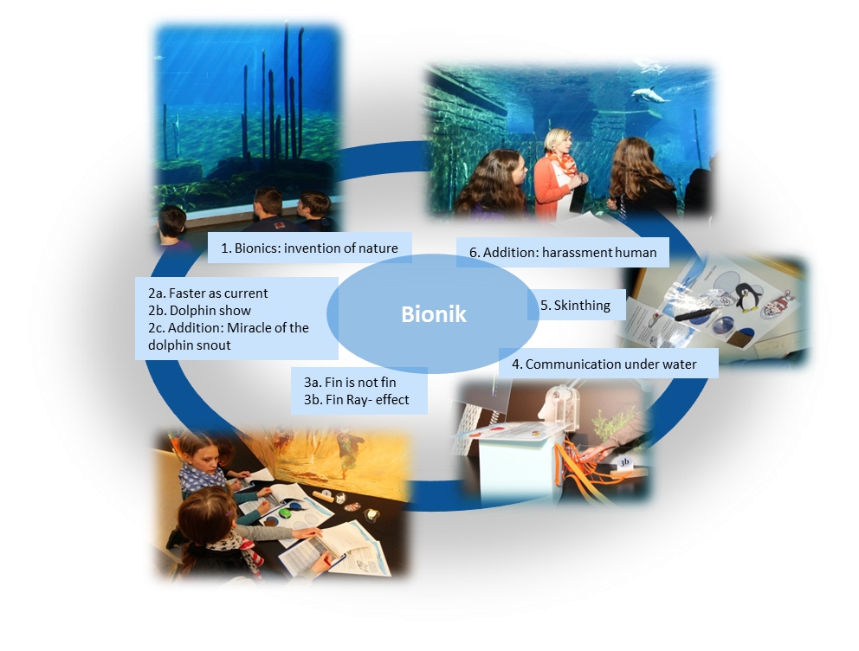
- Integration of the new exhibition "Ideenreich Natur"
- Learning circle:

Science topic: Bionics (Relevance to national curriculum)  Class information: Year Group: 6th grade  Age range: 11-14  Sex: both  Pupil Ability: eg (The scenario allows space for pupils of various abilities to participate) |  | Materials and Resources  What do you need? (eg.printed questionnaires, teleconference, etc.)  printed questionnaires  Where will the learning take place? On site or off site? In several spaces? (e.g. science laboratory, drama space etc), or one? In the zoo of Nuernberg  Health and Safety implications? -  Technology? learning circle  Teacher support? Yes, as a tutor learning with students
Prior pupil knowledge Perception of technology.
Individual session project objectives (What do you want pupils to know and understand by the end of the lesson?)
During this scenario, students will gain an overview about different bionic areas and learn the bionics concept and its importance to know.
Assessment  Formal learning in the zoo. | Differentiation  How can the activities be adapted to the needs of individual pupils?  There are some gradational learning information’s for the students. | Key Concepts and Terminology  Science terminology:  bionics, technolgy  Arts terminology: -
Session Objectives: learning something creative in combination with technology and science in general
During this scenario, students will learn something about creative working and bionic topics.

Learning activities in terms of CREATIONS Approach
IBSE Activity | Interaction with CREATIONs Features | Student | Teacher | Potential arts activity
Phase 1:  QUESTION: students investigate a scientifically oriented question | Students pose, select, or are given a scientifically oriented question to investigate. Balance and navigation through dialogue aids teachers and students in creatively navigating educational tensions, including between open and structured approaches to IBSE. Questions may arise through dialogue between students’ scientific knowledge and the scientific knowledge of professional scientists and science educators, or through dialogue with different ways of knowledge inspired by interdisciplinary and personal, embodied learning. Ethics and trusteeship is an important consideration in experimental design and collaborative work, as well as in the initial choice of question. | Thinking about how inventors find their ideas | Offering some ideas about technical solutions – what might have been the model in nature.
Phase 2:  EVIDENCE: students give priority to evidence | Students determine or are guided to evidence/data, which may come from individual, collaborative and communal activity such as practical work, or from sources such as data from professional scientific activity or from other contexts. Risk, immersion and play is crucial in empowering pupils to generate, question and discuss evidence. | Student find some models, e.g. sharks‘ skin as model for skin for planes or ships (riblet laminations)  Geckos’ sucker for vacuum cup | Teacher reduce their support to assistance but do not give comments | Handicraft work about fin ray effect
Phase 3:  ANALYSE: students analyse evidence | Students analyse evidence, using dialogue with each other and the teacher to support their developing understanding. | Learning at Workstations supports learning, structured in small steps;  A route card gives guide line for successful learning process, uninfluenced by the teacher. | Teachers are asked to do nothing, tutoring when needed | Experiments with models
Phase 4:  EXPLAIN: students formulate an explanation based on evidence | Students use evidence they have generated and analysed to consider possibilities for explanations that are original to them. They use argumentation and dialogue to decide on the relative merits of the explanations they formulate, playing with ideas. | Students work together in small groups of four; they discuss results of their observations to fill in the route cards |  | Handicrafts, creating own models
Phase 5:  CONNECT: students connect explanations to scientific knowledge | Students connect their explanations with scientific knowledge, using different ways of thinking and knowing (‘knowing that’, ‘knowing how’, and ‘knowing this’) to relate their ideas to both disciplinary knowledge and to interdisciplinary knowledge to understand the origin of their ideas and reflect on the strength of their evidence and explanations in relation to the original question. | Own results compared with original information in zoo.
Phase 6:  COMMUNICATE: students communicate and justify explanation | Communication of possibilities, ideas and justifications through dialogue with other students, with science educators, and with professional scientists offer students the chance to test their new thinking and experience and be immersed in a key part of the scientific process. Such communication is crucial to an ethical approach to working scientifically. | After the workstations students discuss their results and ideas with biologist at the zoo (that are zoo educators); they are not told about right or wrong, but discussing; | Teachers are asked to do nothing | Additionally a robot is introduced to the students. It can sing and dance and is an example for bionics with humans as model.
Phase 7:  REFLECT: students reflect on the inquiry process and their learning | Individual, collaborative and community-based reflective activity for change both consolidate learning and enables students and teachers to balance educational tensions such as that between open-ended inquiry learning and the curriculum and assessment requirements of education. | The excursion is completed with the dolphin show where students can observe the bionic model in action | In the open atmosphere of a walk through the park students are involved in open discussions with both biologists and teachers.  (post-test and résumé at school complete the intervention for consolidation)

Additional Information
-

Assessment

It’s a good example for IBSE based teaching. First the problems are collected and then the guided version of IBSE is used to demonstrate the effectiveness and effort of this demonstrator. The multisensory learning with handcraft and drawing is a possible approach to bring something like that in the national school system or even in the national curriculum.
The assessment provides potential questionnaire. The Questionnaire are the SMQII, the Technology Questionnaire and the personality Questionnaire. All in all the Assessment goes through WP 6 the Validation and Evaluation effort. With these Questionnaires the effectiveness should be demonstrated.

Possible Extension
The normal learning in the classroom in comparison with the out-of-school learning with creative aspects could be an extension of these scenarios.

References

- Bogner F.X., Sotiriou S. (2011): A Special Section on Technology-Enhanced Science Education, ASL (Advanced Science Letters), 4(11/12), 3301-3303.
- Deci E.L., Schwartz A. J., Sheinman L., Ryan R.M. (1981): An instrument to assess adults' orientations toward control versus autonomy with children: Reflections on intrinsic motivation and perceived competence, Journal of Educational Psychology, 73(5), 642-650.
- Glynn S. M., Taasoobshirazi G., Brickman P. (2009): Science Motivation Questionnaire: Construct Validation With Nonscience Majors, Journal of Research in Science Teaching 46(2), 127-146.
- Sweller J., Van Merriënboer J., Paas F. (1998): Cognitive architecture and instructional design, Educational Psychology Review 10, 251–296.
- Gian Vittorio Caprara, Claudio Barbaranelli, Laura Borgogni, Marco Perugini (1993) The “big five questionnaire”: A new questionnaire to assess the five factor model. Personality and Individual Differences, 15, Issue 3, September 1993, 281–288
- Harding J., Rennie J.L. (1992): Technology Education in Science and Mathematics, What Research Says to the Science and Methematics Teachers, No.10. Perth, Western Australia, Key Centre for School Science and Methematics, Curtin University of Technology.
- http://images02.futurezone.at/CC_05_10_Bionic_Handling_Assistant_4.jpg/fuzo-slideshow-slide/24.549.287 (online: 27.01.2016)
- Bilder: Mile Cindric

