D3.1.0 Aspects of Venus

Project Reference: | H2020-SEAC-2014-2015/H2020-SEAC-2014-1 , 665917 |  | Author: | Cecilia Kozma, Tanja Nymark, Vetenskapens Hus, KTH
Code: | D 3.1.0 |  | Contributors:
Version & Date: | Version 1.0, 2016-05-23 |  | Approved by:

Table of Contents
1 Introduction / Demonstrator Identity 3
1.1 Subject Domain 3
1.2 Type of Activity 3
1.3 Duration 3
1.4 Setting (formal / informal learning) 3
1.5 Effective Learning Environment 3
2 Rational of the Activity / Educational Approach 4
2.1 Challenge 4
2.2 Added Value 4
3 Learning Objectives 4
3.1 Domain specific objectives 5
3.2 General skills objectives 5
4 Demonstrator characteristics and Needs of Students 6
4.1 Aim of the demonstrator 6
4.2 Student needs addressed 6
5 Learning Activities & Effective Learning Environments 7
6 Additional Information 14
7 Assessment 17
8 Possible Extension 18
9 References 19

Introduction / Demonstrator Identity

Subject Domain
Astronomy, physics, chemistry, math, arts, language

Type of Activity
The activity is a combination of:
- School based and
- Science centre / research centre based
The activity is local in Stockholm, but can be extended to a national activity in Sweden.

Duration
1,5 – 3 hours

Setting (formal / informal learning)
The setting is both formal and informal. The activity involves preparation and follow-up work in the classroom, while the activity itself takes place in an informal setting.
Formal and informal learning settings
- Classroom
- Science centres
- Research centres
- Locations of planet models in Sweden Solar System

Effective Learning Environment
- Communities of practice (physical)
- Dialogic space / argumentation
- Arts-based
- Experimentation (Science laboratories)
- Visits to research centres (physical)
- Communication of scientific ideas to audience

Rational of the Activity / Educational Approach

Challenge
Great challenges in astronomy education are understanding of:
  - The vast distances involved
  - Three-dimensional structures involved (Urban Eriksson 2014; Urban Eriksson et.al 2014).
  - The night/day cycle
  - The origin of seasons on Earth
  - Phases of the inner planets
  - Climate on planets / radiation balance
  - The actual and apparent movement of objects in the sky
Some common misconceptions that we wish to address are e.g. that seasons are caused by variations in the distance to the Sun; that the moon and planets can only be seen at night; that the phases of the moon are caused by the shadow of the Earth.

Added Value
The purpose of the demonstrator is to combine science and arts to visualize complex astronomical phenomena in order to increase students’ interest and understanding, and let them experience the vast distances in the Solar System. In order to do this we will use the worlds’ largest scale model of the solar system – Sweden Solar System.
In Sweden Solar System (SSS), Globen in Stockholm, the largest spherical building in the world, represents the Sun. The planets are lined up in direction north from Globen. All the planets and a number of other astronomical objects are represented by artistic physical models. All models have been created by professional artists. Distances and sizes are scaled according to 1:20 million, and the inner planets are all in the Stockholm area. Although SSS has a great potential, it has up to now not been used much in education.
The demonstrator is grounded on the Collaborative learning approach (Roger Säljö, 2000; Vygotsky, 1978) in the form of group works that culminate in a presentation, which might be artistic or more scientific. In addition there are group works based on Inquiry Based learning where the groups by exploring small models of the planetary system discover the answers to previously given questions that are aimed at addressing some common misconceptions in astronomy.

Learning Objectives

Domain specific objectives
The main aim of the Aspects of Venus (AoV) activity is to increase students’ interest and knowledge in science, particularly astronomy, through the means of inquiry and different forms of artistic expression.

The AoV domain specific objectives are to:
- get students interested in science through artistic expression of astronomical questions
- initiate a discussion on different misconceptions in astronomy
- initiate contact between students and young scientists
- increase students’ self-confidence in the subjects involved

Towards attaining these objectives, peripheral aims are formed addressing students’ needs to:
- develop understandings about scientific inquiry
- identify questions and concepts that guide scientific investigations
- formulate and revise scientific explanations and models using logic and evidence
- communicate and defend a scientific argument
- meet role models in the form of older students and young scientists

General skills objectives
In the context of the AoV, students’ general skills objectives are:
- Active participation and engagement in the presentation of scientific concepts
- Understanding and applying the scientific inquiry approach
- Connecting science with arts
- Language skills
- Developing a spirit of cooperation and teamwork

Demonstrator characteristics and Needs of Students

Aim of the demonstrator
The demonstrator’s main aim is to improve students’ understanding of the geometry and structure of the solar system, the movements of planetary bodies and how this can be observed, as well as how these effects affect us on Earth. By improving understanding of these phenomena, we aim to increase student interests for science in general and astronomy in particular.

Student needs addressed
In the demonstrator students identify relevant questions (within the given framework), investigate and experiment to construct knowledge in order to improve their understanding of certain astronomical phenomena that are often subject of misconceptions. The topic/question to illustrate and the form of the artistic expression are selected by the students. The freedom of the artistic expression is a challenging factor for students both in order to understand their scientific question and be engaged in collaborative discourse and creation.

Learning Activities & Effective Learning Environments

Science topic: Astronomy, physics, chemistry, mathematics  (Relevance to national curriculum) Swedish middle school curriculum  Class information  Year Group: 4th – 6th grade (middle school)  Age range: 10-12 years  Sex: Both  Pupil Ability: Mixed (The scenario allows space for pupils of various abilities to participate) |  |  | Materials and Resources  What do you need?)  Small models of the solar system (Helios planetarium or similar, Tellurium), small telescopes. A model of Venus (part of Sweden Solar System), material about Sweden Solar System.  Where will the learning take place? On site or off site? In several spaces? (e.g. science laboratory, drama space etc), or one?  Preparatory and follow-up activities take place in schools. The activity itself takes place at Vetenskapens Hus in Stockholm.  Health and Safety implications?  None  Technology?  Telescope  Teacher support?  Scaffolding
Prior pupil knowledge
Before the visit to Vetenskapens Hus the student should be familiar with the different components of the solar system.
Individual session project objectives (What do you want pupils to know and understand by the end of the lesson?)
During this scenario, students will
Understand how the planets move with respect to each other and how this can be observed
Understand why the inner planets show phases
Understand the causes of the seasons on Earth
Get a feeling for the immense distances in the solar system and respective sizes of planets/Sun

Assessment  Through clicker questions we assess what the students have learned.  Student engagement during the activity will give an indication of their understanding and how inspired they become. |  | Differentiation  How can the activities be adapted to the needs of individual pupils?  The activity will be adapted for different age groups as needed to take into account variation in prior knowledge between different groups.  The activity is available to students with disabilities. |  | Key Concepts and Terminology  Science terminology:  Astronomy, Mathematics, Geometry, Physics, Chemistry  Arts terminology:  Performance, choreography, music
Session Objectives:
During this scenario, students will
Improve their understanding of the geometry and structure of the solar system, the movements of planetary bodies and how this can be observed, as well as how these effects affect us on Earth.
Meet inspiring role models in the form of older students who guide them during the activity.
Learning activities in terms of CREATIONS Approach
IBSE Activity | Interaction with CREATIONs Features |  |  |  | Student | Teacher | Potential arts activity
Phase 1:  QUESTION: students investigate a scientifically oriented question | Students are given a scientifically oriented question to investigate. Balance and navigation through dialogue aids teachers and students in creatively navigating educational tensions, including between open and structured approaches to IBSE. Questions may arise through dialogue between students’ scientific knowledge and the scientific knowledge of professional scientists and science educators, or through dialogue with different ways of knowledge inspired by interdisciplinarity and personal, embodied learning. Ethics and trusteeship is an important consideration in experimental design and collaborative work, as well as in the initial choice of question. |  |  |  | - Is given a theme for questions to investigate | - Will have a dialogue with the students to clarify and structure the question | - Creativity in formulating a scientific question by for example acting/poetry/dance
Phase 2:  EVIDENCE: students give priority to evidence | Students determine or are guided to evidence/data, which may come from individual, collaborative and communal activity such as practical work, or from sources such as data from professional scientific activity or from other contexts. Risk, immersion and play is crucial in empowering pupils to generate, question and discuss evidence. |  |  |  | - Conduct simple investigations to explore the questions posed | - The teacher divides students into groups and guides the students as and when they need help  - The teacher identifies possible misconceptions
Phase 3:  ANALYSE: students analyse evidence | Students analyse evidence, using dialogue with each other and the teacher to support their developing understanding. |  |  |  | - Students engage in analysing data by interpreting what they observe | - Acts as a facilitator of the process
Phase 4:  EXPLAIN: students formulate an explanation based on evidence | Students use evidence they have generated and analysed to consider possibilities for explanations that are original to them. They use argumentation and dialogue to decide on the relative merits of the explanations they formulate, playing with ideas. |  |  |  | - With the help of experiments students formulate an explanation of the observed phenomena in light of the posed question. | - Acts as a facilitator of the process | - Creativity in describing a phenomenon by for example acting/poetry/dance
Phase 5:  CONNECT: students connect explanations to scientific knowledge | Students connect their explanations with scientific knowledge, using different ways of thinking and knowing (‘knowing that’, ‘knowing how’, and ‘knowing this’) to relate their ideas to both disciplinary knowledge and to interdisciplinary knowledge to understand the origin of their ideas and reflect on the strength of their evidence and explanations in relation to the original question. |  |  |  | - Connect explanations from experiments with the artwork in Sweden Solar System | - Encourages interdisciplinarity in explanations by pointing out connections to art and other disciplines
Phase 6:  COMMUNICATE: students communicate and justify explanation | Communication of possibilities, ideas and justifications through dialogue with other students, with science educators, and with professional scientists offer students the chance to test their new thinking and experience and be immersed in a key part of the scientific process. Such communication is crucial to an ethical approach to working scientifically. |  |  |  | - Students communicate with each other and with tutors (university students) in order to get help with their investigations  - Students communicate their inquiry findings by discussion with the tutor and their teacher | - Assess students’ understanding  - Aid students in interpretation of observations, adjusting the help according to the students’ level of understanding.
Phase 7:  REFLECT: students reflect on the inquiry process and their learning | Individual, collaborative and community-based reflective activity for change both consolidates learning and enables students and teachers to balance educational tensions such as that between open-ended inquiry learning and the curriculum and assessment requirements of education. |  |  |  | - As a conclusion of the activity the whole class reflects together on their findings and the implications for the answers to the posed questions. | - Take part in the final reflection together with the students.  - Assess students’ understanding. | - Art is used as a help to visualize and reflect on the distances and scales of the solar system

Additional Information
The activity consists of four parts:
- An artistic activity centred on the model of the planet Venus situated at Vetenskapens Hus in Stockholm
- An inquiry based activity focusing on some common misconceptions regarding motions and observations of planets and the moon.
- A guided tour of the observatory
- Short lecture and final reflective summary
1) Artistic activity
At the start of the activity the students gather around the model of Venus. The tutor (a university student) briefly presents the SSS and the model of Venus in particular. The five plates surrounding the model of the planet are described, with a short explanation of which aspect each plate represents.

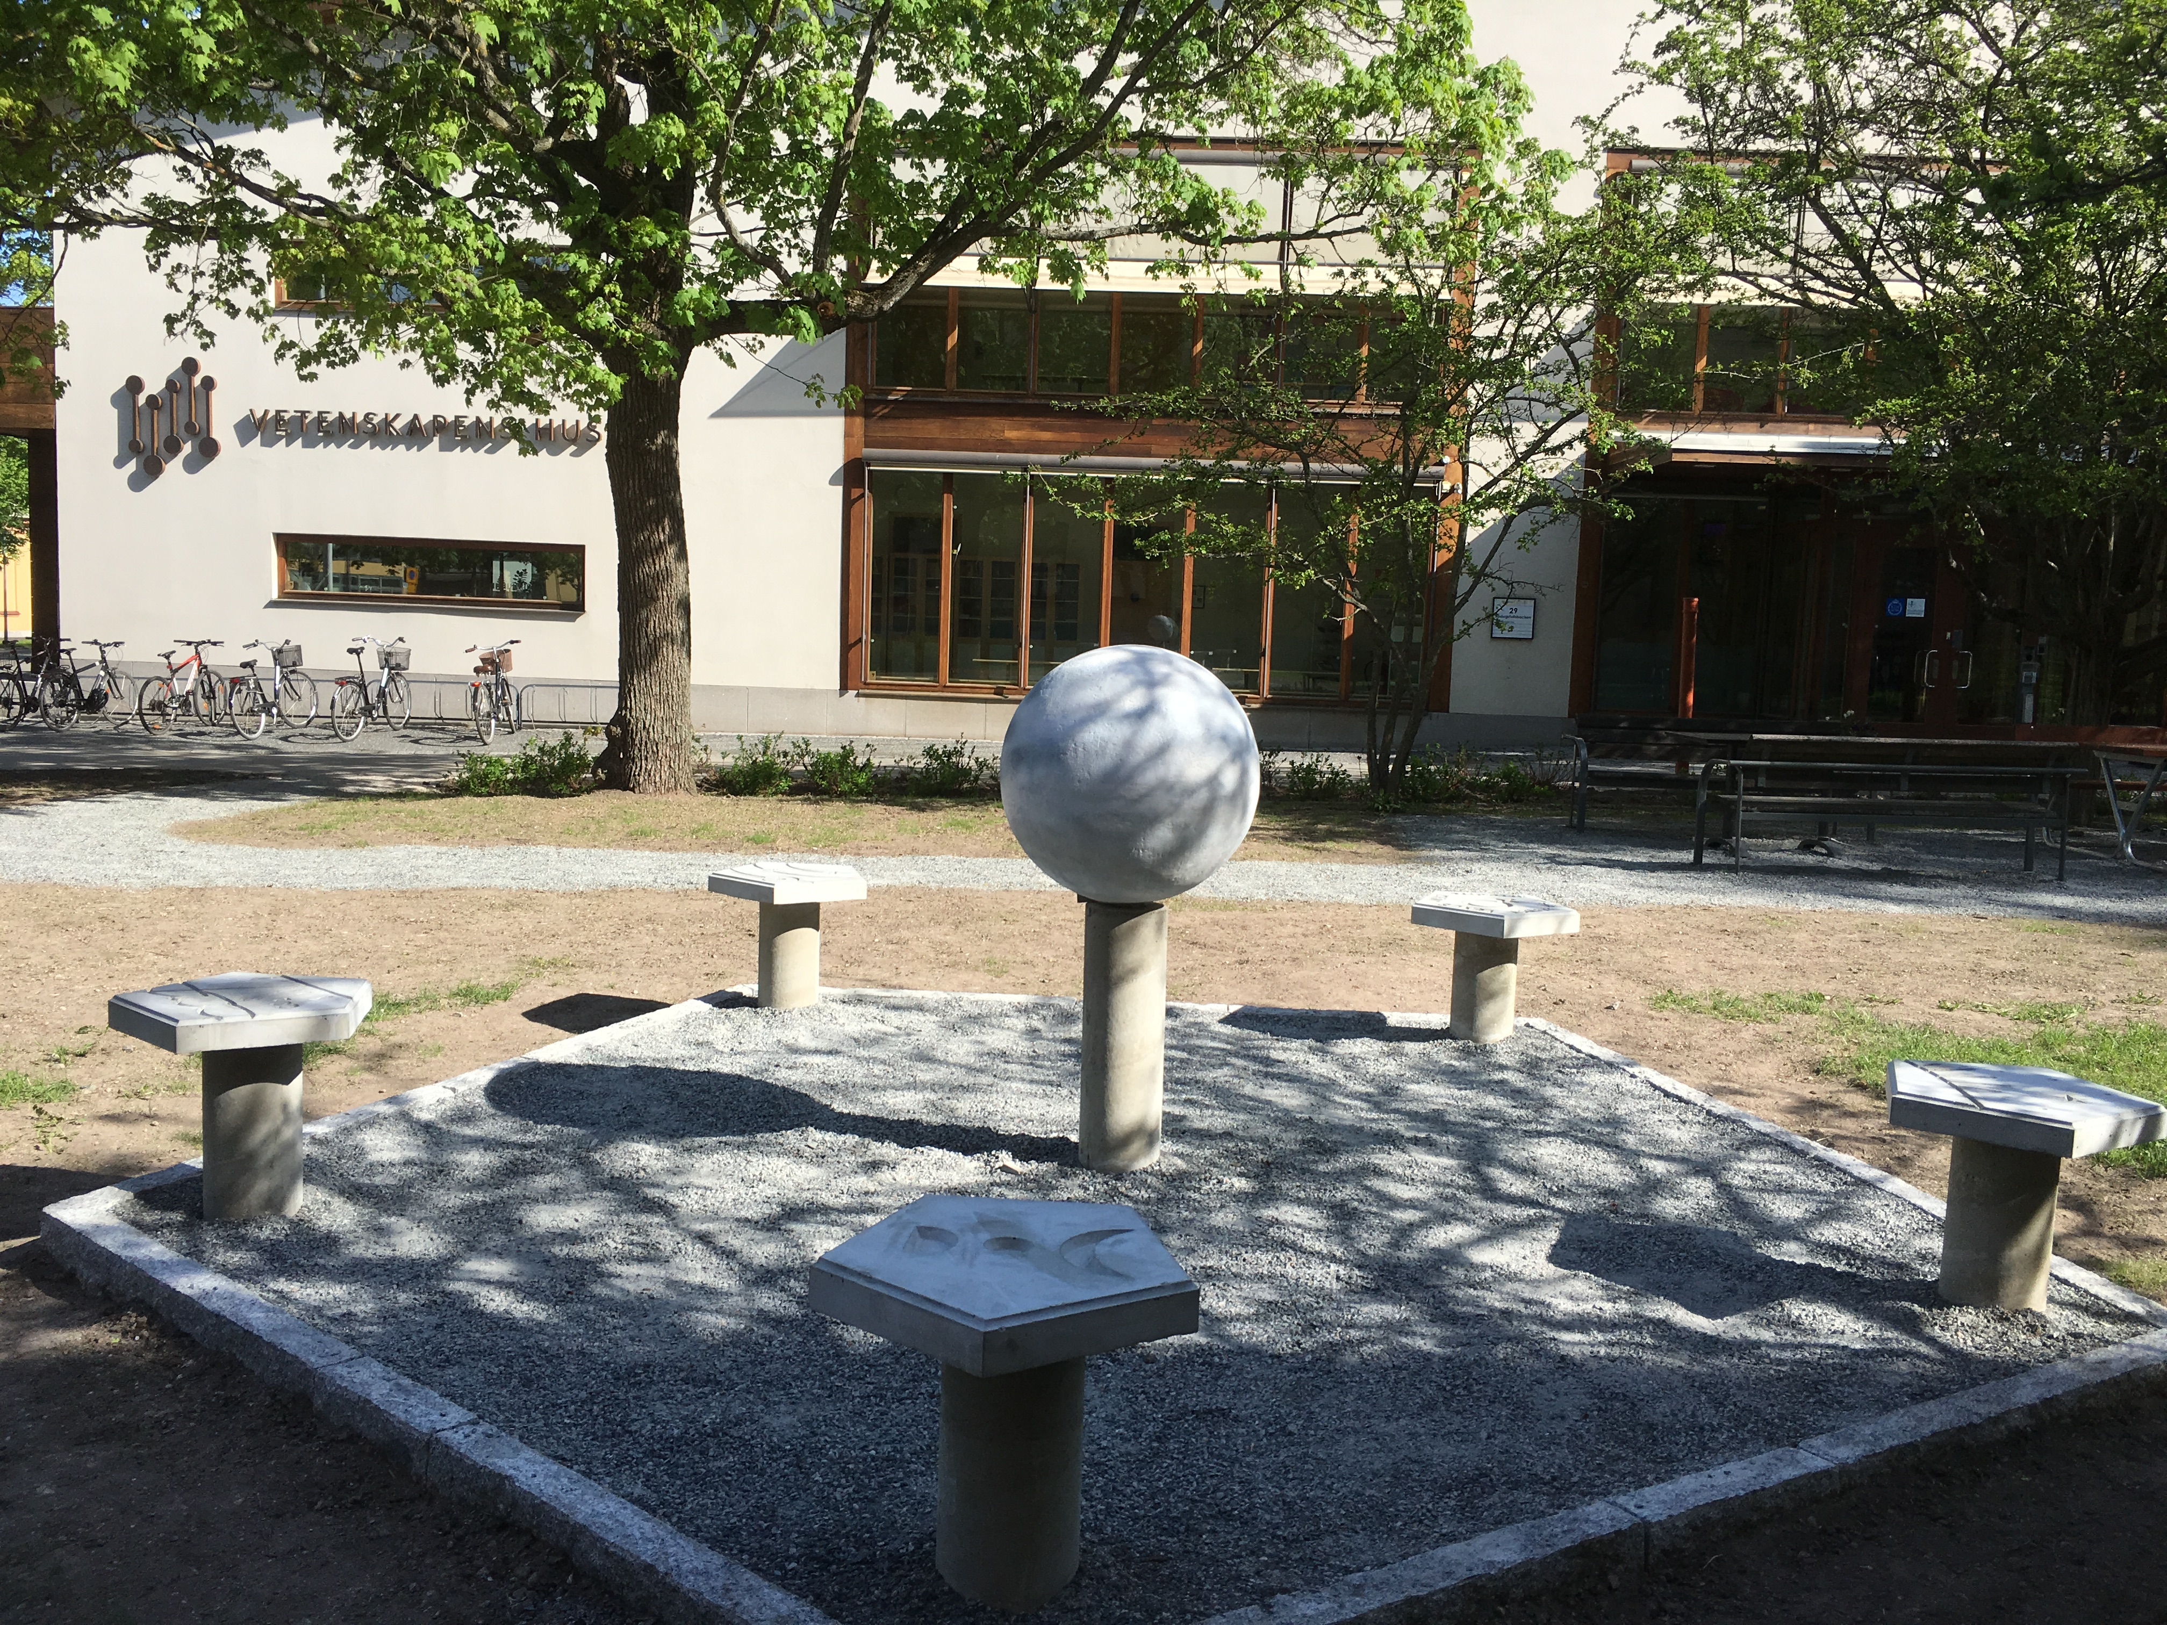

Photo of the model of Venus in Sweden Solar System

2) Inquiry
In this part of the activity the students (in groups of 2-3) investigate certain given questions with the aid of small models of the solar system. The questions to investigate focus on the motions of the planets, the cause of the phases of the moon and inner planets, the times when the moon and planets can be observed and the cause of seasons.
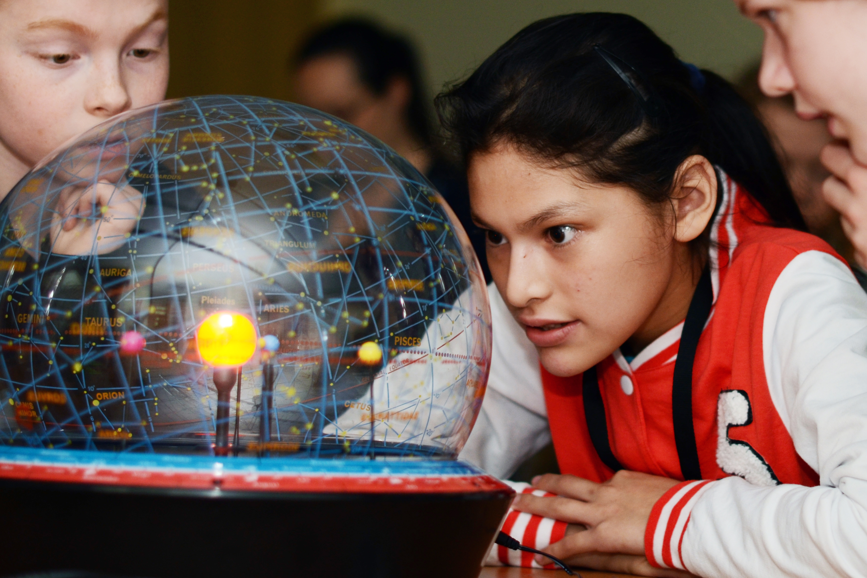

Photo of students working with a model of the solar system

3) Guided tour
The students are given a short guided tour to the observatory, where they also get to visit the roof and look at Globen to see how far away it is. The distances are discussed, and if possible the students get the chance to observe Venus or other planets through the telescope.

Photo from inside of the dome at the observatory during a guided tour with students

4) Lecture/discussion
As a conclusion a short lecture on the solar system, both the actual and the model, is given by the tutor. The students get the opportunity to talk about and reflect on their findings and connect this to the questions posed.

Relevant links:
Sweden Solar System: http://www.swedensolarsystem.se/en/

Assessment

Assessed according to the Swedish middle school curriculum.
Students’ understanding is assessed with the aid of electronic clickers, as well as from the students’ engagement with the activities.

The teachers assess the activity through a questionnaire where they are asked to evaluate the scientific and pedagogical value of the whole activity as well as its connection to the Swedish middle school curriculum.

Possible Extension
The activity can be extended to an activity in a school setting as well as to a national or even international event. It can also easily be extended to other age groups. We envisage the following possibilities for extension:

- Planets on a string – scale model of planets sizes for younger pupils (in school setting)
- Create their own scaled-down solar system in the school vicinity by doing the relevant calculations – older children (in school setting)
- Doing similar activities centred on other planet models in Sweden Solar System (informal setting)
- In collaboration with science centres in other Scandinavian countries, do similar activities at relevant distances from Stockholm in other countries.

References

Urban Eriksson (2014), Reading the Sky - From Starspots to Spotting Stars, Thesis Uppsala university, ISBN 978-91-554-9086-7
Urban Eriksson, Cedric Linder, John Airey, Andreas Redfors (2014), Who needs 3D when the Universe is flat? Science Education, 2014, Vol.98(3), pp.412-442

Säljö, Roger (2000). Lärande i praktiken: Ett sociokulturellt perspektiv. Stockholm: Norstedts Akademiska Förlag.

Lev Vygotsky (1978). Mind in society: The development of higher psychological processes. Cambridge, MA: Harvard University Press.

