D3.1.2 LEARNING SCIENCE THROUGH THEATRE

Project Reference: | H2020-SEAC-2014-2015/H2020-SEAC-2014-1, 665917 |  | Authors: | Menelaos Sotiriou, Vasiliki Grigoriou, Zacharoula Smyrnaiou, Evangelia Petropoulou (NKUA)
Code: | D 3.1.2 |  | Contributors:
Version & Date: | V1, 9/5/2016 |  | Approved by:

Table of Contents
1 Introduction / Demonstrator Identity 3
1.1 Subject Domain 3
1.2 Type of Activity 3
1.3 Duration 3
1.4 Setting (formal / informal learning) 3
1.5 Effective Learning Environment 3
2 Rational of the Activity / Educational Approach 4
2.1 Challenge 4
2.2 Added Value 4
3 Learning Objectives 6
3.1 Domain specific objectives 6
3.2 General skills objectives 7
4 Demonstrator characteristics and Needs of Students 8
4.1 Aim of the demonstrator 8
4.2 Student needs addressed 8
5 Learning Activities & Effective Learning Environments 9
6 Additional Information 19
7 Assessment 21
8 Possible Extension 22
9 References 23

Introduction / Demonstrator Identity

Subject Domain
Mathematics, Physics, Chemistry, Biology

Type of Activity
School Based – Large scale National Activities

Duration
5 months

Setting (formal / informal learning)
Formal and informal. The meetings during the development phase could be within the classroom, the theater of the school (in case that exists), a theater, after class meetings.

Effective Learning Environment
- Communities of practice
- Arts-based
- Dialogic Space / argumentation
- Visits to research centres (virtual/physical)
- Communication of scientific ideas to audience

Rational of the Activity / Educational Approach

Challenge
Traditionally the body has not been used in education. Every involvement of the body had been consistently excluded from the educational practice, the process of learning and the interaction among students. The notion of Embodied Learning was not known and therefore not acceptable by the educational community such as the teachers and the students. Consequently it was difficult to understand that the body does not solely constitute a means of knowledge, or a mediator, but it also reflects the student’s interaction with the environment. (Smyrnaiou Z., Sotiriou M., Georgakopoulou E., Papadopoulou E., 2016). As a result, until now, students are not usually given the chance to learn scientific concepts through expressing them with their body and by the interaction of their body end the environment.

Added Value
Through the principles of embodied learning, basic principles of epistemological knowledge and pedagogical theories can be combined, so that the student can utilize his body as a source of knowledge and feel alive and active during the learning process. As a result, the seemingly absent student’s body can be activated and used as a communication channel between students. (Arvola, Orlandre & Per-Olof Wickram's In Alsop, 2011).Through embodied learning, each time the human motor-sensory system is involved with his body movements, the stimuli he perceives can be converted into a more stable and powerful memory and cognitive representations (Abrahamson, Gutiérrez, Charoenying, Negrete, & Bumbacher, 2012).
Embodied learning has been linked with the field of Science (Smyrnaiou & Kynigos, 2012). According to Hutto et al. (2015), embodied learning enhanced the understanding and acquisition of skills in physics, technology, engineering and mathematics. Gallagher & Lindgren (2015) investigated the advantages of physical representation of transfer (Chun Hung, Hsiu-Hao Hsu, Nian-Shing Chen, 2015) and found that its representation facilitates the learning outcomes more than just reading the transfer. Furthermore, Lozano and Tversky (2006) argue that gestures can facilitate learning, as they are considered as embodied knowledge. Finally, Novack & Goldin- Meadow (2015) argue that even the gestures can be incorporated into educational activities, especially in courses with symbols, such as Mathematics, Physics and Chemistry. Thus, pupils directly connect their movement, gesture and communication with scientific concepts which they perceive, as embedded in the educational activities (Kynigos, Smyrnaiou & Roussou, 2010).
In the LSTT initiative, the scientific concepts are represented with highly original, imaginative and innovative ways. The embodied learning helps in most cases to describe the concepts in another way, more descriptive. During the dramatization of the students’ scenarios, the result was robust when there was a connection between the embodied representation (in its entirety, including the factor of emotion), the scientific concept and verbal description. And it was excellent, if there was extra music or choreography as a representational or embodied system.
It is also worth mentioning that where there was implemented an interdisciplinary and multidisciplinary approach, the scientific concepts were strengthened, as they were in a rich context where, apart from the Art and Science, Literature, Philosophy, Culture (for example this season, or season that Scientist lived) and Society were involved (for example a scientific theatre performance that made reference to the refugee issue, involving harmoniously all previous fields). In this context, science won fr om the embrace with the Art. Science became a vehicle for scientific, social and other messages and challenges. In addition, science acquired emotion and vitality through multiple representations (embodied, verbal, etc.).
Furthermore, in accordance with the constructivist principles, the body is used both inside and outside classroom for experiential learning and is not treated as a place of learning. The principles of Embodied Learning provide answers to questions related to the ways knowledge is constructed by students as they leave behind them the academic model of perceiving knowledge and treat each student as a whole, while they view everyone’s body as a tool for knowledge construction and as a knowledge carrier (Smyrnaiou Z., Sotiriou M., Georgakopoulou E., Papadopoulou E.) Moreover, constructionist learning involves students drawing their own conclusions through creative experimentation and the making of social objects.
Regarding the argumentation approach, by engaging students in argumentation processes provides them with a better insight into the nature of scientific enquiry and the ways in which scientists work. This enculturation in the scientific discourse (Driver, et al., 2000; Duschl & Osborne, 2002; Osborne, 2010) can subsequently lead to epistemic improvement in pupils’ knowledge (Smyrnaiou, et al., 2015). The argumentation process in this case might be the exchange of ideas and dialogue when the script of the theatrical performance is developed.

Learning Objectives

Domain specific objectives
The main aim of the Learning Science Through Theatre (LSTT) approach is to give the opportunity to high school students to stage a play and dramatize scientific concepts and knowledge from the material being taught in schools.
The LSTT’s domain specific objectives are to:
- Get students interested in science and research through theatrical play
- Teach students how to develop a theatrical script, relevant to a scientific topic
- Initiate the development of a theatrical performance from students, regarding a scientific topic
- Initiate contact between students and other professionals (for example directors and musicians)
- Bring schools closer to local community
- Engage parents and the general public into schools’ happenings and events
- Build National-wide student networks
- Open the school to the community and involve all the stakeholders.

Towards attaining these objectives, peripheral aims are formed addressing students’ needs to:
- develop abilities necessary to do scientific inquiry
- develop understandings about scientific inquiry
- identify questions and concepts that guide scientific investigations
- design and conduct theatrical scripts relevant to scientific concepts and issues
- use technology to improve investigations, communications and the development of theatrical performances and videos
- formulate and revise scientific scripts exploiting creativity and imagination
- recognize, analyze and imagine alternative explanations and models
- communicate a scientific argument or issue in a creative way
- develop lifelong learning skills
- develop attitudes befitting a scientific ethos
- link with science and society in a personal context

General skills objectives
In the context of the LSTT, students’ general skills objectives are:
- Active participation in the negotiation of scientific concepts
- Develop creative and critical skills
- Understanding of scientific concepts and phenomena
- Scientific interconnection of science with aspects of art (students will create a multi-disciplinary artistic performance -Science Theater- which demonstrates and deepens understanding, supporting discipline knowledge in both the science and arts educational disciplines).
- Develop spirit of cooperation and teamwork
- Connect the science classroom with professionals, parents and local communities

More Specifically:
- Students will learn and build knowledge about scientific concepts from the curriculum of their courses
- Students will become acquainted with the concept of learning science creatively through Science Theater. They should be aware of what science theater is and how it will help them deepen their science knowledge and express themselves creatively. They should also be specific about key concepts they will be focusing on.
- Students will gain knowledge and experience with group-work in which various groups will create a script, scenography, costumes, music and a video composition. The script should include key concepts connected to the scientific theme. Scientific models and figures can be of great inspiration to scenography, costumes and music.
- The students should be able to describe fundamental concepts concerning their chosen topic. Students will learn to realize common impulses between discipline knowledge in both science and arts by performing a multi-disciplinary artistic performance which demonstrates and deepens scientific and emotional understanding. Throughout the initiative, pupils will learn to make their own decisions during inquiry processes, make their own connections between questions, planning and evaluating evidence, and reflect on outcomes.

Demonstrator characteristics and Needs of Students

Aim of the demonstrator
The demonstrator’s main aim is to give the opportunity to high school students to stage a play and dramatize scientific concepts and knowledge from the material being taught in schools. In this way, students learn science in a creative way.
In the LSTT project, participated 30 schools both public and private. The project is addressed at students between 12 and 16 years old. At least one teacher is responsible for each school/participation (2 teachers are recommended, one from art and one from science). Students and teachers select a science theme that would like to develop as a theatrical performance. In this way, it is given the opportunity to students to inquire about scientific concepts and issues of their interest and express their findings in creative ways, such as the development of theatrical scripts, costumes, scenery, choreography, etc.
The LSTT demonstrator aims at the enhancement of the students’ cognitive involvement, their representation of scientific content using their cognitive processes, the students’ sensorimotor involvement using their bodies or gestures, their emotional involvement, the social interaction and communication between them, the use of past experiences and the creation of new ones based on sociopolitical and historical framework and on beliefs and behaviors, their brain, body and emotion coordination and finally the holistic use of their personality and their motives.

Student needs addressed
The LSTT project includes the development of authentic theatrical scenarios which are performed by the students and are in accordance with their interests and cognitive load. Students develop research questions, identify, investigate and experiment on various scenarios and scripts and construct knowledge. The topic for the development of the theatrical play is selected by the students. This freedom of the topic selection is a challenging factor for students in order to get immersed in active investigations of scientific issues, and be engaged in collaborative discourse and creation. As a result, students manage to constructively build on each other’s ideas, enhance their learning of scientific concepts, co-create and perform theatrical plays. The co-creation engages them in meaningful activities in authentic environments and the theatrical performance helps them learn end express scientific concepts using their body, their gestures, etc. Embodied Learning leads students to the most successful representation of scientific concepts, enables the connection of student to modern forms of Art while even the unconscious movements performed by the students may be indicative of the degree of appropriation and embodiment of scientific concepts. During the implementation of LSTT, students seem to be able to understand the key features of each notion, using scientific terminology and simple vocabulary at the same time, to reliably describe notions and to use their past experience so as to describe scientific knowledge. Additionally, successful rendering of meaning is also possible both through verbal and through non-verbal communication.
Furthermore, collaborative learning is supported through Embodied Learning, which facilitated communication among students. Students’ creativity and imagination is also evident in most LSTT’s theatrical performances (Z., Sotiriou M., Georgakopoulou E., Papadopoulou E., 2016).
Finally, the guidance provided by professionals, not only manages to relate science with art, but also ensures a high-quality production of scientific theatrical play.

Learning Activities & Effective Learning Environments

Science topic: Mathematics, Physics, Biology, Chemistry  (Relevance to national curriculum) Greek Junior and Senior high School curriculum  Class information  Year Group: 1st – 3rd grade of Junior high school and 1st-2nd grade of Senior High School  Age range: 12-16  Sex: both  Pupil Ability: Mixed (The scenario allows space for pupils of various abilities to participate) |  |  | Materials and Resources  What do you need? (eg.printed questionnaires, teleconference, etc.)  material for scenery, costumes, laptop, video editing tools, musical instruments, teleconference platform  Where will the learning take place? On site or off site? In several spaces? (e.g. science laboratory, drama space etc), or one? The preparatory activities will take place mostly in the classroom, but also at local community organizations, such as a city hall, a local police department, etc. Preparation will also take place at students’ homes, with the contribution of their parents. Communication with professionals will be realized in person at schools, but also online. The final event will take place in a conference hall at National and Kapodistrian University of Athens, but also at a Science Center and Technology Museum, Thessaloniki. Finally, participations with video recorded theatre performances will be available online.  Health and Safety implications? none  Technology? Computer and internet access and an online platform to facilitate communication with professionals  Teacher support? scaffolding
Prior pupil knowledge

Individual session project objectives (What do you want pupils to know and understand by the end of the lesson?)
During this scenario, students will
Month 1: Be attracted to engage with scientific topics and theatrical techniques. They form a general group, depending on their interest in participating to the project. They search the internet to find relevant information about the scientific topic/issue they have chosen.
Months 2-3: Acquire a deeper understanding of the topics examined and come up a basic theatrical script. Together with their group members make a plan on the elaboration of the preparation about the theatrical play and split into subgroups (main actors, students responsible for script, for direction, for costumes, for choreography, for lights, etc). They form stories/scenarios based on scientific findings and work on possible theatrical scripts, scenery, costumes, music and choreography.
Month 4: They contact the professionals (director, musician and pedagogist) to discuss about their script, music and direction. They become aware of what it’s like to work creatively, using their imagination and their findings in order to compose innovative theatrical performances. They explore alternative solutions and creative ways to express their arguments.
Month 5: Prepare for their and rehearsals, approximately one week before the 2-days final Theatre Event.
Assessment  Students are engaged in inter-workgroup assessment processes throughout the preparation phase. They define the assessment critreria that acts as activator of reflection processes, engaging members of the same group to strengthen their arguments |  | Differentiation  How can the activities be adapted to the needs of individual pupils?  The LSTT approach is grounded on the respect for students’ needs and interests as a cornerstone for its successful realisation. The selection of the topic to be dramatized and the exploration of relevant issues depend on students. During the inquiry phase all students will participate and contribute with relevant to their interest data. |  | Key Concepts and Terminology  Science terminology:  Maths, Geometry, Physics, Newtonian physics, nuclear physics, astronomy, big bang theory, biology, criminology  Arts terminology:  Theatre performance, direction, scenery, costumes, choreography, music, video editing
Session Objectives:
During this scenario, students will deepen their understanding on scientific concepts and phenomena, using their creativity and imagination

Learning activities in terms of CREATIONS Approach
IBSE Activity | Interaction with CREATIONs Features |  |  |  | Student | Teacher | Potential arts activity
Phase 1:  QUESTION: students investigate a scientifically oriented question | Students pose, select, or are given a scientifically oriented question to investigate. Balance and navigation through dialogue aids teachers and students in creatively navigating educational tensions, including between open and structured approaches to IBSE. Questions may arise through dialogue between students’ scientific knowledge and the scientific knowledge of professional scientists and science educators, or through dialogue with different ways of knowledge inspired by interdisciplinarity and personal, embodied learning. Ethics and trusteeship is an important consideration in experimental design and collaborative work, as well as in the initial choice of question. |  |  |  | Build interest in scientific issues and their explanations/social impact.  engage with open-ended inquiries related to their lives.  use the web and watch videos to explore the selected scientific topic/issue.  Participate in theatrical warm-up activities | The teacher pPicks a specific chapter from the school curriculum in order to involve students to the specific scientific topic.  The teacher tries to attract the students’ attention by eliciting students’ relevant questions or pinpoint unexplored areas to the topic under negotiation. | Team and theatrical warm- up activities
Phase 2:  EVIDENCE: students give priority to evidence | Students determine or are guided to evidence/data, which may come from individual, collaborative and communal activity such as practical work, or from sources such as data from professional scientific activity or from other contexts. Risk, immersion and play is crucial in empowering pupils to generate, question and discuss evidence. |  |  |  | Search on the internet for information relevant to the scientific topic. They work on teams or by their own, exchanging their basic findings. | Ensures that all students have access to information about the scientific topic, either through the internet or through printed materials. Coordinates the group of students. Ensures that the search results will be relevant to the topic that is selected.
Phase 3:  ANALYSE: students analyse evidence | Students analyse evidence, using dialogue with each other and the teacher to support their developing understanding. |  |  |  | Students engage in analysing data (organizing data, finding patterns, assessing data quality), interpreting data, making inferences, modeling, etc.).  They make a first attempt of creation of the script on which they will base their theatrical performance. Improvisation plays a key role in this phase, as students try to set up a basic skeleton of the play. | Acts as a facilitator of the process.  Coordinates the discussions among students regarding the data they collected and encouraging the emergence of organized information models. Encourages and coordinates the group of students to improvise and create a first version of their theatrical performance. | Creation of basic theatrical scripts and improvised theatrical performances.
Phase 4:  EXPLAIN: students formulate an explanation based on evidence | Students use evidence they have generated and analysed to consider possibilities for explanations that are original to them. They use argumentation and dialogue to decide on the relative merits of the explanations they formulate, playing with ideas. |  |  |  | Students collaborate in order to make decisions on the basic explanations they will adopt in order to answer the question that has been set and then proceed with the creation of the theatrical performance.  Students evaluate their explanations in light of alternative explanations, particularly those reflecting scientific understanding. | Acts as a facilitator of the process.  The teacher identifies possible misconceptions.
Phase 5:  CONNECT: students connect explanations to scientific knowledge | Students connect their explanations with scientific knowledge, using different ways of thinking and knowing (‘knowing that’, ‘knowing how’, and ‘knowing this’) to relate their ideas to both disciplinary knowledge and to interdisciplinary knowledge to understand the origin of their ideas and reflect on the strength of their evidence and explanations in relation to the original question. |  |  |  | Explore the topic spherically and find connections with other disciplines (eg arts, theatre, music, technology).  Exploration of new areas according to students’ interests.  Students investigate on the science theatre design and implementation. They are divided into groups:  Script/directing group: Investigate characters and generate ideas for dialogues/actions.  Actor group: Investigate characters and work on performance in collaboration with script/directing group.  Music group: Generate musical ideas which correspond to the script.  Dance group: After consulting with script/directing, actor and music groups, generate choreography ideas to incorporate in the play.  Set/costumes group: Generate ideas after consulting script group and collect materials.  Video group: Generate ideas after consulting script group and collect or create video clips.)  Cooperation occurs both among students who belong to the same of the above groups, and among students who belong to different groups, so that the creative results are aligned. | Allows room and enhances connectivism with other disciplines, such as arts, theatre and music. Teacher also communicates with professionals (director, musician and pedagogist).  Coordinates and encourages the groups of students. | Ιnterdisciplinary activities (science and art activities) that include the creation of the final theatrical script, background music, scenery and costumes, choreography, potential video editing etc.
Phase 6:  COMMUNICATE: students communicate and justify explanation | Communication of possibilities, ideas and justifications through dialogue with other students, with science educators, and with professional scientists offer students the chance to test their new thinking and experience and be immersed in a key part of the scientific process. Such communication is crucial to an ethical approach to working scientifically. |  |  |  | Students communicate with professionals (director and musician) in order to get help about their scientific scripts, the direction and the music.  Students communicate their inquiry findings by implementing a science theatre performance. | Arranges a visit of a scientist and professional artists to the school.  Encourages students to communicate with scientist and artists.  Arranges a final rehearsal of the students to the venue of the final event.  Coordinates the final science performance of the students. | Rehearsals of students’ theatrical performances and final science theatre performances.
Phase 7:  REFLECT: students reflect on the inquiry process and their learning | Individual, collaborative and community-based reflective activity for change both consolidates learning and enables students and teachers to balance educational tensions such as that between open-ended inquiry learning and the curriculum and assessment requirements of education. |  |  |  | Students are evaluated by the evaluators of the final event (scientists, professional artists, science communicator experts). They are also evaluated by the general public of their theatrical play.  Having received their prizes and awards, they discuss with each other and with the teacher about the characteristics of their success (stage design, music composition, group dialogue, ethical decision-making regarding inclusion of all students in the creative process, etc.) and the factors that contributed to some potential unfortunate incidents. | discusses with the students what went well and what did not in the implementation of the final theatrical performance of students. Evaluates whether all students were involved in the creative inquiry process and fills an observation form provided by the organizers, which helps in the description and evaluation of the whole inquiry procedure (meaning making of scientific concepts, participation of students, inquiry learning procedure, embodied learning etc.)  Teacher balances the outcomes of the creative educational process with the assessment features of the curriculum.

Additional Information
During the students’ preparation phase, all participants are supported by professionals in the field of theatre and arts (director and musician) and teachers are supported pedagogically by pedagogists. These professionals share and exchange their ideas and communicate with the students and teachers in order to support them to the whole process. If necessary, visits of the organisers to the schools during the project are organized, in order to help and advise teachers and students during the development, preparation and rehearsal periods. Furthermore, online and in-person workshops are implemented for the teachers to guide and support them. Moreover, the Open Discovery Space Platform (ODS - http://www.opendiscoveryspace.eu/el/community/learning-science-through-theater-2-834218) is an online platform where teachers and students have the opportunity to share their opinions and their educational resources.
Participants that are not able to participate in the two areas for live performances (Athens and Thessaloniki), have the chance to film their performances and send them to the organisers. These films are evaluated as a different category.
Additional information on the LSTT can be found at:
- http://www.scienceview.gr/project/lstt/?lang=en
- http://lstt2.weebly.com/
- https://www.facebook.com/learningsciencethroughtheater/
- http://www.opendiscoveryspace.eu/el/community/learning-science-through-theater-2-834218

So pictures are provided below.
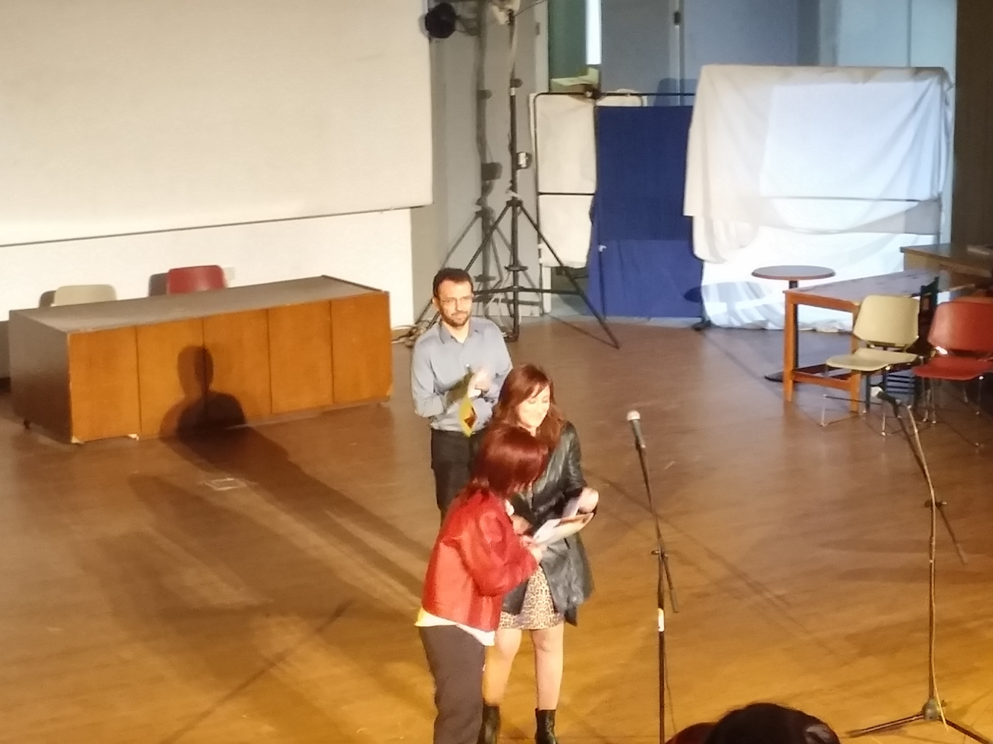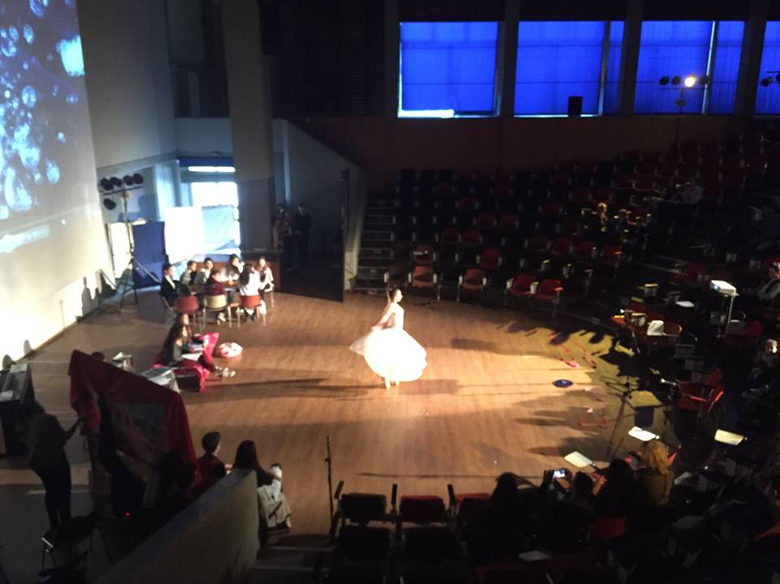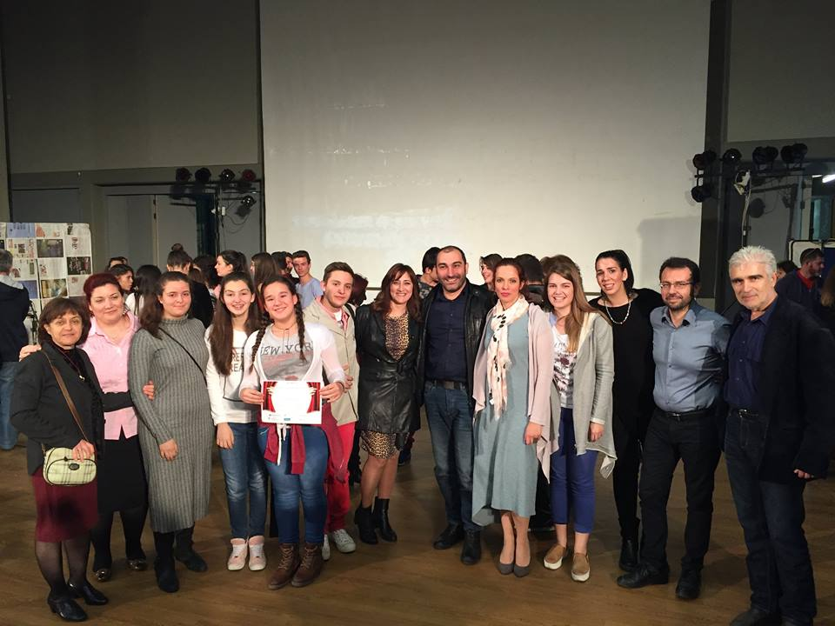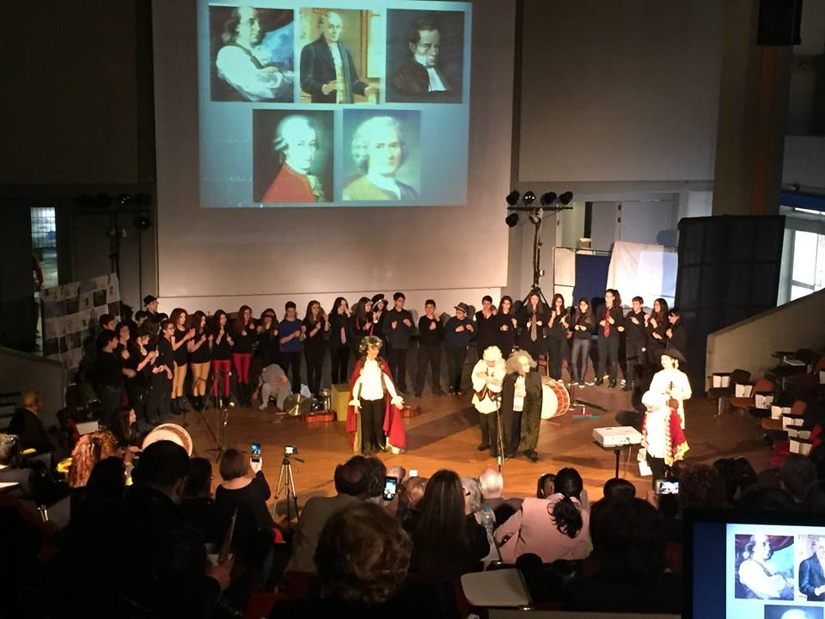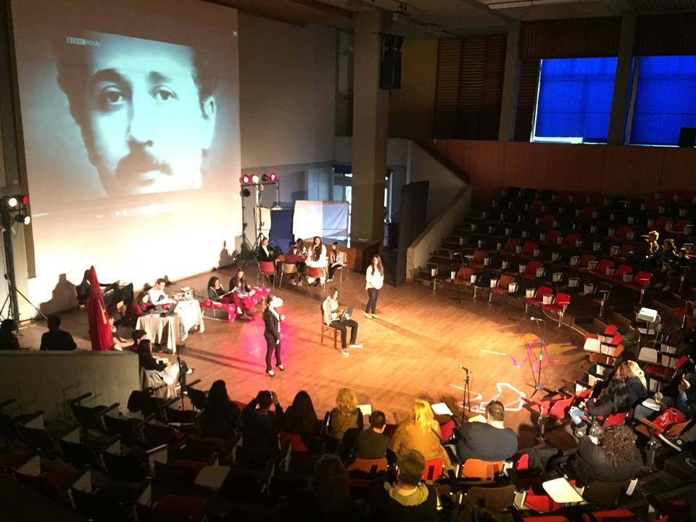

Assessment
The performances are evaluated by evaluation panel of academics, science teachers, directors, actors, musicians (50%) and 1 teacher and 1 student from each school (50%). Awards for different categories are given to the participating schools. These include:
- Best Performance as a whole
- Best Script
- Best Direction
- Best Soundtrack
- Best stage sets and costumes
- Best Choreography
Both quantitative and qualitative data are required to assess students’ and teachers’ cognitive and creative development through the implementation of the LSTT Demonstrator.
For quantitative assessment we recommend the use of the ‘Science Motivation Questionnaire II (SMQ-II)’ (Glynn, et al., 2011; Maximiliane, Schumm, Bogner, 2016) that is addressed to students and the ‘VALNET’ questionnaire addressed to teachers.
Regarding qualitative assessment, each group of participating pupils will be provided with a questionnaire that includes questions about their level of enjoyment, comparisons to more traditional teaching methods, etc. More specifically, since “Entertainment” is an important part of a theatrical performance, it is worth mentioning that students will retain their interest throughout and will enjoy the whole procedure. (Smyrnaiou Z., Sotiriou M., Georgakopoulou E., Papadopoulou E., 2016)
The questionnaire will also include questions based in three categories relevant to Embodied Learning: a) representation of scientific content/generation of meaning, b) communication between students, c) entertainment of the audience, while students dramatize scientific scenarios which take into account both the teaching of sciences and theatre techniques (Smyrnaiou Z., Sotiriou M., Georgakopoulou E., Papadopoulou E., 2016).
Each group of participating pupils will be expected to conduct a report about their experience from the first moment of involvement until the implementation of the action, recording on how they represented scientific concepts, what theater techniques they used, significant episodes that demonstrated their creativity (imagination, innovation, uniqueness), their improvisation and also some significant moves (embodied movements) that they used for the representation of scientific knowledge. At this point, it is worth mentioning that the procedure that is followed during Embodied Learning is gradually escalating. During the first stage, the student may not proceed to a movement related to the representation of concepts. During the second stage, movements are produced sometimes unconsciously or even as the result of imitation while during the third stage the students are asked to think of ways of representing the suggested content. During the final stage which is also the most important one, students apply the newly acquired knowledge to new environments, through dramatization (image/interactive theatre) or role play, where they represent the scientific concept not only verbally or by using body movements, but also by participating both mentally and emotionally to the extent of embodying this new knowledge. (Smyrnaiou Z., Sotiriou M., Georgakopoulou E., Papadopoulou E., 2016)
Teachers are expected to fill an observation rubric, which is significantly important about the scientific and pedagogical evaluation of the whole procedure. This rubric includes the following questions:
- What was the starting point for writing of the script? Did you use an existing script? Did you start from the theatre techniques or from the scientific content? Describe.

- Record two or three important events that demonstrate the creativity of the students (the concept of creativity is associated with imagination, originality, innovation).

- Was embodied learning obvious during the dramatization of the scientific concepts? In which way? Tick the cells of the following table.

Characteristics of embodied learning | Representation of scientific content |  | Communication |  | Entertainment |  | Random, uncategorizable movements
 | Understanding | Imlementation, Fidelity | Successful transfer of meaning | Interaction/ Collaboration | Interest/Fun | Clarity of Roles
Isolated Gestures
Full body movements
Emotional attachment
Facial expressions

- Outline the students’ cognitive path/process from the first moment until the implementation of the first sketch, indicating 2-3 examples in each category:
Α. Initial ideas that remained constant
Β. Initial ideas that evolved
C. Initial ideas that were rejected
D. Important ideas that arose along with the action
- Indicate theatre techniques or other techniques that you implemented/exploited.
- Were there any points where students self-corrected the way that they would represent the concept?
- Were there any points where students improvised? Indicate 2-3 important examples where students deviated from what was agreed, but the final result was equally excellent.
The above rubric is then expected to be analysed using qualitative methodologies, resulting in three different categories of analysis:
- The category of “Representation of scientific context/ meaning generation”
- The category of “Communication
- The category of “Entertainment”
(Smyrnaiou Z., Sotiriou M., Georgakopoulou E., Papadopoulou E., 2016)

Finally, the dramatized scenarios are expected to be observed by a scientist and an artist, who will then analyze the data collected from their observation and they will connect them to the characteristics of Embodied Learning. Thus, a cross analysis of the dramatized scenarios will be implemented from two different points of view (one scientific and one artistic), resulting in a merge into one final analysis.

Possible Extension
Through the LSTT project, students learn about scientific concepts by following the inquiry cycle and creating their own theatrical performances. Engaging parents and local community to the preparation of the theatrical scripts, costumes, etc is one possible extension. Furthermore, The LSTT project is a large scale national activity. By encouraging teachers and students from other countries to participate to the project, it could become a large scale international activity, where students from different countries communicate and share their creative ideas, their own scientific understandings and their own cultural elements.

References
- Abrahamson, D., Gutiérrez, J. , Charoenying, T., Negrete, A., & Bumbacher, E. (2012). Fostering hooks and shifts: Tutorial tactics for guided mathematical discovery. Technology, Knowledge and Learning, 17(1/2), 61–86.
- Alsop, S. (2011). The body bites back!. Cultural Studies of Science Education, 6, 611-623.
- Chun Hung, I., Hsiu-Hao Hsu, Nian-Shing Chen, Kinshuk. (2015). Communicating through body, embodiment strategies. Educational Technology Research and Development. doi: 10.1007/s11423-015-9386-5
- Craft, A. (2011). Creativity and Education Futures. Changing Childhood and Youth in a Digital Age.
- Duschl, R., & Osborne, J. (2002). Supporting and promoting argumentation discourse. Studies in Science Education, 38, 39–72.
- Gallagher, S., & Lindgren, R. (2015). Enactive metaphors: learning through full-body engagement. Educational Psychology Review.
- Hutto, D. D., Mc Givern, P., & Kirchoff, M. D. (2015). Exploring the enactive roots of STEM education. Educational Psychology Review.
- Kynigos, C., Smyrnaiou, Z., & Roussou, M. (2010, June). Exploring rules and underlying concepts while engaged with collaborative full-body games. In Proceedings of the 9th International Conference on Interaction Design and Children (pp. 222-225). ACM.
- Lozano, S. C., & Tversky, B. (2006). Communicative gestures facilitate problem solving for both communicators and recipients. Journal of Memory and Language, 55(1), 47-63.
- Maximiliane F. Schumm & Franz X. Bogner (2016) Measuring adolescent
science motivation, International Journal of Science Education, 38:3, 434-449, DOI:
10.1080/09500693.2016.1147659
- Novack, M., & Goldin-Meadow, S. (2015). Learning from gesture: how our hands change our minds. Educational Psychology Review, 27(3), 405-412.
- Osborne, J. (2010). Osborne, J., Arguing to learn in science: The role of collaborative, critical discourse. Science, 328(5977), 463-466
- Smyrnaiou Z., Sotiriou M., Georgakopoulou E., Papadopoulou E. (2016), Connecting Embodied Learning in educational practice to the realisation of science educational scenarios through performing arts
- Smyrnaiou, Z., Petropoulou, E., Sotiriou, M. (2015). “Applying Argumentation Approach in STEM Education: A Case Study of the European Student Parliaments Project in Greece.” American Journal of Educational Research, 3(12), 1618-1628.
- Smyrnaiou, Z., Kynigos, C. (2012). Interactive Movement and Talk in Generating Meanings from Science, IEEE Technical Committee on Learning Technology, Special Theme "Technology-Augmented Physical Educational Spaces" Hernández Leo, D. (Ed). Bulletin of the Technical Committee on Learning Technology, 14, (4), 17-20. Retrieved October 2012, available online at http://www.ieeetclt.org/ content/bulletin-14-4.

2011 Shawn M. Glynn, University of Georgia, USA http://www.coe.uga.edu/smq/

