D3.1.x Global Science Opera (GSO)

Project Reference: | 665917 |  | Author: | Oded Ben-Horin (HSH),  Sofoklis Sotiriou (EA),  Petros Stergiopoulos (EA)  Janne Robbestad (HSH)
Code: | D 3.1.x |  | Contributors: | NKUA, art@CMS
Version & Date: | 1.0 / May 9th, 2016 |  | Approved by:

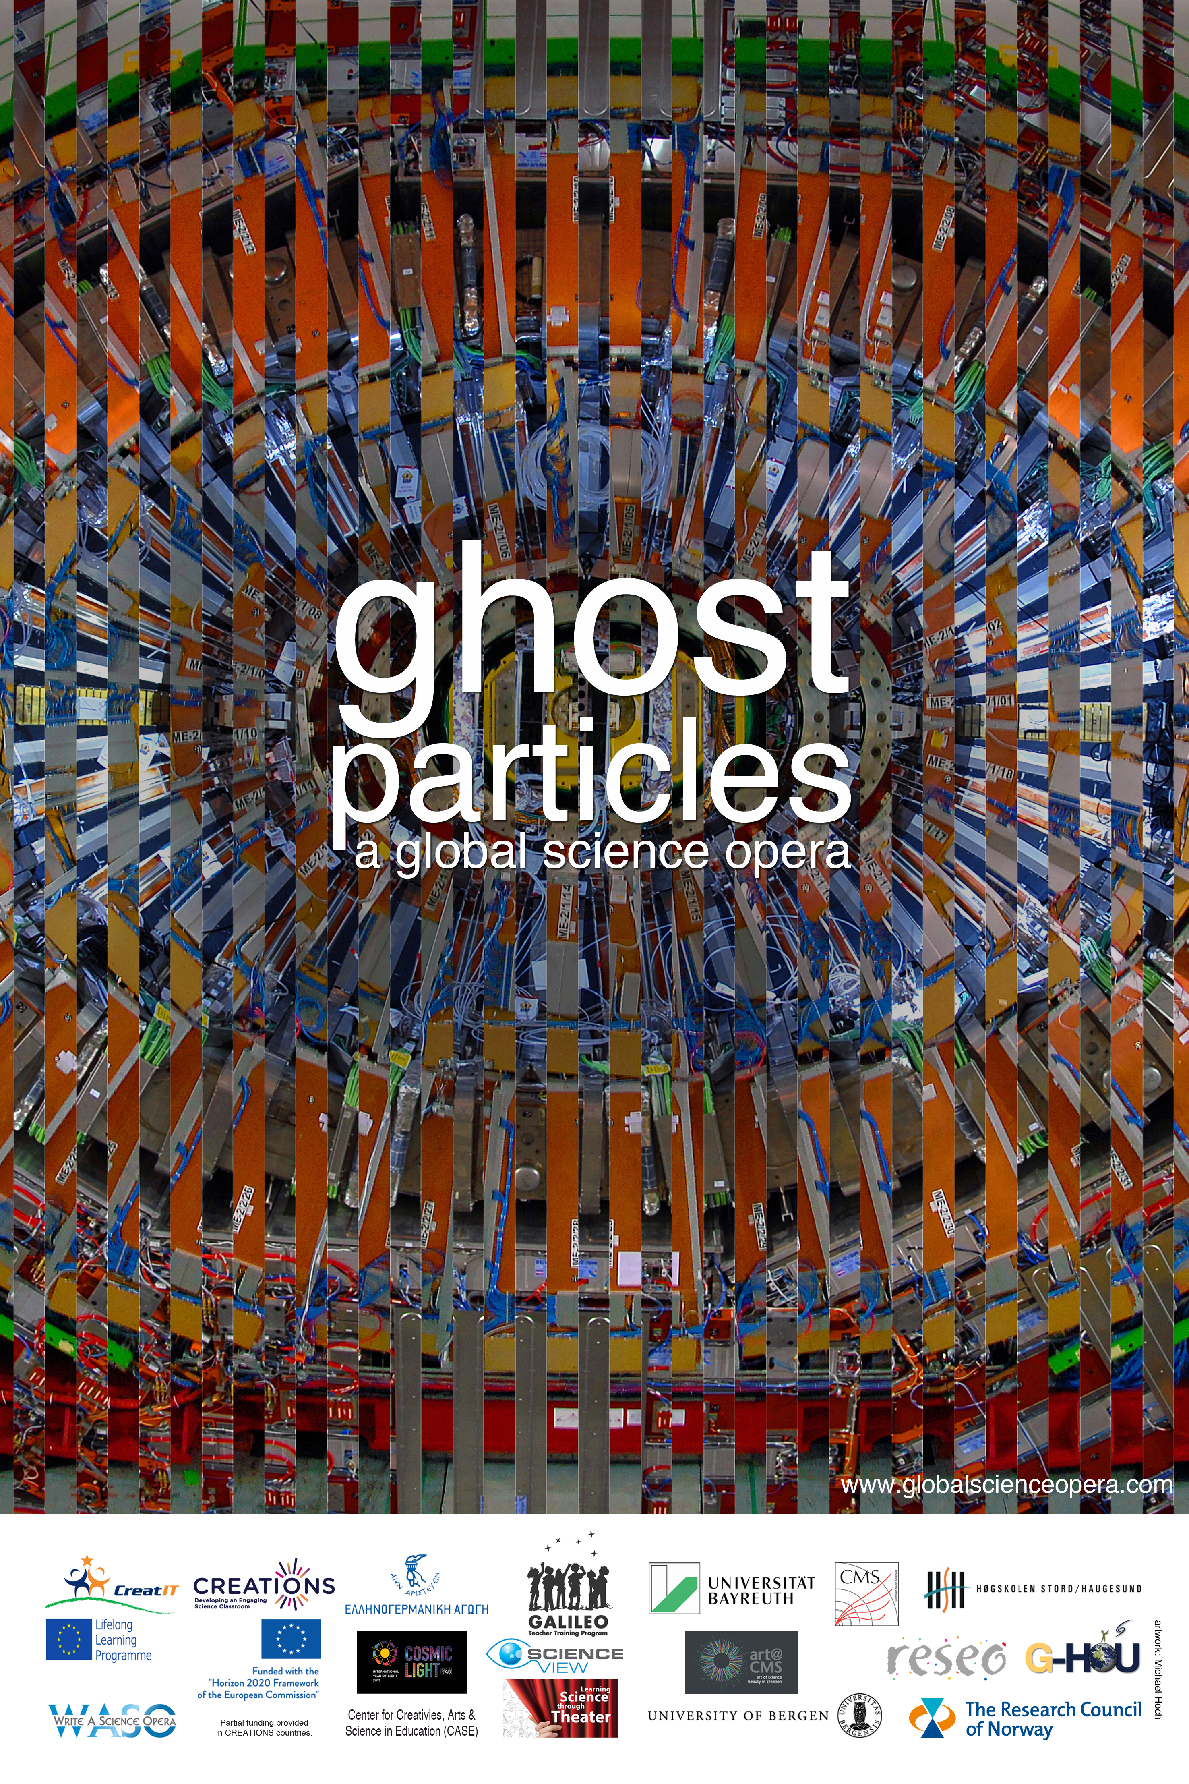

Table of Contents
1 Introduction / Demonstrator Identity 3
1.1 Subject Domain 3
1.2 Type of Activity 3
1.3 Duration 3
1.4 Setting (formal / informal learning) 4
1.5 Effective Learning Environment 4
2 Rational of the Activity / Educational Approach 6
2.1 Challenge 6
2.2 Added Value 6
3 Learning Objectives 7
3.1 Domain specific objectives 7
3.2 General skills objectives 7
4 Demonstrator characteristics and Needs of Students 9
4.1 Aim of the demonstrator 9
4.2 Student needs addressed 9
5 Learning Activities & Effective Learning Environments 10
6 Additional Information 19
7 Assessment 20
8 Possible Extension 21
9 References 22

Introduction / Demonstrator Identity

Subject Domain
The Global Science Opera (GSO) annual production in 2016 (“Ghost Particles”) focuses on particle physics, and specifically the particles photon, neutrino and Higgs boson. The opera communicates scientific knowledge about these particles as well as some of the creative processes that led up to our understanding of them (e.g. Wolfgang Pauli’s postulation of the Neutrino particle in 1930 and the process that ensued). Through both science and arts education activities and a virtual visit to CERN, pupils engage with inquiry-based activities.
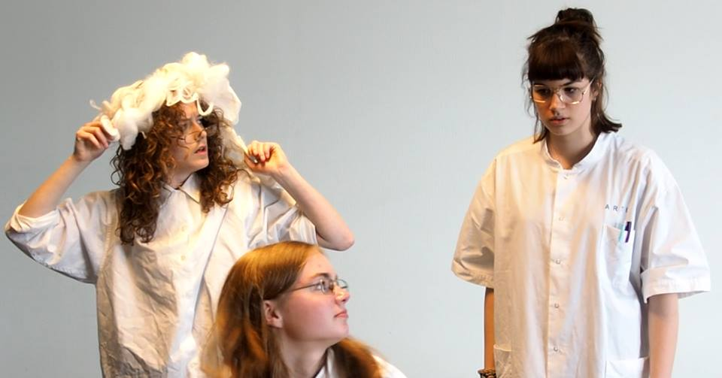
Ghost Particles rehearsal for European Opera Days (EOD), Holland (May, 2016)

Type of Activity
GSO is a global, trans-disciplinary creative education initiative made possible through digital interactions. It is a network of scientists, art institutions, schools, universities, in all of the inhabited continents. It exists at the meeting point of science and art, of pupils and scientists, of research and practice, and of all human cultures. GSO envisions, creates, produces and performs educational operas by and for a global community through real-time live streaming. Each school takes part in a local implementation which is also part of the international effort.

Duration
The process of creating a GSO production lasts for approximately 10 months. During this time, teachers in the various countries choose to dedicate time according to their capacities, and their roles in the opera (e.g. performing countries usually dedicate more time than others). The premier opera performance (scheduled for November 19th, 2016) is expected to last for 5 hours including sound checks, general rehearsal, and actual performance.

Setting (formal / informal learning)
GSO is open to all kinds of educational frameworks. Most of the performing parties are schools which have integrated the GSO into their activities (e.g. the Premier Academy in Milton Keynes, England). There have also been examples of other types of institutions, such as universities (e.g. the Dance company of the University of Antofagasta in Chile), or groups of disabled pupils coached by a theater school (e.g. Speel je Wijs, Holland).
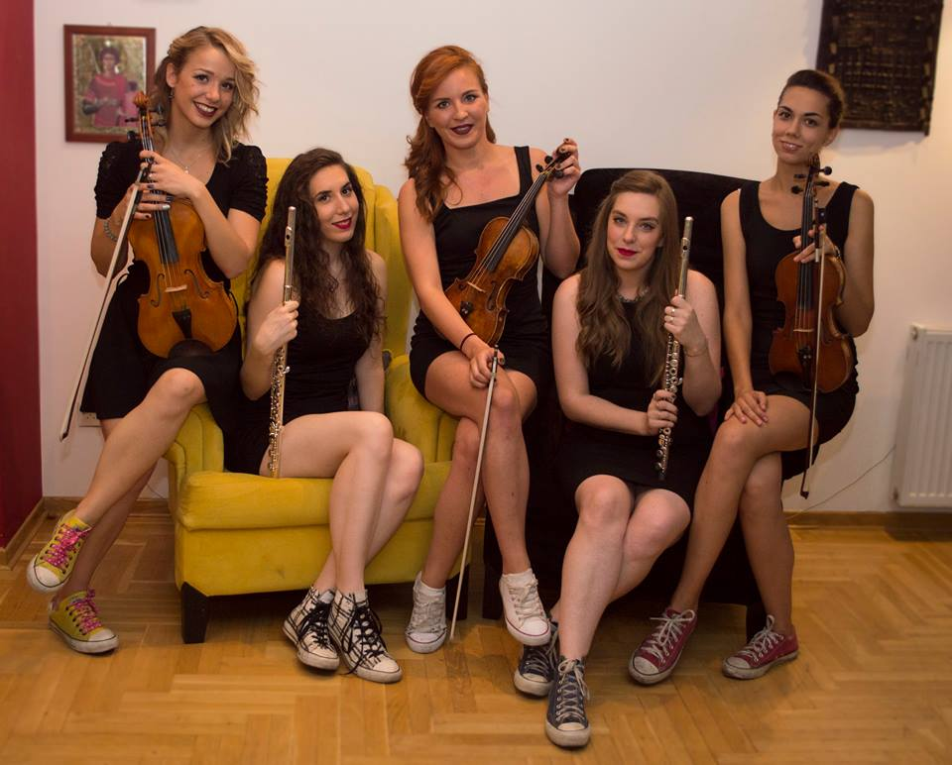
The Serbian Music and Science ensemble, "Galactic Echo" is composing music for the "Ghost Particles" opera

Effective Learning Environment
This demonstrator relates to the following categorization (please see CREATIONS D2.3 for further details):
- Arts-based which addresses and enhances scientific interconnection of science with aspects of art
- Dialogic space / argumentation aiming to engage students in argumentation and dialogic processes for a better insight into the nature of scientific enquiry and the ways in which scientists work
- Communities of practice (web-based/physical) aiming to develop a network of online communities and channels sharing multicast-activities inspired by science on national or international level.
- Communication of scientific ideas to audience addressing the need to establish settings in which learners will be enhanced to externalize and elaborate on scientific concepts they have acquired while interacting with an audience (learners, teachers, scientists, parents, etc.); promoting this way a dual channel of communication: a) reflective processes (self-engagement for scientific consistency and verification) and b) explicit elaboration of scientific ideas through interaction and ‘extroversion’.

The GSO approach has been to communicate with “alpha-contacts” in each country, who thereafter engage institutions in their countries. For this reason, there has been a wide diversity in the approach to implementation, and to what effective learning environments represent.
- Global environment: Digital platform (Adobe Connect for meetings/rehearsals, and live-streaming for performance)
- Local environment: School, university, art institution or research center

Rational of the Activity / Educational Approach

Challenge
While GSO provides many opportunities, it also poses challenges in the areas of implementation, common learning goals across country borders in different continents and different age-groups, common understanding of arts education procedures, the definition of artistic quality in this context, and a disparity regarding technical means between schools in varying countries.
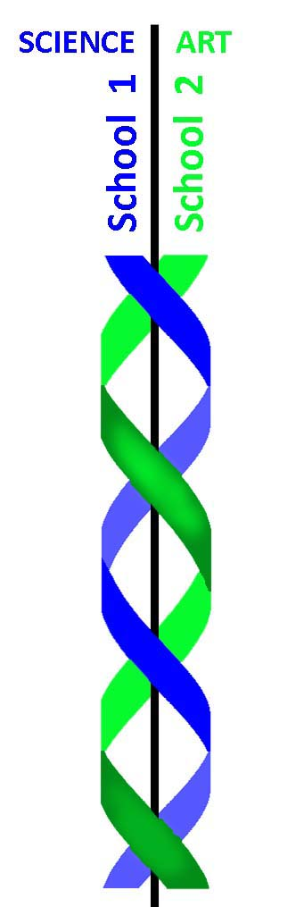
Relevance for RRI: A goal of the GSO is to facilitate inclusion of any and every pupil regardless of any circumstances. That leads to situations, though, in which some participating schools have barriers to participation due to lack of basic technological equipment. Due to its global character, many of the participating countries are not eligible for EU funding. Rather, in the long-term, the inclusion of these pupils must be based on a creative activity which can provide inclusion for many such schools. One approach to this is the development of a “Science Opera” app which will enable participation of whole communities of schools in the GSO. This app is currently being developed by students of the AP college in Belgium’s European Project Semester (EPS), who will receive 20 ECTS for their effort. Delivery time: Spring 2017.

Added Value
GSO provides learning opportunities in which pupils from around the globe may cross-inspire and learn from and with each other. In addition to being a crowd-sourced collaborative creativity environment, it provides social and emotional settings during which pupils of various cultures, traditions, ages and religions, may explore together. GSO necessitates Possibility Thinking (see CREATIONS Deliverable 2.1), as it requires the invention of solutions for a variety of artistic, science education and technological procedures. Also, for school pupils, preliminary data has shown that the concept of “performing in front of the whole world” provides a growing opportunity. Several of the scenes in “Ghost Particles” are being created by educational institutions in more than one country together (e.g. Spain/Portugal, Greece/UK, Norway/Iran/Germany). In some cases (e.g. Australia/UK), continued collaboration has been established beyond the GSO production boundaries.
Relevance for RRI: Robbestad (2016) has proposed that the GSO’s scope is fitting to the integration of concepts of eco-scenography, and thus communicating sustainable procedures with regard to materials used for the GSO’s scenography of productions, and possible inspiring the thematic field of exploration in future productions.

Learning Objectives

Domain specific objectives
The domain in 2016 is particle physics. Due to the fact that GSO pupil ages vary from country to country, learning objectives must be defined locally by each school. Generally speaking, the objectives of the 2016 production have been to become acquainted with the particles photon, Higgs boson, Neutrino, with the discovery process of the Neutrino, with the research at CERN, and, through virtual visits to CERN, to engage in questions inspiring inquiry in this field (Chappell et al, 2016).
In arts education, the objectives are to learn school opera as a methodology, including specific skills and inquiry with the various included arts education domains (music, drama, scenography, light design, etc.).
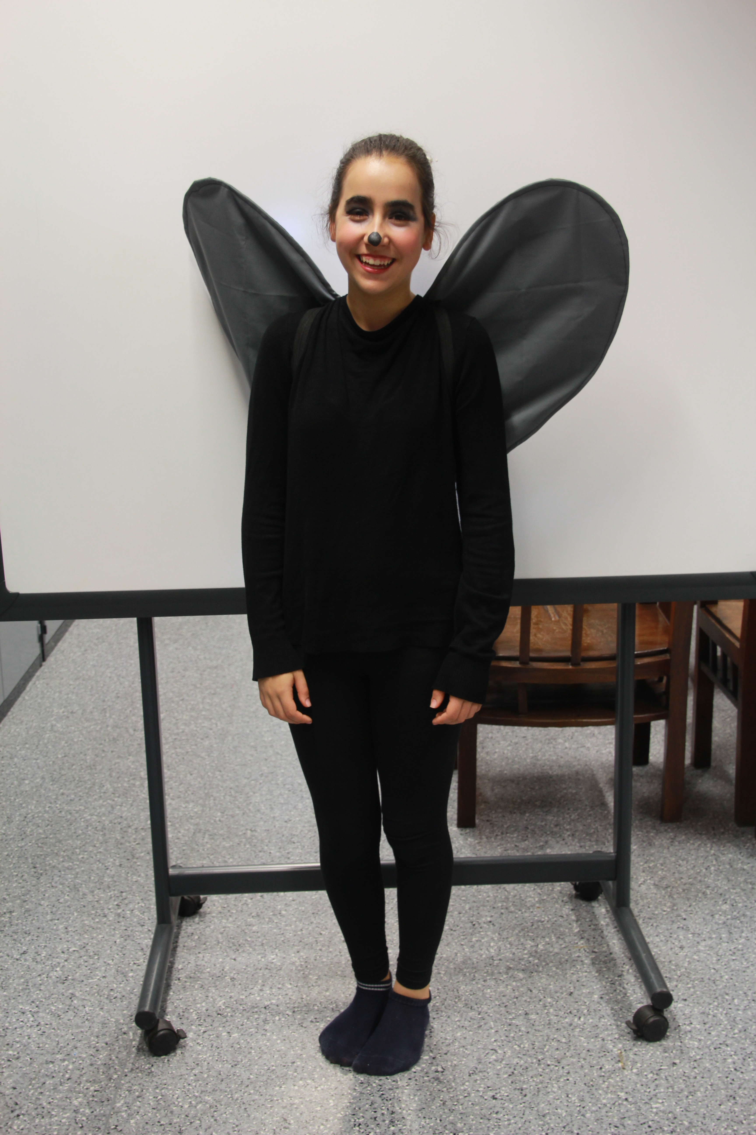
"Firefly" is one of the main characters in the "Ghost Particles" opera

General skills objectives
The objective of skills may be seen as developing social and emotional skills, cognitive skills, and, especially, meeting points between these, within an international context. Creativity and critical thinking, both considered to be “21st century skills”, may largely be said to occur in the interaction, and cross-fertilization between these groups of skills (OECD, 2015).
More specifically, learning across boundaries, inquiry spanning over more than one school collaboratively, and technological skills, may be seen to be part of the inquiry process exemplified by GSO.

Demonstrator characteristics and Needs of Students

Aim of the demonstrator
The aim of the demonstrator is to describe the GSO methodology for implementation, explore further its challenges and opportunities, receive rigorous feedback regarding this relatively new practice, and support its implementation within the CREATIONS project.

Student needs addressed
Needs addressed are the creation of a Living Dialogic Space within creative science exploration, and rigorous engagement with Possibility Thinking (see CREATIONS Deliverable 2.1).

Learning Activities & Effective Learning Environments
Due to its character, GSO exercises a flexible implementation, whereby several options are provided to the “alpha-contacts”, from which they may choose to implement their participation.
Over the complete production, the complete GSO network simulates an “opera company” in which performers, composers, designers, scenographers, science educators, etc., collaborate to create an opera. There is therefore no “one size fits all” approach to the activity. Typically, though, a school will receive a scene in the opera, which they will write the libretto for following their exploration of the scientific theme at hand, and thereafter compose music for it, and perform that scene by video or online, as part of a global community.
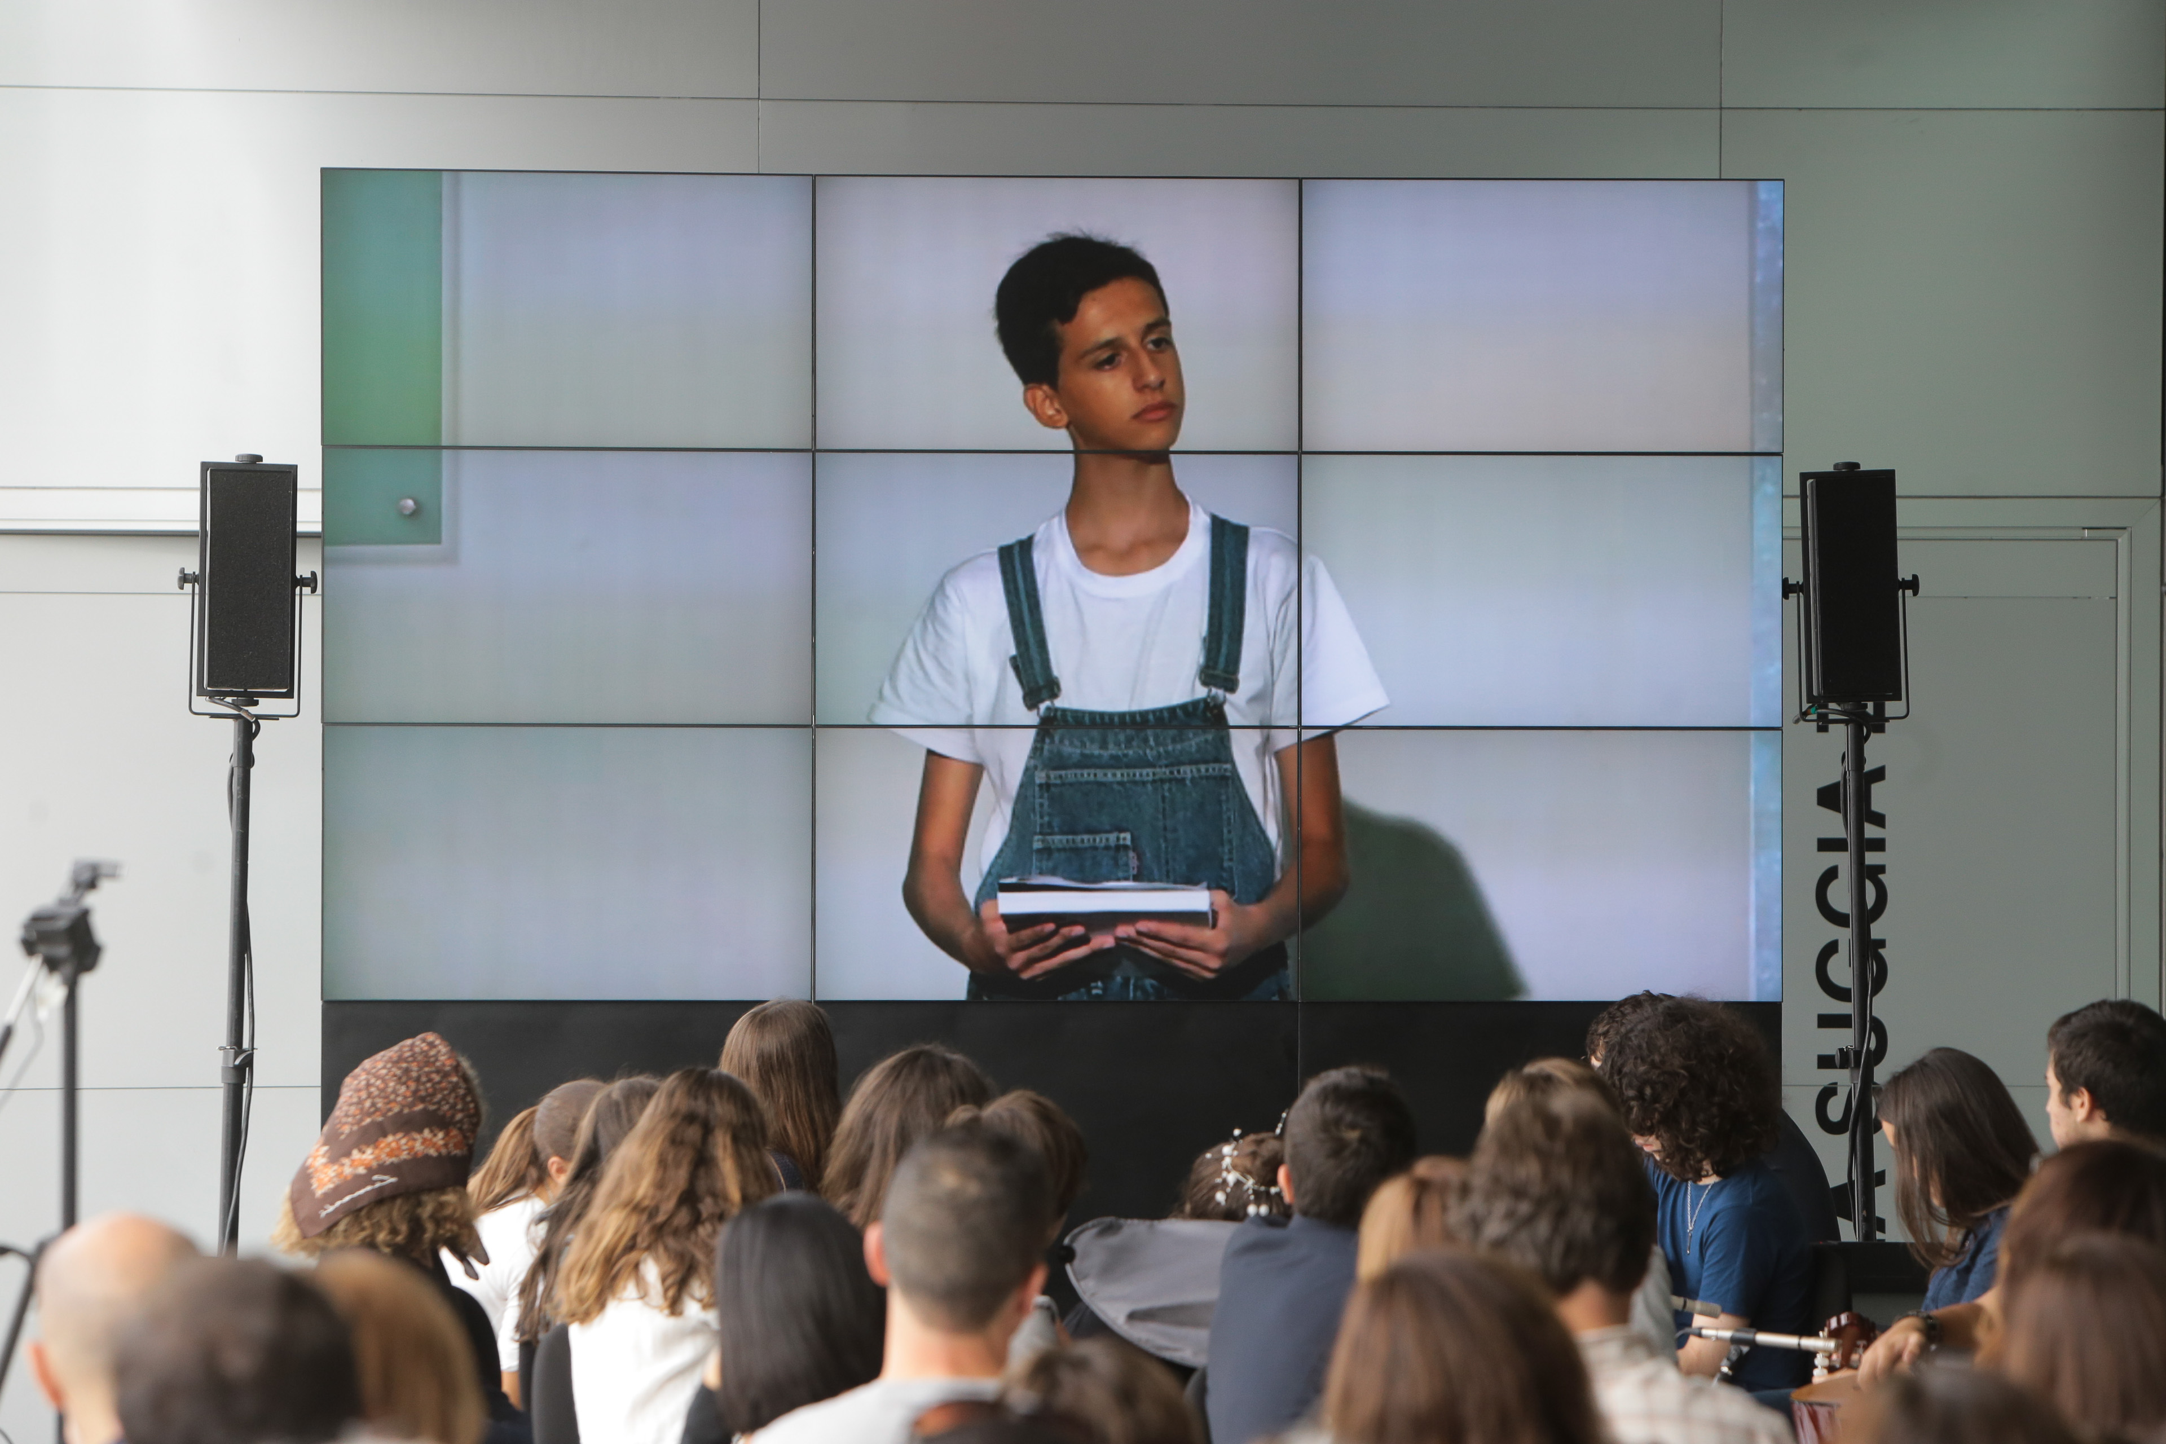
1 In the Global Science Opera, the various opera scenes take place around the globe in real time

Science topic: particle physics  (Relevance to national curriculum)  Class information  Year Group: GSO is open to all grades. Most classes are 5th grade or higher.  Age range: GSO is open to all ages. Most pupils are of age 10 and older  Sex: both  Pupil Ability: The scenario allows space for pupils of various abilities to participate. Each teacher is responsible for connecting the scientific theme to the level of his/her pupils, with a focus on science and/or art, according to the educator’s specialization, yet all participate in both exploratory processes to various degrees. GSO is open to pupils with disabilities, and the Dutch team has focused on involving pupils with disabilities in the project. |  |  | Materials and Resources  What do you need?  This depends on the specific activity taking place in each school. Examples : Performers will need access to video and/or streaming facilities, as well as costumes. Composers need access to music lessons and instruments. All participants need access to high level scientific information, which is continuously in dialogue with scientists and science educators, and will achieve its highlight during the virtual visit(s) to CERN during the process.  Where will the learning take place?  Each class will decide this for themselves. Most learning will take place in the classroom, in a local arts institution, and during virtual visits to CERN.  Health and Safety implications?  These are not considerable.  Technology?  Yes. Taking part in the rehearsals and streaming (for countries performing live) involves access to internet.  Teacher support?  Both science and art teacher support is needed. In countries in which the GSO teachers belong to only one of these disciplines, GSO has encouraged making contact with teachers or professionals within the other discipline(s), or collaboration with one of the other teams in order to make up for the lacking capacity in that specific school/university.
Prior pupil knowledge

Individual session project objectives:
The GSO “Ghost Particles” scenario/production will be an opportunity for students to explore issues related to particles and their scientific qualities, and general acquaintance with the research at CERN, based on virtual visits (Alexopoulos, 2016) which will set the inquiry process for the opera in motion.
GSO is focused on science inquiry in a creative framework. In addition, science communication is also a major factor by allowing a scientific theme to inspire a multi-disciplinary artistic project’s outputs. The complete process is guided by persons from within a variety of disciplines including both science and the arts. Characters, libretto, composition, stage design, costume, etc. will be studied by pupils and realized during the project.
The project will also allow students to interact and develop social and collaboration skills, thus experiencing how science can be a group activity and not only a solitary one: Individual, collaborative and communal activities for change. This takes place also within the added digital dimension, in which pupils take part in a “Global Classroom” with other pupils around the world.
Pupils will be introduced to the common creative impulses of science and the arts.
Specifically, the following aims are present:
- Active participation in the negotiation of scientific concepts
- Developing creative skills based on the CREATIONS inquiry approach
- Understanding of scientific concepts and phenomena
- Scientific interconnection of science with aspects of art (students will undergo a multi-disciplinary artistic process which demonstrates and deepens understanding, supporting discipline knowledge in both the science and arts educational disciplines).
- Developing a cross-country, multi-cultural spirit of friendship, cooperation and teamwork
- Digital competences and their social impacts
Connecting the science classroom with research infrastructures

Assessment  The WASO Guidelines’ Appendix 1 provides an evaluation plan for students who took part in the WASO project. This questionnaire includes questions about their level of enjoyment, level of difficulty, comparisons to more traditional teaching methods, etc.  The issue of assessment of the artistic quality is relevant as well, especially with regard to GSO’s outreach capabilities. |  | Differentiation  How can the activities be adapted to the needs of individual pupils?  This is up to the local teachers. GSO provides a framework which needs local adaptation. In the future, it will be possible to develop GSO’s for a specific age group, with a tailor-made curriculum focus. |  | Key Concepts and Terminology  Science terminology:  Higgs Boson, Photons, Neutrinos, Mass, Light, Big Bang, the Sun, Oscillations of Neutrino particles  Arts terminology:  1) Aria: Solo song by one character. The plot’s “action” is stopped to allow this character to express a certain emotion and inner feelings.  2) Duet: Two singers, preferably each singing their own verse followed by a section in which they sing together.  3) Ensembles: Three or more singers  4) Choir: The choir can be used to ”comment” during the other songs, or as simple choir pieces.  5) Overture: Instrumental (no voices) opening piece which sets the mood of the opera.  6) Interlude: Music performed between acts or scenes.  7) Recitative: ”Spoken Song” which tells a story, and which propels the plot further by revealing action (what has taken place, what will take place, a secret, etc.).  8) Tableau– A dramatic activity in which a group of pupils are asked to physically construct an opera scene through body placement, facial expressions, and props  9) Various musical instruments
Session Objectives:
During this scenario, students will
Explore the art@CMS website, and learn about modern research concerning the relevant particles (Neutrinos, Photons, Higgs Boson); Take part in a virtual visit to CERN; Experience musical, visual design, drama techniques as tools for the opera; be introduced to pupils from other countries.

Students will gain knowledge and experience with group-work in which various groups will create specific synopsis, libretto, composition, scenography, costumes for the Science Opera, accompanied by a continued exploration of the particles. The libretto should include key concepts connected to the scientific theme. Scientific models and figures can be of great inspiration to scenography, costumes and music.

Throughout the scenario, pupils will learn to make their own decisions during inquiry processes, make their own connections between questions, planning and evaluating evidence, and reflect on outcomes.

Learning activities in terms of CREATIONS Approach
IBSE Activity | Interaction with CREATIONs Features |  |  | Student | Teacher | Potential arts activity
Phase 1:  QUESTION: students investigate a scientifically oriented question | Students pose, select, or are given a scientifically oriented question to investigate. Balance and navigation through dialogue aids teachers and students in creatively navigating educational tensions, including between open and structured approaches to IBSE. Questions may arise through dialogue between students’ scientific knowledge and the scientific knowledge of professional scientists and science educators, or through dialogue with different ways of knowledge inspired by interdisciplinarity and personal, embodied learning. Ethics and trusteeship is an important consideration in experimental design and collaborative work, as well as in the initial choice of question. |  |  | Generate and writes down words\ideas about Neutrinos, Photons, Higgs Boson, and shares with others in order to learn from their previous knowledge. | Activates previous knowledge in the fields of scientific exploration, and introduces particles by means of a virtual visit to CERN. | Begin cooperation with music/fine arts/drama/dance teacher(s) at your school in order to explore those subjects. Examples: experimenting with various musical instruments and drama techniques.
Phase 2:  EVIDENCE: students give priority to evidence | Students determine or are guided to evidence/data, which may come from individual, collaborative and communal activity such as practical work, or from sources such as data from professional scientific activity or from other contexts. Risk, immersion and play is crucial in empowering pupils to generate, question and discuss evidence. |  |  | Students compare their ideas to existing evidence. Take part in virtual visit to CERN. | Guide students to relevant evidence. | Comparing artistic ideas to other art-works, especially school art works created by pupils. Give preference to art projects inspired by scientific phenomena.
Phase 3:  ANALYSE: students analyse evidence | Students analyse evidence, using dialogue with each other and the teacher to support their developing understanding. |  |  | Students analyse evidence and make conclusions regarding their own initiative. | Help students interpret the potential implications of the evidence for the students’ own inquiry. | Begin creating and rehearsing the opera within the various arts disciplines (libretto, costumes, music, etc.)
Phase 4:  EXPLAIN: students formulate an explanation based on evidence | Students use evidence they have generated and analysed to consider possibilities for explanations that are original to them. They use argumentation and dialogue to decide on the relative merits of the explanations they formulate, playing with ideas. |  |  | Formulations of scientific explanations, and sharing ideas with GSO schools in other countries | Guide students in their consideration of possibilities. | Continued production of original material (music, etc.), and opera rehearsals, and expanding awareness of what other GSO students are developing.
Phase 5:  CONNECT: students connect explanations to scientific knowledge | Students connect their explanations with scientific knowledge, using different ways of thinking and knowing (‘knowing that’, ‘knowing how’, and ‘knowing this’) to relate their ideas to both disciplinary knowledge and to interdisciplinary knowledge to understand the origin of their ideas and reflect on the strength of their evidence and explanations in relation to the original question. |  |  | Formulating ideas in relation to discipline knowledge in a larger context, including how scientific and artistic ideas may cross-fertilize each other within the inquiry process. | Ensure scientific quality with regard to explanations | Continued rehearsals, costumes making. Rehearsals may take place with other countries at this stage.
Phase 6:  COMMUNICATE: students communicate and justify explanation | Communication of possibilities, ideas and justifications through dialogue with other students, with science educators, and with professional scientists offer students the chance to test their new thinking and experience and be immersed in a key part of the scientific process. Such communication is crucial to an ethical approach to working scientifically. |  |  | Students communicate their knowledge and explore its ethical implications. | Supports the communication process and the opera performance logistics | Opera performance locally and online (streaming)
Phase 7:  REFLECT: students reflect on the inquiry process and their learning | Individual, collaborative and community-based reflective activity for change both consolidates learning and enables students and teachers to balance educational tensions such as that between open-ended inquiry learning and the curriculum and assessment requirements of education. |  |  | Reflection process regarding the scientific and artistic conclusions | Discuss the implications of a global collaboration with students | Reflection on the process, and collection of documentation of data from the GSO event to the extent possible / sharing experiences via social media.

Additional Information
Ghost Particles premier will take place on 19th November, 2016.
Website: www.globalscienceopera.com

Assessment

During your training workshop for teachers, you will be asked to assess the workshop. Please refer to the CREATIONS project website in order to learn more about assessment structures for pupils.
In assessing the GSO activities, it is important to consider the scientific content, the artistic content, as well as the creative environment of the activity as it emerges at the meeting point of science and art, with regard to the CREATIONS pedagogical principles (see CREATIONS D2.1).
The issue of assessment of the artistic quality is relevant as well, especially with regard to GSO’s outreach capabilities.
To summarize, there is as of yet no standardized approach to assessing the process and outcome of a GSO production. It would seem as though the field of cross-analysis, in which emerging themes from e.g. science and arts, may be explored within one unified framework, would be a positive approach to pursue in this regard. Efforts are currently underway in this direction.

Possible Extension
The CREATIONS approach to inquiry has highlighted dialogue between science and the arts. Also, communal/community are a focal point. Within the scope of the GSO, it is possible to integrate these elements within the initiative’s design to a greater extent. This entails bringing closer the various processes occurring in the different countries involved. Stergiopoulos (2015) has approached this by establishing a real-time interactive platform for music-making within the opera. The diagram above also expresses an attempt to unify a more homogenous process of “trading” between schools and across disciplines (Ben-Horin, 2015).
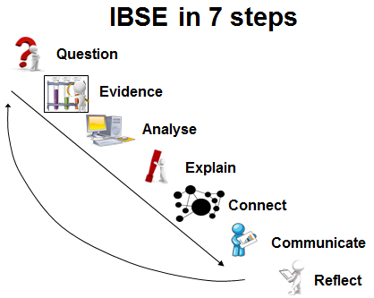

References

Alexopoulos A., (2015). Deliverable 5.1: Implementation Plan CREATIONS - Developing an Engaging Science Classroom, H2929-SEAC-2014-1 CSA, 665917.
Craft, Chappell & Slade (2014). D2.1: The CREAT-IT Pedagogical Framework.
Chappell et al (2016). CREATIONS Features of Inquiry. CREATIONS - Developing an Engaging Science Classroom, H2929-SEAC-2014-1 CSA, 665917.
Ben-Horin, O. (2015). Project Presentation. Grieg Research School Conference. Bergen.
Ben-Horin, O. (2014). D3.1 The WASO Guidelines. CREAT-IT project. Available at: http://www.opendiscoveryspace.eu/edu-object/write-science-opera-waso-guidelines-820499
Ben-Horin, O. and Stergiopoulos, P. (2015). “SkyLight – a Global Science Opera Implementation Scenario”. Available at: http://www.opendiscoveryspace.eu/edu-object/skylight-global-science-opera-waso-implementation-scenario-833946
OECD (2015). Skills for Social Progress: The Power of Social and Emotional Skills, OECD Skills Studies, OECD Publishing. http://dx.doi.org/10.1787/9789264226159-en. Available at: http://www.oecd.org/edu/skills-for-social-progress-9789264226159-en.htm. Retrieved on April 15th, 2016.
Robbestad, J. (2016). “How will sustainable theater design principles integrated into the visual frames of the Global Science Opera projects affect the creative process and the finished result?”. MacREL research draft, HSH
Stergiopoulos, P. (2015). Global Science Opera online meetings.

